|  |
| --- |
|  |
| Capstone Project Document |

**BAKERY STORE ONLINE**

|  |  |  |
| --- | --- | --- |
| **Bakery Store Online** | | |
| **Group member** | Phạm Thị Minh Phương | SE03773 |
| Cao Anh Tuấn | SE03737 |
| Hoàng Anh Phương | SE03715 |
| Ngô Trung Kiên | SE03736 |
| Nguyễn Xuân Hà | SE03484 |
| **Supervisor** | Mr. Nguyễn Văn Sang | |
| **Project code** | BSO | |

**- Hanoi, 12/2017 -**

TABLE CONTENTS

1 INTRODUCTION 2

1.1 Purpose 2

1.2 Acronyms and Definitions 2

1.3 Abstract 2

1.4 Literature Review 2

1.5 Proposal 4

1.6 Benefits from Project 7

1.7 Critical Assumption and Constraints 8

1.8 Potential Risks 8

2 PROJECT MANAGEMENT 9

2.1 Introduction 9

2.2 Project Overview 9

2.3 Project Development Approach 15

2.4 Estimation 18

2.5 Project Organization 23

2.6 Communication & Reporting 25

3 SOFTWARE REQUIREMENT 27

3.1 Introduction 27

3.2 Software Requirements Specification 28

4 SOFTWARE DESIGN 94

4.1 Introduction 94

4.2 Architecture design 94

4.3 Detail Design 108

4.4 Data design 180

4.5 Screen Design 185

5 SOFTWARE TESTING 224

5.1 Introduction 224

5.2 Test plan 226

5.3 Test case 233

5.4 Test Report 233

6 USER MANUAL 235

6.1 Introduction 235

6.2 Installation Guideline 235

6.3 User Guideline 245

6.4 Staff 266

7 PROJECT RESULT REPORT 270

7.1 Product Judging 270

7.2 Project Summary 271

7.3 Lesson Learnt 272

8 REFERENCES 273

# INTRODUCTION

## Purpose

This document is created as the introduction for project Bakery Store Online– our Capstone Project at FPT University. In this document, we will descript the overview of some existing systems, the initial idea for our project, a brief description about our expected system and some potential risks, critical assumptions, constrains. Moreover, this document also shows opportunities what it offers for users.

## Acronyms and Definitions

|  |  |
| --- | --- |
| Acronym & Abbreviation | Definition |
| BSO | Bakery Store Online |
| FU | FPT University |
| Q&A | Question and Answer |

1. Definitions and Acronyms

## Abstract

Bakery Store Online a standalone application which is based on ordering and selling the cake and other items and generating bill. The main principle behind the need of Bakery Store Online is easy supervision of shop. It has user friendly & modular approach. The modular approach of the software increases the flexibility of the software. Data storing is easier. It will be able to check any report at any time. Paper work and manual work is reduced. The system is user friendly and easy to use. The record of each customer is stored that is customer’s name and contact details are added for reference. Next the item is selected, flavours, pounds and quantity is also added. At the end of the day, report is generated to calculate the payment for each user in each day..

## Literature Review

There are quite a few major platform for Sales Online your project idea. However just have one Sales Online in Vietnam and that major platform just aim to project. For example: parisgateaux.vn, madamehuong.vn

### Paris Gateaux

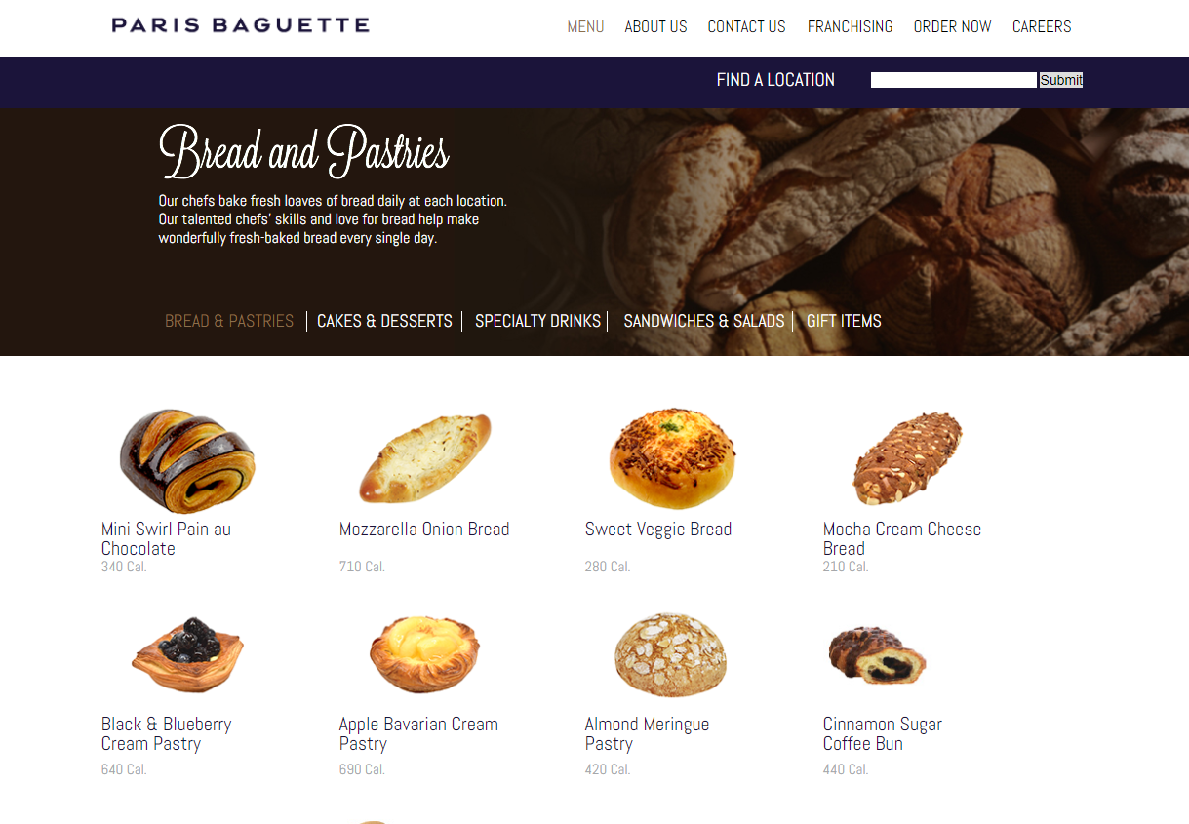

* Advantages:
* There are many different types of cakes
* Friendly site, easy to use
* Disadvantages:
* Can not see the price of the product
* Can not place order on website
* Not support online payment

### Madame Huong

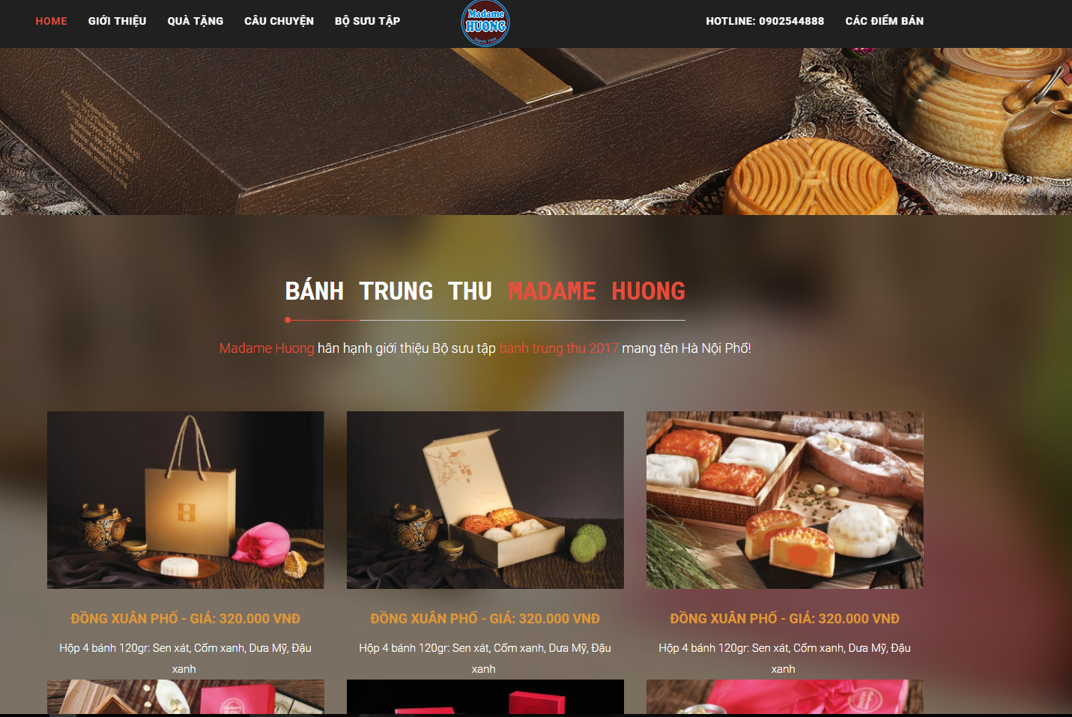

* Advantages:
* Friendly site, easy to use
* Can see the price of product in the website
* Disadvantages:
* Can not place order on website
* Only moon cake

## Proposal

### The idea

The need to enjoy delicious cakes is the constant need of every person, now we make our work become art, the more stimulated the demand is increasing. Society is growing thanks to the internet, we do not have to run out to buy bread.

Bakery Store Online - is an online website that sells cakes. With a friendly interface and easy to use, anyone can buy the cake they need (for example, birthday cake, biscuits, diabetic cake ...). In addition, the site shares some simple recipes that people can reference and perform at home

### The objective

This project is the Capstone Project in FPT University studying the program.

This project is responsible for all team members. So, we must complete all requirements from teacher and FU. During 3 months of capstone project, we hope that all member can get more knowledge about processing of software development, skill do document, coding, testing. Moreover, soft skill also very important, we can get skill management time, working in group, skill communication… It is not long time for project but our group hope that can do this project successfully. This project also makes our CV more beautiful after graduating from FU. This is also an opportunity for us to prove capacity with recruiters.

### Brief description about system

This site will promote the business and increase the store's sales. With a friendly and attractive interface, users can easily find or reference the cake samples.

Bakery Store Online uses familiar technologies as: Bootstraps, MVC5, NodeJS… And we are planning to develop a mobile version for easily connecting.

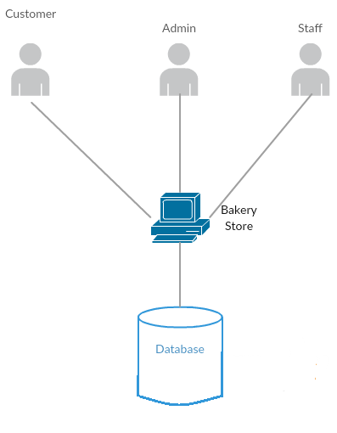

1. Brief descriptions diagram of Bakery Store Online system

### System features

About the features of Bakery Store Online, we focus to provide for users main features as searching, login, order, etc. Admin can manage users, manage staff, manage database, manage cake and manage blog.

In here, we focus on features which can help users can understand the best way what user want to have with features of Bakery Store Online. There are the detailed features of Bakery Store Online.

#### Client features

* Register: User can register an account and login to use all features of BSO.
* Login/Logout: Users login/logout an account to use or exit system BSO .
* Search: User can search with name of cake and system will display all of cake relate to keywords.
* Filter: User can filter with category (Introduce, Product, News, Service, Blog, Contact). And system will display projects relate to these selected options.
* Cake:
  + Shopping cart: after choose the cake and order, the cake will be in the cart.
  + View order history: after order success, user can review all the cake odered.
* Profile:
  + Change password: User can change password to keep security.
  + Update profile: User can change or update information.

#### Admin features

* Login/Logout: Amin login/logout an account to use or exit system BSO.
* Manage customer:
  + Search customer: Admin can search with name of customer and system will display simple information about that customer(name, email, phone number…)
  + Active/Deactivate user: admin can set customer’s account to active or deactivate.
* Manage staff:
  + Search staff: Admin can search with name of staff and system will display simple information about that staff(name, email, phone number…)
  + Active/Deactivate staff: admin can set staff’s account to active or deactivate.
* Manage cake:
  + Search cake: Admin can search with name of cake and system will display information about cake (name, size, cost,…)
  + Update cake: admin can change information about cake (name, size, number,…)
  + Add cake: admin can add new cake
  + Block cake: admin can block cake when it will not sale
  + Unblock cake: admin can unblock cake when it will sale
* Manage blog:
  + Search blog: Admin can search with title of blog and system will display blog
  + Add blog: admin can add new post
  + Block blog: admin can block blog
  + Update blog: admin can update blog
* Manage event:
  + Search event: Admin can search with title of event and system will display event
  + Add event: admin can add new event
  + Block event: admin can block event
  + Update event: admin can update event
* Manage category:
  + Search category: Admin can search with title of category and system will display category
  + Add category: admin can add new category
  + Block category: admin can block category
  + Update category: admin can update category
* Manage benefit:
  + Search by date: admin can search benefit by date of BSO
  + Search by from date to date: admin can search benefit by from date to date of BSO
  + View benefit: admin can view detail benefit of BSO

#### Staff features

* Login/Logout: Staff login/logout an account to use or exit system BSO.
* Forgot pasword: when staff forgot their password to login the system, this function will receiving their password to email.
* Manage order:
  + Search order: staff can search order of staff
  + Confirm order: staff can confirm order transaction successful
  + Unconfirm order: staff can confirm order transaction unsuccessful
  + Cancel order: staff can cancel order of customer
* Update profile: staff can edit profile

## Benefits from Project

### For our group

After developing and implementing this project, our group will get some benefits:

* Have more experiences of software project management how to manage plan, time, member and risk.
* Have more knowledge and skill about Node.js MVC5
* Know how to communicate with team members and how to teamwork more effective.

### For Community

Just need to have a device that connect to the internet and any web browser, user can:

* Easy buy cake
* Easy recieve cake

## Critical Assumption and Constraints

* Critical assumption:
  + Training: All developers can train Node.js in 2 weeks. Before starting this project, just 1 member in our team have knowledge about Node.js, but with programming techniques which we studied at FU, we have to try the best to not missing any deadline in project plan.
  + Human resources: Assume that all members in team have a good healthy to do their tasks.
* Constraints:
  + Time and deadline: We must complete task on time. We work on 14 weeks, each member works 5 hours/day and 5 days/week. We do not have more time for us to complete developing and deliver application to teachers. Besides, we have to submit report documents before deadline to teacher can review.
  + Quality: The products must be run well when users perform main functions in Google Chrome 40 and Firefox 30 or higher.
  + Process: We have to follow the software processing of FPT Software
  + Human resources: There are 5 member in our team, each member have to study 2 subjects (Japanese and JFE) at school.

## Potential Risks

After studying about this project, we find out some problem that we may be encountered:

* Under-estimate scope and time or miss deadline because lack of experience in group working, managing and controlling work.
* Loss data, source code before uploading data to server because of careless.
* Equipment got broken because of careless or accident.
* Human resources: Team member cannot complete their works because of health reasons, key member leave team or un-cooperating on team.
* Change requirements: Requirement changed when some functions cannot be completed or some technologies is not suitable.

# PROJECT MANAGEMENT

## Introduction

### Purpose

This part is the project management plan of Bakery Store Online (BSO) Project – our Capstone Project in FPT University. It is included the project overview, project organization, tools and  
infrastructures, schedule of this project.

### Definitions and Acronyms

|  |  |  |
| --- | --- | --- |
| Acronym | Definition | Note |
| CC | Infrastructure Configuration Controller |  |
| CCB | Change Control Board |  |
| CI | Configuration Item |  |
| CM | Configuration Management |  |
| CSCI | Computer Software Configuration Items |  |
| DEV | Developer |  |
| PIC | Person in charge |  |
| PM | Project Manager |  |
| PTL | Project Technical Leader |  |
| QA | Quality Assurance Officer |  |
| SRS | Software Requirement Specification |  |
| TP | Test Plan |  |
| TC | Test Case |  |

1. Definitions and acronyms

## Project Overview

### Project Description

|  |  |  |  |
| --- | --- | --- | --- |
| **Project Code** | BSO | **Contract Type** | None |
| **Customer** | FPT University | 2nd Customer | None |
| **Project Level** | Group | Project Rank | None |
| **Application Type** | Website | Project Manager | Pham Thi Minh Phuong |
| **Project Category** | Development | Business Domain | E-commerce |

1. Project Description

### Scope and Purpose

#### Purpose

The need to enjoy delicious cakes is the constant need of every person, now we make our work become art, the more stimulated the demand is increasing. Society is growing thanks to the internet, we do not have to run out to buy bread.

Bakery Store Online- is an online website that sells cakes. With a friendly interface and easy to use, anyone can buy the cake they need (for example, birthday cake, biscuits, diabetic cake ...). In addition, the site shares some simple recipes that people can reference and perform at home.

#### Scope

The scope of this project contains: Requirement Analysis, Design, Coding and Testing (Unit Test, Integration Test, and System Test).

#### The functions of Project

These are the functions of BSO project:

##### Client Module.

* Register: User can register an account and login to use all features of BSO.
* Login/Logout: Users login/logout an account to use or exit system BSO.
* Search: User can search with name of cake and system will display all of cake relate to keywords.
* Filter: User can filter with category (Introduce, Product, News, Service, Blog, Contact). And system will display projects relate to these selected options.
* Cake:
  + Shopping cart: after choose the cake and order, the cake will be in the cart.
  + View order history: after order success, user can review all the cake odered.
* Profile:
  + Change password: User can change password to keep security.
  + Update profile: User can change or update information.

##### Admin Module

* Login/Logout: Amin login/logout an account to use or exit system BSO.
* Manage customer:
  + Search customer: Admin can search with name of customer and system will display simple information about that customer(name, email, phone number…)
  + Active/Deactivate user: admin can set customer’s account to active or deactivate.
* Manage staff:
  + Search staff: Admin can search with name of staff and system will display simple information about that staff(name, email, phone number…)
  + Active/Deactivate staff: admin can set staff’s account to active or deactivate.
* Manage cake:
  + Search cake: Admin can search with name of cake and system will display information about cake (name, size, cost,…)
  + Update cake: admin can change information about cake (name, size, number,…)
  + Add cake: admin can add new cake
  + Block cake: admin can block cake when it will not sale
  + Unblock cake: admin can unblock cake when it will sale
* Manage blog:
  + Search blog: Admin can search with title of blog and system will display blog
  + Add blog: admin can add new post
  + Block blog: admin can block blog
  + Update blog: admin can update blog
* Manage event:
  + Search event: Admin can search with title of event and system will display event
  + Add event: admin can add new event
  + Block event: admin can block event
  + Update event: admin can update event
* Manage category:
  + Search category: Admin can search with title of category and system will display category
  + Add category: admin can add new category
  + Block category: admin can block category
  + Update category: admin can update category
* Manage benefit:
  + Search by date: admin can search benefit by date of BSO
  + Search by from date to date: admin can search benefit by from date to date of BSO
  + View benefit: admin can view detail benefit of BSO

##### Staff Module

* Login/Logout: Staff login/logout an account to use or exit system BSO.
* Forgot pasword: when staff forgot their password to login the system, this function will receiving their password to email.
* Manage order:
  + Search order: staff can search order of staff
  + Confirm order: staff can confirm order transaction successful
  + Unconfirm order: staff can confirm order transaction unsuccessful
  + Cancel order: staff can cancel order of customer
* Update profile: staff can edit profile

### Constraints

|  |  |  |
| --- | --- | --- |
| No | Description | Note |
| Constraints | | |
| 1 | This project must be completed and delivered before 25/12/2017 | Schedule |
| 2 | In doing project processing, PM must submit report (include 6 reports) on certain date. | Schedule |
| 3 | Software Requirement Specification Document and Project Plan must be completedwithin17dayssince09/09/2017  **Deadline**: 27/09/2017 | Schedule |
| 4 | Design Document (include Architecture Design, Screen Design, Database Design) must be completed within 18 days since 25/09/2017  Deadline:16/10/2017 | Schedule |
| 5 | Integration TestPlan (include test plan and test case…) must be completed within15dayssince25/10/2017  **Deadline**: 10/11/2017 | Schedule |
| 6 | Completed coding activity and have unit test result within 22 days since 30/10/2017  **Deadline**: 28/11/2017 | Schedule |
| 7 | Deliver report about User manual, software package and installation guide on 5 days since 08/12/2017  **Deadline**: 13/12/2017 | Schedule |
| 8 | Complete all of document and application before finishingtheprojecton22/12/2017 | Schedule |
| 9 | Project contains 5 members | Resource |

1. Project Description

### Project Objectives

#### Standard Objectives

|  |  |  |  |  |
| --- | --- | --- | --- | --- |
| Metrics | Unit | Committed | Re-committed | Note |

|  |  |  |  |  |
| --- | --- | --- | --- | --- |
| Start Date | 06/09/2017 |  |  |  |
| End Date | 25/12/2017 |  |  |  |
| Duration | Day | 81 |  |  |
| Maximum Team Size | Person | 5 |  |  |
| Calendar effort | Person-day | 405 |  | 1 Person-day = 5 hours |
| Effort Usage | Person-day | 100 |  | 1 Person-day = 5 hours |

1. Standard Objectives

|  |  |  |
| --- | --- | --- |
| Metrics | Unit | Basic for setting Goals |

|  |  |  |
| --- | --- | --- |
| Customer Satisfaction | Point | 9.5 |
| Leakage | def/mm | 5 |
| Effort Efficiency | % | 80 |
| Timeliness | % | 100 |

1. Standard Objectives 2

#### Specific Objectives

|  |  |  |  |
| --- | --- | --- | --- |
| Metrics | Unit | Basic for setting Goals | |
| Plan | Actual |
| Training technology: MVC, Bootstrap, Mongod, Node.js | Person-day | 15 | 15 |

|  |  |  |  |
| --- | --- | --- | --- |
| Execute group review | Person-day | 8 | 5 |
| Training requirements, process before coding | Person-day | 8 | 5 |

1. Specific Objectives

### Critical Dependencies

|  |  |  |  |
| --- | --- | --- | --- |
| No | Dependency | Expected delivery date | Note |

|  |  |  |  |
| --- | --- | --- | --- |
| 1 | This project must be completed and delivered to FPT University. | 25/12/2017 |  |
| 2 | Project Plan and SRS must be completed and delivered to Supervisor. | 27/09/2017 |  |
| 3 | User manual, Software Package and Installation Guide must be completed and delivered to Supervisor and FPT University. | 13/12/2017 |  |
| 4 | Beside Capstone Project, Team members have to joining in Japanese class and Japanese Fundamental Exam class. | 06/09/2017 |  |

1. Critical Dependencies

### Project Risk

PM identifies risks in the Risk Management Plan. The document is updated to trigger each milestone, each event also. The document is updated weekly by the PM, Risk Management Plan will be notified to all of the stakeholders affected. Status of risk is reported to supervisor at Project Milestones Report.

Reference to BSO_Risk Management Plan_v1.0_EN.xlsx

## Project Development Approach

### Requirement Change Management

|  |  |
| --- | --- |
| Who logs the change request? | Any team members |
| Who reviews the change request? | PM or who is PM assign |
| Who approves the change request? | PM by default. PTL if:   * Changes to project scope * Changes in delivery plan of project deliverable * Changes to assignment for key roles (PM, PTL) |

1. Requirement Change Management

### Quality Management

#### Defect Prevention Strategy

|  |  |  |
| --- | --- | --- |
| Item (Process/Product) | Strategy | Expected Benefits |
| Requirement missing | List up all of requirement into SRS document. | 10–20% reduction in defect injection rate and about 2% improvement in productivity |
| Careless mistake in Design Document Format/Template wrong | After designing, QA will review Document Format base on checklist review design | Improvement in quality as overall defect removal efficiency will improve; some benefits in productivity as defects will be detected early |
| Use wrong template | Have a meeting to disseminate all template that is used in this project for all member | All member will use right template when do document |
| Coding application does not match with User Requirement. | Develop Team must study about Requirement/Design within 1 weeks since project is assigned.  PM and PTL has responsibility to review task results and explain User Requirement for Develop Team | Coding Application match with User Requirement. |

1. Defect Prevention Strategy

#### Review Strategy

|  |  |  |  |  |
| --- | --- | --- | --- | --- |
| Review Item | Reviewer | Review Type | Review Method | Completion Criteria |
| Project plan  Project schedule  CM Plan | PM, QA, Supervisor | Group review  Group review  One-person review | Use checklist and Self-review |  |
| Business analysis and requirements specification document, Use Case catalog | PM, QA, Supervisor | Group review | Use checklist |  |
| Design document, object model | Self-review, PM, QA, Supervisor | Group review | Use checklist |  |
| Stage plans | PM, QA, Supervisor | One-person review | Use checklist |  |
| Complex/first time generated program specs incl. test cases, interactive diagrams |  | Group review |  |  |
| Code | Self-review or Team Lead review or Peer review | Group review | Self-review and use checklist |  |

1. Review Strategy

#### Integration Testing Strategy

|  |  |  |  |  |
| --- | --- | --- | --- | --- |
| Item to be Integration Tested | Integration Test Type | Integration Test Technique | Tool Used | Completion Criteria |
| Do test by flow of functions and items which have concern each other | Black-Box Test |  | Checklist, Boundary | - Number of UTC/KLOC: 20  - Number of defects/KLOC: 2-3 |

1. Integration Testing Strategy

#### System Testing Strategy

|  |  |  |  |  |
| --- | --- | --- | --- | --- |
| Item to be System Tested | System Test Type | System Test Technique | Tool Used | Completion Criteria |
| Test whole system | Black-Box Test |  | None | -Number of UTC/KLOC: 60  -Number of defects/KLOC: 4-6 |

1. System Testing Strategy

#### Estimates of Defects to be detected

|  |  |  |  |
| --- | --- | --- | --- |
| Review/Testing Stage | Targeted No. of Defects to be detected | % of Defects to be detected | Basic for Estimation |
| Requirements review | 10 | 12% | Referenced to similar project estimations |
| Design review | 15 | 18% | Referenced to similar project estimations |
| Code review | 30 | 35% | Referenced to similar project estimations |
| Integration Test | 15 | 18% | Referenced to similar project estimations |
| System Test | 10 | 12% | Referenced to similar project estimations |
| User Acceptance Test | 5 | 6% | Referenced to similar project estimations |
| Total | 85 | 100% |  |

1. Estimates of Defects

#### Measurements Program

|  |  |  |  |
| --- | --- | --- | --- |
| Data to be collected | Purpose | PIC | When |
| Size: No. of KLOC | Achieve target | PM | At the end of stages |
| Effort: No. person-day | Monitor and controlling team member to keep plan. | Team members | Daily |
| Quality: No. defects detected | Managing product’s quality. | Reviewer  Tester | Right after the review/test |
| Schedule | Monitor and controlling software developing processing keep plan. | PM | Weekly and at the end of stages |

1. Measurements Program

## Estimation

### Size

This project is performed and must complete all requirements from teacher and FPT University. So size of our project is in Capstone Project limit.

### Effort

The Effort estimation is documented in the table below:

|  |  |  |  |  |  |
| --- | --- | --- | --- | --- | --- |
|  | Initiation | Solution | Construction | Termination | Total |
| **Effort(person/day)** | 72 | 168 | 186 | 54 | **480** |
| **Total % budgeted Effort Usage (%)** | 100 | 100 | 100 | 100 |  |

1. Effort Estimation

### Schedule

#### Project Milestone & Deliverables

|  |  |  |  |  |
| --- | --- | --- | --- | --- |
| No | Stage | Committed Delivery date | Description of Deliverable | Delivery media |
| Initiation | |  | Requirements agreed, Report 1 reviewed | |
| 1 | Develop project idea | 07-09-2017 | Project goals and scope defined, milestone description defined, resource committed | SmartGit |
| 2 | Q&A Management Sheet | 13-09-2017 | Criteria: Documentation reviewed | SmartGit |
| 3 | Submit report no.1 final | 21-09-2017 | Completed report no.1 | SmartGit |
| 4 | Project Plan | 21-09-2017 | Criteria: Documentation reviewed | SmartGit |
| 5 | Submit report no.2 final | 17-10-2017 | Completed report no.2 | SmartGit |
| Solution | |  |  | |
| 1 | Screen Prototype | 04-10-2017 | Criteria: Documentation reviewed | SmartGit |
| 2 | Architecture Design | 09-10-2017 | Criteria: Documentation reviewed | SmartGit |
| 3 | Screen Design | 11-10-2017 | Criteria: Documentation reviewed | SmartGit |
| 4 | Class Design | 16-10-2017 | Criteria: Documentation reviewed | SmartGit |
| 5 | Detail Data Design | 05-10-2017 | Criteria: Documentation reviewed | SmartGit |
| 6 | SRS | 27-09-2017 | Criteria: Documentation reviewed | SmartGit |
| 7 | Submit Report no.3 Final | 26-10-2017 | Completed report no.3 | SmartGit |
| 8 | Submit Test Plan Final | 25-10-2017 | Criteria: Documentation reviewed | SmartGit |
| 9 | Create Test Case | 10-11-2017 | Criteria: Documentation reviewed | SmartGit |
| 10 | Submit Report no.4 Final | 21-11-2017 | Completed report no.4 | SmartGit |
| Construction | |  | Product developed & tested and released to supervisor, documentation reviewed. | |
| 1 | Review Test Document | 09-11-2017 | Criteria: Documentation reviewed | SmartGit |
| 2 | Submit report no.5 Final | 10-12-2017 | Completed report no.5 | SmartGit |
| 3 | Complete Coding and Unit Test | 20-11-2017 | Source code  Acceptance criteria: Product unit tested | SmartGit |
| 4 | Complete Testing | 04-12-2017 | Completed Test | SmartGit |
| 5 | Submit report no.6 Final | 12-12-2017 | Completed report no.6 | SmartGit |
| 6 | Submit the last document and CD source code | 12-12-2017 | Final Documents and Source Code | SmartGit |
| Termination | |  | Project post-mortem is conducted, Project assets archived and released to supervisor | |
| 1 | Lesson learned | 11-12-2017 | Criteria: Completed | SmartGit |
| 2 | Complete Presentation Slide | 13-12-2017 | Criteria: Completed | SmartGit |
| 3 | Represent capstone project | 22-12-2017 | Criteria: Completed | SmartGit |
| 4 | Project Complete | 20-12-2017 | Criteria: Completed | SmartGit |

1. Project Milestone and Deliverables

#### Detail Schedule

The detail project schedule is available in <…>. The Project Schedule is weekly updated by the Project Manager.

|  |  |  |  |  |
| --- | --- | --- | --- | --- |
| No. | Activity | Start date | Responsible | Note |
| Defect Prevention | | | | |
| 1 | Training coding convention Node.js | 24-09-2017 | 24-09-2017 | Cao Anh Tuan |
| 2 | Training for Q&A and tester to use checklist | 15-10-2017 | 16-10-2017 | Pham Thi Minh Phuong |
| Quality Control | | | | |
| 1 | Group review requirement | 14-10-2017 | 16-10-2017 | Pham Thi Minh Phuong |
| 2 | Group review design | 07-10-2017 | 09-10-2017 | Ngo Trung Kien |
| 3 | Group review coding | 22-11-2017 | 24-11-2017 | Nguyen Xuan Ha |
| Project Tracking | | | | |
| 1 | Solution: Milestone review meeting | 27-10-2017 | 28-10-2017 | Pham Thi Minh Phuong |
| 2 | Construction: Milestone review meeting | 06-12-2017 | 08-12-2017 | Pham Thi Minh Phuong |
| 3 | Transition: Milestone review meeting | 14-12-2017 | 15-12-2017 | Pham Thi Minh Phuong |
| Configuration Management | | | | |
| 1 | Baseline code | 17-10-2017 | 20-10-2017 | Nguyen Xuan Ha |
| 2 | Base line test report, test case and test plan | 22-10-2017 | 29-10-2017 | Pham Thi Minh Phuong |
| QA | | | | |
| 1 | Final Inspection: Report 1 | 07-09-2017 | 22-09-2017 | Pham Thi Minh Phuong |
| 2 | Final Inspection: Report 2 | 22-09-2017 | 19-10-2017 | Pham Thi Minh Phuong |
| 3 | Final Inspection: Report 3 | 20-10-2017 | 28-10-2017 | Pham Thi Minh Phuong |
| 4 | Final Inspection: Report 4 | 29-10-2017 | 25-11-2017 | Pham Thi Minh Phuong |
| 5 | Final Inspection: Report 5 | 26-11-2017 | 10-12-2017 | Pham Thi Minh Phuong |
| 6 | Final Inspection: Report 6 | 11-12-2017 | 14-12-2017 | Pham Thi Minh Phuong |

### Resource

Specified as in the section 2.5.1 Project Team

### Infrastructure

|  |  |  |  |
| --- | --- | --- | --- |
| **Item** | **Description** | **Expected Availability by** | **Note** |
| Development Environment | | | |
| Operating System | Window 8.1 (32 bit, 64 bit) |  |  |
| Browser | Chrome (40 or above), Firefox (30 or above) |  |  |
| Development language | Node.js |  |  |
| Technology | | | |
| Development language | Node.js |  |  |
| Database | MongoDB |  |  |
| Hardware Requirement | | | |
| Hardware Configuration | 2GB workspaces on server |  |  |
| Design | Rational Rose |  |  |
| Equipment & Tools | | | |
| Source Version Control | SmartGit | Definition stage |  |
| Task Tracking | MS Project Professional 2013 | Initiation stage |  |
| SRS | Microsoft Office Word 2013, Microsoft Office Excel 2013, Microsoft Office Visio 2013 | Initiation stage |  |

1. Infrastructure

### Training Plan

|  |  |  |  |
| --- | --- | --- | --- |
| Training Area | Participants | Duration | Waiver Criteria |
| Technical | | | |
| MVC5 | TuanCA,  HaNX | 1 week | Mandatory |
| NodeJS, jQuery | TuanCA,  HaNX | 1 week | Mandatory |
| Bootstrap | KienNT,  PhuongHA | 1 week |  |
| **Process** | | | |
| Quality system |  | 3 hours | If already trained |
| Configuration management |  | 2 hours | If already trained for CC. For others, on-the-job training |
| Group review |  | 2 hours | If already trained |
| Defect prevention |  | 2 hours | Mandatory |

1. Training Plan

### Finance

Because this project is non-business, it is a Capstone Project at FPT University. So we do not estimate about finance.

## Project Organization

### Project Team

|  |  |  |  |  |  |
| --- | --- | --- | --- | --- | --- |
| Role | Responsibility | Full name | Effort (%) | Start date | End date |
| PM | Have overall responsibility of the project:  - Project planning and scheduling  - Task assignment and tracking processing  - Review documents  - Reporting to supervisor | Pham Thi Minh Phuong | 50 | 07-09-2017 | 25-12-2017 |
| PTL | PTL is responsible for the technical project execution | Nguyen Xuan Ha | 50 | 07-09-2017 | 25-12-2017 |
| Programmer #1 | - Study technique (MVC, Node.js, etc.)  - Coding functions and modules of system.  - Peer-review source code of others members | Cao Anh Tuan, Nguyen Xuan Ha, | 100 | 07-09-2017 | 25-12-2017 |
| Programmer #2 | - Support coding functions and modules of system. | KienNT | 50 | 07-09-2017 | 25-12-2017 |
| Programmer #3 | - Support coding functions and modules of system. | PhuongHA | 100 | 07-09-2017 | 30-10-2017 |
| Test Leader | - Create test plan, test case, test report, quality report  - Execute test. | Hoang Anh Phuong | 100 | 30-10-2017 | 25-12-2017 |
| Tester | - Support creating test plan, test case, test report, quality report  Execute test. | Pham Thi Minh Phuong | 100 | 30-10-2017 | 25-12-2017 |
| Design | - Create screen design, prototype  - Review design of others member  - Review design of others member | Ngo Trung Kien | 100 | 07-09-2017 | 25-12-2017 |

1. Project Team description

### External Interfaces

FPT University Interfaces

|  |  |  |  |
| --- | --- | --- | --- |
| Function | Contact Person  (name, position) | Contact address  (email, telephone) | Responsibility |
| Teacher | Nguyen Van Sang | [SangNV@fpt.edu.vn](mailto:SangNV@fpt.edu.vn) | - Review and accept documents during project  - Review and accept products of the project.  - Resolve escalated issues and receive project reports. |
| Training Department |  | [acad.hn@fpt.edu.vn](mailto:acad.hn@fpt.edu.vn) | Management course of student |

## Communication & Reporting

|  |  |  |  |  |
| --- | --- | --- | --- | --- |
| **Communication Type** | **Method/Tool** | **When** | **Information** | **Participants/ Responsible** |
| Project Task Tracking | | | | |
| Task scheduling | MS Project Professional 2013 | At the beginning of every stage, and weekly  Refinement and rescheduling as necessary |  | PM |
| Task assignment | MS Project Professional 2013 | Weekly |  | PTL |
| Task status reporting | Daily Report | Daily |  | Project Team members |
| **Project Meeting** | | | | |
| Kick-off Meeting | Face to face | Initiation stage | Project introduction; Project plan review; Risk identification; stakeholders identify. | PM, Project Team Members |
| Project Progress Review Meetings | Face to face | Weekly and on event | Communicate project status  Communicate and resolve any open issue, risks, and changes  Discuss any suggested improvement | PM, Project Team Members |
| Milestone Meetings | Face to face | 5 days after the completion of stages: Definition, Solution & Construction | Project objective review, evaluate project performance (quality, schedule, effort), Causal analysis, update project plan for next stage | PM, Project Team Members, QA, Supervisor |
| Transfer/Sharing of project documentation/information | TortoiseGit | When available | All project documentation and information | PM, Project Team Members, QA |
| **Customer Communication and Reporting:** | | | | |
| Project Report | Agreed FPT Software and FU standard format | 5pm Monday, Weekly | Project status report, Issue requiring clarifications, escalation, if any | PM |
| Project Meetings with supervisor | Face to face | 12h30 Wednesday, Weekly | As above | PM |
| Requirement gathering/clarification | Face to face meeting | During requirement analysis phase | As in Q&A list | PM |
| **Communication with Senior Management** | | | | |
| Review Project Plan & Project schedule | By attend project meeting | Significant changes to WO, PP and Project schedule (scope, objectives Organization, HR, major milestone, deliverables ) |  | PM |
| Project Progress Review | By email and/or via Operation meeting at Group/Division level | Weekly | Project status report, Issue requiring clarifications, escalation, if any | PM |
| Project Milestone Review | By email and via project milestone review meeting | End of every stage | Project objective review, evaluate project performance (quality, schedule, effort), Causal analysis, update project plan for next stage | PM |
| **Other Communication and Reporting:** | | | | |
| Raise issue or request service/support of BA groups (IT, Admin, QA, HR, Training, Recruitment, etc) | Call log; email; phone | Upon request | Request content, expected completion date | PM |

1. Communication and Reporting Plan

# SOFTWARE REQUIREMENT

## Introduction

### Purpose

This document is created as the introduction for project BSO – our Capstone Project at FPT University. In this document, we provide the describing of general requirement and non-functional requirements. These requirements will assure that the system will correctly and reliably perform its intended functionality. This specification will provide general, as well as specific requirements to be used in the design, testing and validation of the system. It is intended for both stakeholders and the project team of the system.

### Definitions and Acronyms

|  |  |  |
| --- | --- | --- |
| **Acronym** | **Definition** | **Note** |
| BSO | Bakery Store Online |  |
| SRS | Software Requirements Specifications |  |

1. Definition and Acronyms

## Software Requirements Specification

### Overall Description

#### System use case

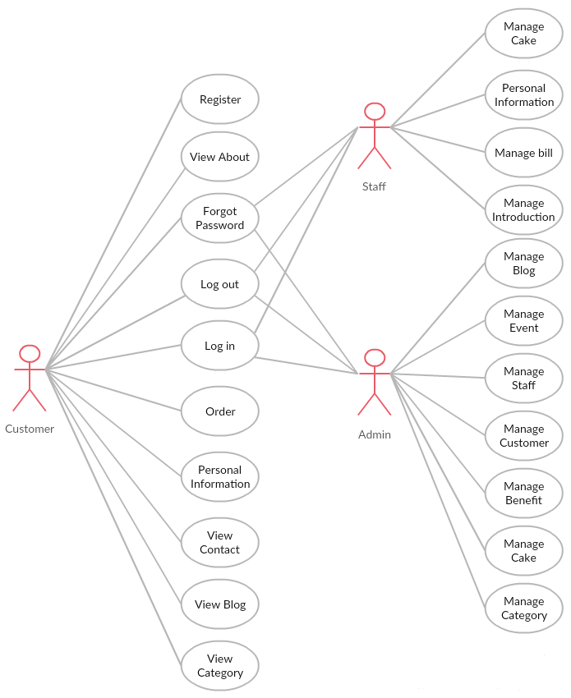

1. Use case diagram of BSO system

#### Product Features

|  |  |  |
| --- | --- | --- |
| **UC No.** | **Group Of Functions** | **Function** |
| **Administrator** | | |
| UC001 | Common | Admin Login |
| UC002 |  | Admin Logout |
| UC003 | Admin Forgot Password |
| UC004 | Manage Staff | View list staff |
| UC005 | View staff profile |
| UC006 | Activate staff account |
| UC007 | Deactivate staff account |
| UC008 | Search staff account |
| UC009 | Update staff account |
| UC010 | Insert a new staff account |
| UC011 | Manage Customer | View list customer |
| UC012 | Activate customer account |
| UC013 | Deactivate customer account |
| UC014 | View customer profile |
| UC015 | Search customer account |
| UC016 | Manage Benefit | Search benefit |
| UC017 | View benefit |
| UC018 | Manage Cake | Search cake |
| UC019 | Add cake |
| UC020 | Update cake |
| UC021 | Block Cake |
| UC022 | Unblock Cake |
| UC023 | View information cake |
| UC024 | Manage blog | View list blog |
| UC025 | Search blog |
| UC026 | Add blog |
| UC027 | Block blog |
| UC028 | Unblock blog |
| UC029 | Manage Event | Search event |
| UC030 | Add event |
| UC031 | Block event |
| UC032 | Unblock event |
| UC033 | Manage Category | Add Category |
| UC034 |  | Block Category |
| UC035 | Unblock Category |
| **Staff** | | |
| UC036 | Common | Log in |
| UC037 | Log out |
| UC038 | Forgot Password |
| UC039 | Manage Bill | Search order |
| UC040 | Confirm Order |
| UC041 | Unconfirm Order |
| UC042 | Manage Cake | View Cake |
| UC043 | Search Cake |
| UC044 | Personal information | Update Information |
| UC045 | Change Password |
| UC046 | Manage Introduction | Create Introduction |
| UC047 | Update Introduction |
| **Customer** | | |
| UC048 | Common Module | Register |
| UC049 | Login |
| UC050 | Logout |
| UC051 | Forgot Password |
| UC052 | View About |
| UC053 | View Contact |
| UC054 | View Blog |
| UC055 | View Catgory |
| UC056 | Order | Order Cake |
| UC057 | Check Out |
| UC058 | Personal Information | Edit Profile |
| UC059 | Change Password |
| UC060 | Purchase History |

1. List of use case diagram

#### User Characteristics

BSO website is the site sell cake online. The website requires users to have the ability to use a browser with an internet connection. Use can easy use the functions in website, but if they want to use all function, they must be login. BSO has three objective users:

* Administrator: They can manage all information of BSO.
* Staff: They can manage information about order, contact,...
* Customer: they can use functions of BSO like Login, Logout, Order,...

### Functional Specification

#### Administrator Group Function

##### Common Module

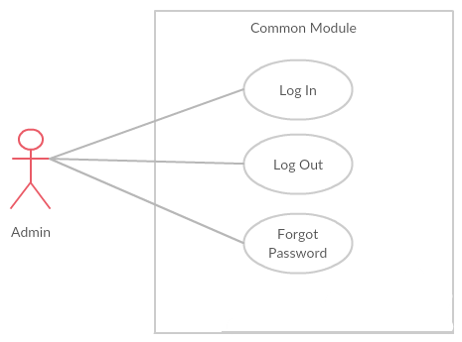

1. Common use case

###### UC001- Admin login

|  |  |  |  |  |
| --- | --- | --- | --- | --- |
| **Use Case ID** | | UC001 | **Version** | 1.0 |
| **Use Case Name** | | Admin login | | |
| **Created by:** | | PhuongPTM | **Date Created:** | 28/09/2017 |
| **Primary Actor** | | Administrator(Admin) | **Secondary Actor** |  |
| **Description:** | | This function allows Admin logins into website | | |
| **Preconditions:** | | 1. BSO website is available 2. Admin browsed BSO website 3. Admin are viewing Login page for admin | | |
| **Trigger:** | | Admin clicks on Login button | | |
| **Post conditions:** | | 1. Log Admin into system 2. Redirect Admin to Admin home page | | |
| **Normal Flow** | | | | |
| **Step** | **Actor** | **Action** | | |
| 1 | BSO | Display Admin Login page. If Admin choose Remember Me function before, fill all needed information | | |
| 2 | Admin | Type email address and password if Admin does not choose Remember Me function before | | |
| 3 | BSO | Verify:  Email address  Password | | |
| 4 | BSO | * Log Admin into system * Redirect Admin to Admin home page | | |
| **Alternative Flows: N/A** | | | | |
| **Exceptions:** | | | | |
| **EC1** | At step 2 in main flow, if Admin entered wrong Email address or Password | | | |
| **Step** | **Actor** | **Action** | | |
| 2.1 | BSO | Display Login popup message point out error field | | |
| 2.2 | BSO | Mark error fields | | |
| **Priority** | | High | | |
| **Frequency of Use:** | | High | | |
| **Business Rules:** | | B1 | | |
| **Other Information:** | | N/A | | |

1. Admin login Use case

###### UC002- Admin logout

|  |  |  |  |  |
| --- | --- | --- | --- | --- |
| **Use Case ID** | | UC002 | **Version** | 1.0 |
| **Use Case Name** | | Admin logout | | |
| **Created by:** | | PhuongPTM | **Date Created:** | 28/09/2017 |
| **Primary Actor** | | Administrator(Admin) | **Secondary Actor** |  |
| **Description:** | | This function allows Admin logout website | | |
| **Preconditions:** | | Admin logged website as Administrator | | |
| **Trigger:** | | Admin clicks on Sign out button | | |
| **Post conditions:** | | Admin logged out from BSO website | | |
| **Normal Flow** | | | | |
| **Step** | **Actor** | **Action** | | |
| 1 | Admin | Choose sign out button | | |
| 2 | BSO | Sign out Admin  Redirect to Admin Sign in page | | |
| **Alternative Flows: N/A** | | | | |
| **Exceptions: N/A** | | | | |
| **Priority** | | High | | |
| **Frequency of Use:** | | High | | |
| **Business Rules:** | | B1 | | |
| **Other Information:** | | N/A | | |

1. Admin logout Use case

###### UC003 – Admin Forgot Password

|  |  |  |  |  |
| --- | --- | --- | --- | --- |
| **Use Case ID** | | UC003 | **Version** | 1.0 |
| **Use Case Name** | | Admin forgot password | | |
| **Created by:** | | PhuongPTM | **Date Created:** | 28/09/2017 |
| **Primary Actor** | | Administrator(Admin) | **Secondary Actor** |  |
| **Description:** | | This function allows Admin receiving her/his password to mail | | |
| **Preconditions:** | | 1. BSO website is available 2. Admin browsed BSO website 3. Admin are viewing Sign in page for admin | | |
| **Trigger:** | | Click Forgot password in Sign in page | | |
| **Post conditions:** | | Admin get new password on her/his email | | |
| **Normal Flow** | | | | |
| **Step** | **Actor** | **Action** | | |
| 1 | Admin | Click Forgot password in Sign in page | | |
| 2 | BSO | Display Email text box | | |
| 3 | Admin | Enter registered email | | |
| 4 | Admin | Click Forgot Password | | |
| **Alternative Flows: N/A** | | | | |
| **Exceptions: N/A** | | | | |
| **Priority** | | High | | |
| **Frequency of Use:** | | High | | |
| **Business Rules:** | | B1 | | |
| **Other Information:** | | N/A | | |

1. Admin Forgot Password Use case

##### Manage customer’s account

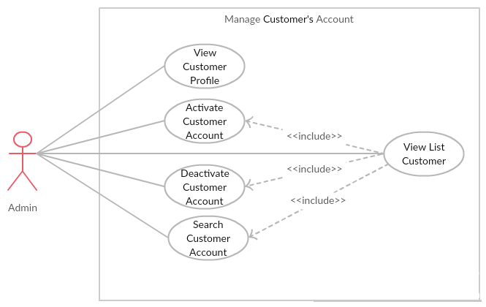

1. Manage customer’s use case

###### UC004- View List Customer

|  |  |  |  |  |
| --- | --- | --- | --- | --- |
| **Use Case ID** | | UC004 | **Version** | 1.0 |
| **Use Case Name** | | View list customer | | |
| **Created by:** | | PhuongPTM | **Date Created:** | 28/09/2017 |
| **Primary Actor** | | Administrator(Admin) | **Secondary Actor** |  |
| **Description:** | | This function allows Administrator to view list customer | | |
| **Preconditions:** | | 1. BSO website is available 2. Admin browsed BSO website 3. Admin are viewing Login page for admin | | |
| **Trigger:** | | Admin click on Manage Account | | |
| **Post conditions:** | | Customer List is displayed | | |
| **Normal Flow** | | | | |
| **Step** | **Actor** | **Action** | | |
| 1 | Admin | * Click on “Choose role you want” drop down list * Click on Customer | | |
| 2 | BSO | Display list of customer | | |
| **Alternative Flows: N/A** | | | | |
| **Exceptions: N/A** | | | | |
| **Priority** | | High | | |
| **Frequency of Use:** | | High | | |
| **Business Rules:** | | B1 | | |
| **Other Information:** | | N/A | | |

1. View List Customer

###### UC005- View Customer Profile

|  |  |  |  |  |
| --- | --- | --- | --- | --- |
| **Use Case ID** | | UC005 | **Version** | 1.0 |
| **Use Case Name** | | View customer profile | | |
| **Created by:** | | PhuongPTM | **Date Created:** | 28/09/2017 |
| **Primary Actor** | | Administrator(Admin) | **Secondary Actor** |  |
| **Description:** | | This function allows Administrator to view profile of a customer | | |
| **Preconditions:** | | 1. BSO website is available 2. Admin browsed BSO website 3. Admin are viewing Login page for admin | | |
| **Trigger:** | | Admin click on Manage Account | | |
| **Post conditions:** | | Profile of this customer is displayed | | |
| **Normal Flow** | | | | |
| **Step** | **Actor** | **Action** | | |
| 1 | Admin | * Click on “Choose role you want” drop down list * Click on Customer | | |
| 2 | BSO | Display profile of this customer | | |
| **Alternative Flows: N/A** | | | | |
| **Exceptions: N/A** | | | | |
| **Priority** | | High | | |
| **Frequency of Use:** | | High | | |
| **Business Rules:** | | B1 | | |
| **Other Information:** | | N/A | | |

1. View Customer Profile Use case

###### UC006- Activate Customer Account

|  |  |  |  |  |
| --- | --- | --- | --- | --- |
| **Use Case ID** | | UC006 | **Version** | 1.0 |
| **Use Case Name** | | Activate customer’s account | | |
| **Created by:** | | PhuongPTM | **Date Created:** | 28/09/2017 |
| **Primary Actor** | | Administrator(Admin) | **Secondary Actor** |  |
| **Description:** | | This function allows Administrator to active a customer’s account | | |
| **Preconditions:** | | * Admin is viewing Customers List * Status of this customer is Lock | | |
| **Trigger:** | | Admin click on Unlock button | | |
| **Post conditions:** | | Customer’s account is activated | | |
| **Normal Flow** | | | | |
| **Step** | **Actor** | **Action** | | |
| 1 | Admin | Click on Unlock button at Status column of the customer whom want to activate | | |
| 2 | BSO | * Change displayed status from Lock to Unlock * Change status of this customer’s account to Unlock on database | | |
| **Alternative Flows: N/A** | | | | |
| **Exceptions: N/A** | | | | |
| **Priority** | | High | | |
| **Frequency of Use:** | | High | | |
| **Business Rules:** | | B1 | | |
| **Other Information:** | | N/A | | |

1. Activate Customer Account Use case

###### UC007 – Deactivate Customer Account

|  |  |  |  |  |
| --- | --- | --- | --- | --- |
| **Use Case ID** | | UC007 | **Version** | 1.0 |
| **Use Case Name** | | Deactivate customer’s account | | |
| **Created by:** | | PhuongPTM | **Date Created:** | 28/09/2017 |
| **Primary Actor** | | Administrator(Admin) | **Secondary Actor** |  |
| **Description:** | | This function allows Administrator to deactivate a customer’s account | | |
| **Preconditions:** | | * Admin is viewing Customers List * Status of this customer is Unlock | | |
| **Trigger:** | | Admin click on Lock button | | |
| **Post conditions:** | | Customer’s account is deactivated | | |
| **Normal Flow** | | | | |
| **Step** | **Actor** | **Action** | | |
| 1 | Admin | Click on Lock button at Status column of the customer whom want to deactivate | | |
| 2 | BSO | * Change displayed status from Unlock to Lock * Change status of this customer’s account to Lock on database | | |
| **Alternative Flows: N/A** | | | | |
| **Exceptions: N/A** | | | | |
| **Priority** | | High | | |
| **Frequency of Use:** | | High | | |
| **Business Rules:** | | B1 | | |
| **Other Information:** | | N/A | | |

1. Deactivate Customer Account Use case

###### UC008 – Search Customer Account

|  |  |  |  |  |
| --- | --- | --- | --- | --- |
| **Use Case ID** | | UC008 | **Version** | 1.0 |
| **Use Case Name** | | Search customer’s account | | |
| **Created by:** | | PhuongPTM | **Date Created:** | 28/09/2017 |
| **Primary Actor** | | Administrator(Admin) | **Secondary Actor** |  |
| **Description:** | | This function allows Administrator to search a customer’s account | | |
| **Preconditions:** | | Admin is viewing Customers List | | |
| **Trigger:** | | Admin types phone number of customer at Search textbox | | |
| **Post conditions:** | | Display list of searched customer | | |
| **Normal Flow** | | | | |
| **Step** | **Actor** | **Action** | | |
| 1 | Admin | Type phone number of customer whom want to search | | |
| 2 | BSO | Display list of customer who have the phone number is typed | | |
| **Alternative Flows: N/A** | | | | |
| **Exceptions: N/A** | | | | |
| **Priority** | | High | | |
| **Frequency of Use:** | | High | | |
| **Business Rules:** | | B1 | | |
| **Other Information:** | | N/A | | |

1. Search Customer Account Use case

##### Manage Staff’s Account

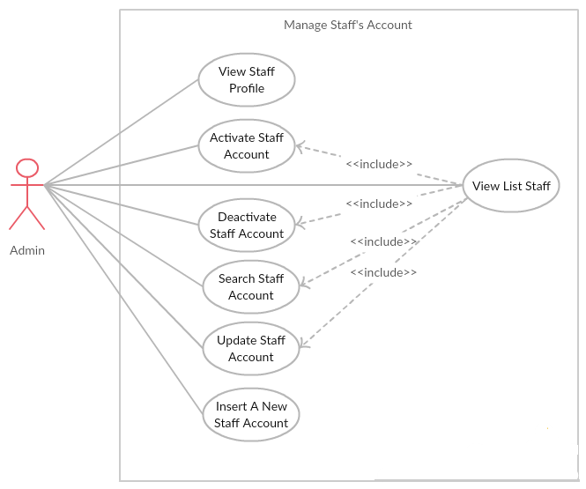

###### UC009 – View List Staff

|  |  |  |  |  |
| --- | --- | --- | --- | --- |
| **Use Case ID** | | UC009 | **Version** | 1.0 |
| **Use Case Name** | | View list staff | | |
| **Created by:** | | PhuongPTM | **Date Created:** | 28/09/2017 |
| **Primary Actor** | | Administrator(Admin) | **Secondary Actor** |  |
| **Description:** | | This function allows Administrator to view list staff | | |
| **Preconditions:** | | 1. BSO website is available 2. Admin browsed BSO website 3. Admin are viewing Login page for admin | | |
| **Trigger:** | | Admin click on Manage Account | | |
| **Post conditions:** | | Staff List is displayed | | |
| **Normal Flow** | | | | |
| **Step** | **Actor** | **Action** | | |
| 1 | Admin | * Click on “Choose role you want” drop down list * Click on Staff | | |
| 2 | BSO | Display list of staff | | |
| **Alternative Flows: N/A** | | | | |
| **Exceptions: N/A** | | | | |
| **Priority** | | High | | |
| **Frequency of Use:** | | High | | |
| **Business Rules:** | | B1 | | |
| **Other Information:** | | N/A | | |

1. View List Staff Use case

###### UC010 – View Staff Profile

|  |  |  |  |  |
| --- | --- | --- | --- | --- |
| **Use Case ID** | | UC010 | **Version** | 1.0 |
| **Use Case Name** | | View staff profile | | |
| **Created by:** | | PhuongPTM | **Date Created:** | 28/09/2017 |
| **Primary Actor** | | Administrator(Admin) | **Secondary Actor** |  |
| **Description:** | | This function allows Administrator to view profile of a staff | | |
| **Preconditions:** | | Admin is viewing Staff List | | |
| **Trigger:** | | Admin click on Manage Account | | |
| **Post conditions:** | | Profile of this staff is displayed | | |
| **Normal Flow** | | | | |
| **Step** | **Actor** | **Action** | | |
| 1 | Admin | Click on Manage Account button at action column of the staff whom want to see profile | | |
| 2 | BSO | Display profile of this staff | | |
| **Alternative Flows: N/A** | | | | |
| **Exceptions: N/A** | | | | |
| **Priority** | | High | | |
| **Frequency of Use:** | | High | | |
| **Business Rules:** | | B1 | | |
| **Other Information:** | | N/A | | |

1. View Staff Profile Use case

###### UC011 – Activate Staff Account

|  |  |  |  |  |
| --- | --- | --- | --- | --- |
| **Use Case ID** | | UC011 | **Version** | 1.0 |
| **Use Case Name** | | Activate staff’s account | | |
| **Created by:** | | PhuongPTM | **Date Created:** | 28/09/2017 |
| **Primary Actor** | | Administrator(Admin) | **Secondary Actor** |  |
| **Description:** | | This function allows Administrator to active a staff’s account | | |
| **Preconditions:** | | * Admin is viewing Staff List * Status of this staff is Lock | | |
| **Trigger:** | | Admin click on Unlock button | | |
| **Post conditions:** | | Staff’s account is activated | | |
| **Normal Flow** | | | | |
| **Step** | **Actor** | **Action** | | |
| 1 | Admin | Click on Unlock button at Status column of the staff whom want to activate | | |
| 2 | BSO | * Change displayed status from Lock to Unlock * Change status of this staff’s account to Unlock on database | | |
| **Alternative Flows: N/A** | | | | |
| **Exceptions: N/A** | | | | |
| **Priority** | | High | | |
| **Frequency of Use:** | | High | | |
| **Business Rules:** | | B1 | | |
| **Other Information:** | | N/A | | |

1. Activate Staff Account Use case

###### UC012 – Deactivate Staff Account

|  |  |  |  |  |
| --- | --- | --- | --- | --- |
| **Use Case ID** | | UC012 | **Version** | 1.0 |
| **Use Case Name** | | Deactivate staff’s account | | |
| **Created by:** | | PhuongPTM | **Date Created:** | 28/09/2017 |
| **Primary Actor** | | Administrator(Admin) | **Secondary Actor** |  |
| **Description:** | | This function allows Administrator to deactivate a staff’s account | | |
| **Preconditions:** | | * Admin is viewing Staff List * Status of this staff is Unlock | | |
| **Trigger:** | | Admin click on Lock button | | |
| **Post conditions:** | | Staff’s account is deactivated | | |
| **Normal Flow** | | | | |
| **Step** | **Actor** | **Action** | | |
| 1 | Admin | Click on Lock button at Status column of the staff whom want to deactivate | | |
| 2 | BSO | * Change displayed status from Unlock to Lock * Change status of this staff’s account to Lock on database | | |
| **Alternative Flows: N/A** | | | | |
| **Exceptions: N/A** | | | | |
| **Priority** | | High | | |
| **Frequency of Use:** | | High | | |
| **Business Rules:** | | B1 | | |
| **Other Information:** | | N/A | | |

1. Deactivate Staff Account Use case

###### UC013 – Search Staff Account

|  |  |  |  |  |
| --- | --- | --- | --- | --- |
| **Use Case ID** | | UC013 | **Version** | 1.0 |
| **Use Case Name** | | Search staff’s account | | |
| **Created by:** | | PhuongPTM | **Date Created:** | 28/09/2017 |
| **Primary Actor** | | Administrator(Admin) | **Secondary Actor** |  |
| **Description:** | | This function allows Administrator to search a staff’s account | | |
| **Preconditions:** | | Admin is viewing Staff List | | |
| **Trigger:** | | Admin types name of staff at Search textbox | | |
| **Post conditions:** | | Display list of searched staff | | |
| **Normal Flow** | | | | |
| **Step** | **Actor** | **Action** | | |
| 1 | Admin | Type name of staff whom want to search | | |
| 2 | BSO | Display list of staff who have the name is typed | | |
| **Alternative Flows: N/A** | | | | |
| **Exceptions: N/A** | | | | |
| **Priority** | | High | | |
| **Frequency of Use:** | | High | | |
| **Business Rules:** | | B1 | | |
| **Other Information:** | | N/A | | |

1. Search Staff Account Use case

###### UC014 – Update Staff Account

|  |  |  |  |  |
| --- | --- | --- | --- | --- |
| **Use Case ID** | | UC014 | **Version** | 1.0 |
| **Use Case Name** | | Update staff’s account | | |
| **Created by:** | | PhuongPTM | **Date Created:** | 28/09/2017 |
| **Primary Actor** | | Administrator(Admin) | **Secondary Actor** |  |
| **Description:** | | This function allows Administrator to update a staff’s account | | |
| **Preconditions:** | | Admin is viewing Staff List | | |
| **Trigger:** | | Admin click on Update button | | |
| **Post conditions:** | | Update staff’s account page is displayed | | |
| **Normal Flow** | | | | |
| **Step** | **Actor** | **Action** | | |
| 1 | Admin | Choose the staff who want to change information | | |
| 2 | Admin | Click on Update button | | |
| 3 | Admin | Update information | | |
| 4 | Admin | Click on Save button | | |
| 5 | BSO | Save change | | |
| **Alternative Flows: N/A** | | | | |
| **Exceptions:** | | | | |
| **EC1** | At step 3 in the main flows, if user miss fill 1 or more information | | | |
| **Step** | **Actor** | **Action** | | |
| **3.1** | BSO | Display Dialog to remind user | | |
|  | | | | |
| **Priority** | | High | | |
| **Frequency of Use:** | | High | | |
| **Business Rules:** | | B1 | | |
| **Other Information:** | | N/A | | |

1. Update Staff Account Use case

###### UC015 – Insert A New Staff Account

|  |  |  |  |  |
| --- | --- | --- | --- | --- |
| **Use Case ID** | | UC015 | **Version** | 1.0 |
| **Use Case Name** | | Insert a new staff’s account | | |
| **Created by:** | | PhuongPTM | **Date Created:** | 28/09/2017 |
| **Primary Actor** | | Administrator(Admin) | **Secondary Actor** |  |
| **Description:** | | This function allows Administrator to insert a new staff’s account | | |
| **Preconditions:** | | 1. BSO website is available 2. Admin browsed BSO website 3. Admin are viewing Login page for admin | | |
| **Trigger:** | | Admin click on Insert Staff | | |
| **Post conditions:** | | Insert staff page is displayed | | |
| **Normal Flow** | | | | |
| **Step** | **Actor** | **Action** | | |
| 1 | Admin | Click on Insert Staff | | |
| 2 | BSO | Insert staff page is displayed | | |
| 3 | Admin | * Type Staff name * Type Password * Type Address * Type Phone number * Type Email * Choose image * Click Add button | | |
| **Alternative Flows: N/A** | | | | |
| **Exceptions:** | | | | |
| **EC1** | At step 3 in the main flows, if user miss fill 1 or more information | | | |
| **Step** | **Actor** | **Action** | | |
| **3.1** | BSO | Display Dialog to remind user | | |
|  | | | | |
| **Priority** | | High | | |
| **Frequency of Use:** | | High | | |
| **Business Rules:** | | B1 | | |
| **Other Information:** | | N/A | | |

1. Insert A New Staff Account Use case

##### Manage Cake

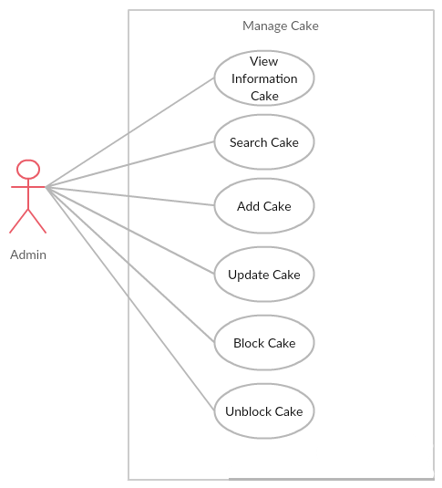

1. Manage Cake Use case

###### UC016 – View Information Cake

|  |  |  |  |  |
| --- | --- | --- | --- | --- |
| **Use Case ID** | | UC016 | **Version** | 1.0 |
| **Use Case Name** | | View information cake | | |
| **Created by:** | | PhuongPTM | **Date Created:** | 28/09/2017 |
| **Primary Actor** | | Administrator(Admin) | **Secondary Actor** |  |
| **Description:** | | This function allows Administrator to view list cake | | |
| **Preconditions:** | | 1. BSO website is available 2. Admin browsed BSO website 3. Admin are viewing Login page for admin | | |
| **Trigger:** | | Admin click on Manage Cake | | |
| **Post conditions:** | | Cake List is displayed | | |
| **Normal Flow** | | | | |
| **Step** | **Actor** | **Action** | | |
| 1 | Admin | Click on Manage Cake | | |
| 2 | BSO | Display list of cake | | |
| **Alternative Flows: N/A** | | | | |
| **Exceptions: N/A** | | | | |
| **Priority** | | High | | |
| **Frequency of Use:** | | High | | |
| **Business Rules:** | | B1 | | |
| **Other Information:** | | N/A | | |

1. View Information Cake Use case

###### UC017 – Search Cake

|  |  |  |  |  |
| --- | --- | --- | --- | --- |
| **Use Case ID** | | UC017 | **Version** | 1.0 |
| **Use Case Name** | | Search cake | | |
| **Created by:** | | PhuongPTM | **Date Created:** | 28/09/2017 |
| **Primary Actor** | | Administrator(Admin) | **Secondary Actor** |  |
| **Description:** | | This function allows Administrator to search cake | | |
| **Preconditions:** | | Admin is viewing Cake List | | |
| **Trigger:** | | Admin types name of cake at Search textbox | | |
| **Post conditions:** | | Display list of searched cake | | |
| **Normal Flow** | | | | |
| **Step** | **Actor** | **Action** | | |
| 1 | Admin | Click on Manage Cake | | |
| 2 | BSO | List cake is displayed | | |
| 3 | Admin | Type name of cake what admin want to search | | |
| 4 | BSO | Display list of cake what have the name is typed | | |
| **Alternative Flows: N/A** | | | | |
| **Exceptions: N/A** | | | | |
| **Priority** | | High | | |
| **Frequency of Use:** | | High | | |
| **Business Rules:** | | B1 | | |
| **Other Information:** | | N/A | | |

1. Search Cake Use case

###### UC018 – Add Cake

|  |  |  |  |  |
| --- | --- | --- | --- | --- |
| **Use Case ID** | | UC018 | **Version** | 1.0 |
| **Use Case Name** | | Add cake | | |
| **Created by:** | | PhuongPTM | **Date Created:** | 28/09/2017 |
| **Primary Actor** | | Administrator(Admin) | **Secondary Actor** |  |
| **Description:** | | This function allows Administrator to add a new cake | | |
| **Preconditions:** | | 1. BSO website is available 2. Admin browsed BSO website 3. Admin are viewing Login page for admin | | |
| **Trigger:** | | Admin click on Insert Cake | | |
| **Post conditions:** | | Insert cake page is displayed | | |
| **Normal Flow** | | | | |
| **Step** | **Actor** | **Action** | | |
| 1 | Admin | Click on Insert Cake | | |
| 2 | BSO | Insert cake page is displayed | | |
| 3 | Admin | * Choose Cake type * Type Cake name * Type Material * Type Description * Type Size * Type Price * Type Quantity * Choose image * Click Add button | | |
| **Alternative Flows: N/A** | | | | |
| **Exceptions:** | | | | |
| **EC1** | At step 3 in the main flows, if user miss fill 1 or more information | | | |
| **Step** | **Actor** | **Action** | | |
| **3.1** | BSO | Display Dialog to remind user | | |
|  | | | | |
| **Priority** | | High | | |
| **Frequency of Use:** | | High | | |
| **Business Rules:** | | B1 | | |
| **Other Information:** | | N/A | | |

1. Add Cake Use case

###### UC019 – Update Cake

|  |  |  |  |  |
| --- | --- | --- | --- | --- |
| **Use Case ID** | | UC019 | **Version** | 1.0 |
| **Use Case Name** | | Update cake | | |
| **Created by:** | | PhuongPTM | **Date Created:** | 28/09/2017 |
| **Primary Actor** | | Administrator(Admin) | **Secondary Actor** |  |
| **Description:** | | This function allows Administrator to update a cake | | |
| **Preconditions:** | | Admin is viewing Cake List | | |
| **Trigger:** | | Admin click on Update button | | |
| **Post conditions:** | | Update cake page is displayed | | |
| **Normal Flow** | | | | |
| **Step** | **Actor** | **Action** | | |
| 1 | Admin | Choose the cake what admin want to change information | | |
| 2 | Admin | Click on Update button | | |
| 3 | Admin | Update information | | |
| 4 | Admin | Click on Save button | | |
| 5 | BSO | Save change | | |
| **Alternative Flows: N/A** | | | | |
| **Exceptions:** | | | | |
| **EC1** | At step 3 in the main flows, if user miss fill 1 or more information | | | |
| **Step** | **Actor** | **Action** | | |
| **3.1** | BSO | Display Dialog to remind user | | |
|  | | | | |
| **Priority** | | High | | |
| **Frequency of Use:** | | High | | |
| **Business Rules:** | | B1 | | |
| **Other Information:** | | N/A | | |

1. Update Cake Use case

###### UC020 – Block Cake

|  |  |  |  |  |
| --- | --- | --- | --- | --- |
| **Use Case ID** | | UC020 | **Version** | 1.0 |
| **Use Case Name** | | Block cake | | |
| **Created by:** | | PhuongPTM | **Date Created:** | 28/09/2017 |
| **Primary Actor** | | Administrator(Admin) | **Secondary Actor** |  |
| **Description:** | | This function allows Administrator to block cake when the cake was not sold | | |
| **Preconditions:** | | * Admin is viewing Cake List * Status of this cake is Selling | | |
| **Trigger:** | | Admin click on Not Sell button | | |
| **Post conditions:** | | Cake is block | | |
| **Normal Flow** | | | | |
| **Step** | **Actor** | **Action** | | |
| 1 | Admin | Click on Not Sell button at Status column of the cake what want to block | | |
| 2 | BSO | * Change displayed status from Selling to Not Sell * Change status of this cake to Not Sell on database | | |
| **Alternative Flows: N/A** | | | | |
| **Exceptions: N/A** | | | | |
| **Priority** | | High | | |
| **Frequency of Use:** | | High | | |
| **Business Rules:** | | B1 | | |
| **Other Information:** | | N/A | | |

1. Block Cake Use case

###### UC021 – Unblock Cake

|  |  |  |  |  |
| --- | --- | --- | --- | --- |
| **Use Case ID** | | UC021 | **Version** | 1.0 |
| **Use Case Name** | | Unblock cake | | |
| **Created by:** | | PhuongPTM | **Date Created:** | 28/09/2017 |
| **Primary Actor** | | Administrator(Admin) | **Secondary Actor** |  |
| **Description:** | | This function allows Administrator to unblock cake when the cake is selling | | |
| **Preconditions:** | | * Admin is viewing Cake List * Status of this cake is Not Sell | | |
| **Trigger:** | | Admin click on Sell Again button | | |
| **Post conditions:** | | Cake is unblock | | |
| **Normal Flow** | | | | |
| **Step** | **Actor** | **Action** | | |
| 1 | Admin | Click on Sell Again button at Status column of the cake what want to unblock | | |
| 2 | BSO | * Change displayed status from Not Sell to Selling * Change status of this cake to Selling on database | | |
| **Alternative Flows: N/A** | | | | |
| **Exceptions: N/A** | | | | |
| **Priority** | | High | | |
| **Frequency of Use:** | | High | | |
| **Business Rules:** | | B1 | | |
| **Other Information:** | | N/A | | |

1. Unblock Cake Use case

##### Manage Blog

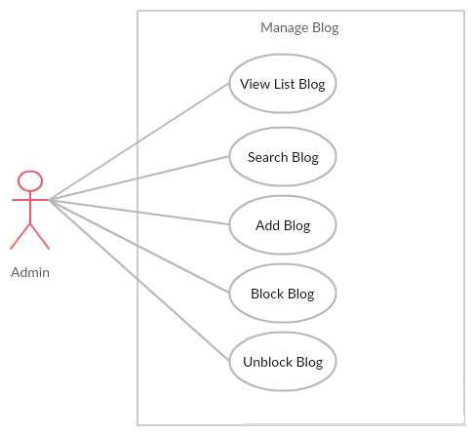

1. Manage blog use case

###### UC022 – View List Blog

|  |  |  |  |  |
| --- | --- | --- | --- | --- |
| **Use Case ID** | | UC022 | **Version** | 1.0 |
| **Use Case Name** | | View list blog | | |
| **Created by:** | | PhuongPTM | **Date Created:** | 28/09/2017 |
| **Primary Actor** | | Administrator(Admin) | **Secondary Actor** |  |
| **Description:** | | This function allows Administrator to view list blog | | |
| **Preconditions:** | | 1. BSO website is available 2. Admin browsed BSO website 3. Admin are viewing Login page for admin | | |
| **Trigger:** | | Admin click on Manage Blog | | |
| **Post conditions:** | | Blog List is displayed | | |
| **Normal Flow** | | | | |
| **Step** | **Actor** | **Action** | | |
| 1 | Admin | Click on Manage Blog | | |
| 2 | BSO | Display list of blog | | |
| **Alternative Flows: N/A** | | | | |
| **Exceptions: N/A** | | | | |
| **Priority** | | High | | |
| **Frequency of Use:** | | High | | |
| **Business Rules:** | | B1 | | |
| **Other Information:** | | N/A | | |

1. View List Blog Use case

###### UC023 – Add Blog

|  |  |  |  |  |
| --- | --- | --- | --- | --- |
| **Use Case ID** | | UC023 | **Version** | 1.0 |
| **Use Case Name** | | Add blog | | |
| **Created by:** | | PhuongPTM | **Date Created:** | 28/09/2017 |
| **Primary Actor** | | Administrator(Admin) | **Secondary Actor** |  |
| **Description:** | | This function allows Administrator to add a new blog | | |
| **Preconditions:** | | 1. BSO website is available 2. Admin browsed BSO website 3. Admin are viewing Login page for admin | | |
| **Trigger:** | | Admin click on Insert Blog | | |
| **Post conditions:** | | Insert blog page is displayed | | |
| **Normal Flow** | | | | |
| **Step** | **Actor** | **Action** | | |
| 1 | Admin | Click on Insert Blog | | |
| 2 | BSO | Insert blog page is displayed | | |
| 3 | Admin | * Type title * Type Content * Choose image * Click Post button | | |
| **Alternative Flows: N/A** | | | | |
| **Exceptions:** | | | | |
| **EC1** | At step 3 in the main flows, if user miss fill 1 or more information | | | |
| **Step** | **Actor** | **Action** | | |
| **3.1** | BSO | Display Dialog to remind user | | |
|  | | | | |
| **Priority** | | High | | |
| **Frequency of Use:** | | High | | |
| **Business Rules:** | | B1 | | |
| **Other Information:** | | N/A | | |

1. Add Blog Use case

###### UC024 – Block Blog

|  |  |  |  |  |
| --- | --- | --- | --- | --- |
| **Use Case ID** | | UC024 | **Version** | 1.0 |
| **Use Case Name** | | Block blog | | |
| **Created by:** | | PhuongPTM | **Date Created:** | 28/09/2017 |
| **Primary Actor** | | Administrator(Admin) | **Secondary Actor** |  |
| **Description:** | | This function allows Administrator to block blog | | |
| **Preconditions:** | | * Admin is viewing Blog List * Status of this blog is Unlock | | |
| **Trigger:** | | Admin click on Lock button | | |
| **Post conditions:** | | Blog is block | | |
| **Normal Flow** | | | | |
| **Step** | **Actor** | **Action** | | |
| 1 | Admin | Click on Lock button at Status column of the blog what want to block | | |
| 2 | BSO | * Change displayed status from Unlock to Lock * Change status of this blog to Lock on database | | |
| **Alternative Flows: N/A** | | | | |
| **Exceptions: N/A** | | | | |
| **Priority** | | High | | |
| **Frequency of Use:** | | High | | |
| **Business Rules:** | | B1 | | |
| **Other Information:** | | N/A | | |

1. Block Blog Use case

###### UC025 – Unblock Blog

|  |  |  |  |  |
| --- | --- | --- | --- | --- |
| **Use Case ID** | | UC025 | **Version** | 1.0 |
| **Use Case Name** | | Unblock blog | | |
| **Created by:** | | PhuongPTM | **Date Created:** | 28/09/2017 |
| **Primary Actor** | | Administrator(Admin) | **Secondary Actor** |  |
| **Description:** | | This function allows Administrator to unblock blog | | |
| **Preconditions:** | | * Admin is viewing Blog List * Status of this blog is Lock | | |
| **Trigger:** | | Admin click on Unlock button | | |
| **Post conditions:** | | Blog is unblock | | |
| **Normal Flow** | | | | |
| **Step** | **Actor** | **Action** | | |
| 1 | Admin | Click on Unlock button at Status column of the blog what want to unblock | | |
| 2 | BSO | * Change displayed status from Lock to Unlock * Change status of this blog to Unlock on database | | |
| **Alternative Flows: N/A** | | | | |
| **Exceptions: N/A** | | | | |
| **Priority** | | High | | |
| **Frequency of Use:** | | High | | |
| **Business Rules:** | | B1 | | |
| **Other Information:** | | N/A | | |

1. Unblock Blog Use case

###### UC026 – Search Blog

|  |  |  |  |  |
| --- | --- | --- | --- | --- |
| **Use Case ID** | | UC026 | **Version** | 1.0 |
| **Use Case Name** | | Search blog | | |
| **Created by:** | | PhuongPTM | **Date Created:** | 28/09/2017 |
| **Primary Actor** | | Administrator(Admin) | **Secondary Actor** |  |
| **Description:** | | This function allows Administrator to search blog | | |
| **Preconditions:** | | Admin is viewing Blog List | | |
| **Trigger:** | | Admin types name of blog at Search textbox | | |
| **Post conditions:** | | Display list of searched blog | | |
| **Normal Flow** | | | | |
| **Step** | **Actor** | **Action** | | |
| 1 | Admin | Click on Manage blog | | |
| 2 | BSO | List blog is displayed | | |
| 3 | Admin | Type name of blog what admin want to search | | |
| 4 | BSO | Display list of blog what have the name is typed | | |
| **Alternative Flows: N/A** | | | | |
| **Exceptions: N/A** | | | | |
| **Priority** | | High | | |
| **Frequency of Use:** | | High | | |
| **Business Rules:** | | B1 | | |
| **Other Information:** | | N/A | | |

1. Search Blog Use case

##### Manage Event

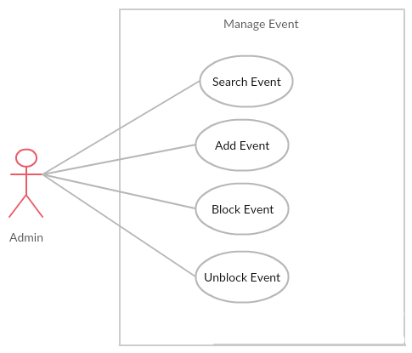

###### UC027 – Search Event

|  |  |  |  |  |
| --- | --- | --- | --- | --- |
| **Use Case ID** | | UC027 | **Version** | 1.0 |
| **Use Case Name** | | Search event | | |
| **Created by:** | | PhuongPTM | **Date Created:** | 28/09/2017 |
| **Primary Actor** | | Administrator(Admin) | **Secondary Actor** |  |
| **Description:** | | This function allows Administrator to search event | | |
| **Preconditions:** | | Admin is viewing Event List | | |
| **Trigger:** | | Admin types name of event at Search textbox | | |
| **Post conditions:** | | Display list of searched event | | |
| **Normal Flow** | | | | |
| **Step** | **Actor** | **Action** | | |
| 1 | Admin | Click on Manage event | | |
| 2 | BSO | List event is displayed | | |
| 3 | Admin | Type name of event what admin want to search | | |
| 4 | BSO | Display list of event what have the name is typed | | |
| **Alternative Flows: N/A** | | | | |
| **Exceptions: N/A** | | | | |
| **Priority** | | High | | |
| **Frequency of Use:** | | High | | |
| **Business Rules:** | | B1 | | |
| **Other Information:** | | N/A | | |

1. Search Event Use case

###### UC028 – Add Event

|  |  |  |  |  |
| --- | --- | --- | --- | --- |
| **Use Case ID** | | UC028 | **Version** | 1.0 |
| **Use Case Name** | | Add event | | |
| **Created by:** | | PhuongPTM | **Date Created:** | 28/09/2017 |
| **Primary Actor** | | Administrator(Admin) | **Secondary Actor** |  |
| **Description:** | | This function allows Administrator to add a new event | | |
| **Preconditions:** | | 1. BS website is available 2. Admin browsed BS website 3. Admin are viewing Login page for admin | | |
| **Trigger:** | | Admin click on Insert Event | | |
| **Post conditions:** | | Insert event page is displayed | | |
| **Normal Flow** | | | | |
| **Step** | **Actor** | **Action** | | |
| 1 | Admin | Click on Insert Event | | |
| 2 | BSO | Insert event page is displayed | | |
| 3 | Admin | * Type title * Type Content * Choose image * Click Add button | | |
| **Alternative Flows: N/A** | | | | |
| **Exceptions:** | | | | |
| **EC1** | At step 3 in the main flows, if user miss fill 1 or more information | | | |
| **Step** | **Actor** | **Action** | | |
| **3.1** | BSO | Display Dialog to remind user | | |
|  | | | | |
| **Priority** | | High | | |
| **Frequency of Use:** | | High | | |
| **Business Rules:** | | B1 | | |
| **Other Information:** | | N/A | | |

1. Add Event Use case

###### UC029 – Block Event

|  |  |  |  |  |
| --- | --- | --- | --- | --- |
| **Use Case ID** | | UC029 | **Version** | 1.0 |
| **Use Case Name** | | Block event | | |
| **Created by:** | | PhuongPTM | **Date Created:** | 28/09/2017 |
| **Primary Actor** | | Administrator(Admin) | **Secondary Actor** |  |
| **Description:** | | This function allows Administrator to block event | | |
| **Preconditions:** | | * Admin is viewing Event List * Status of this event is Unlock | | |
| **Trigger:** | | Admin click on Lock button | | |
| **Post conditions:** | | Event is block | | |
| **Normal Flow** | | | | |
| **Step** | **Actor** | **Action** | | |
| 1 | Admin | Click on Lock button at Status column of the event what want to block | | |
| 2 | BSO | * Change displayed status from Unlock to Lock * Change status of this event to Lock on database | | |
| **Alternative Flows: N/A** | | | | |
| **Exceptions: N/A** | | | | |
| **Priority** | | High | | |
| **Frequency of Use:** | | High | | |
| **Business Rules:** | | B1 | | |
| **Other Information:** | | N/A | | |

1. Block Event Use case

###### UC030 – Unblock Event

|  |  |  |  |  |
| --- | --- | --- | --- | --- |
| **Use Case ID** | | UC030 | **Version** | 1.0 |
| **Use Case Name** | | Unblock event | | |
| **Created by:** | | PhuongPTM | **Date Created:** | 28/09/2017 |
| **Primary Actor** | | Administrator(Admin) | **Secondary Actor** |  |
| **Description:** | | This function allows Administrator to unblock event | | |
| **Preconditions:** | | * Admin is viewing Event List * Status of this event is Lock | | |
| **Trigger:** | | Admin click on Unlock button | | |
| **Post conditions:** | | Event is unblock | | |
| **Normal Flow** | | | | |
| **Step** | **Actor** | **Action** | | |
| 1 | Admin | Click on Unlock button at Status column of the event what want to unblock | | |
| 2 | BSO | * Change displayed status from Lock to Unlock * Change status of this event to Unlock on database | | |
| **Alternative Flows: N/A** | | | | |
| **Exceptions: N/A** | | | | |
| **Priority** | | High | | |
| **Frequency of Use:** | | High | | |
| **Business Rules:** | | B1 | | |
| **Other Information:** | | N/A | | |

1. Unblock Event Use case

##### Manage Benefit

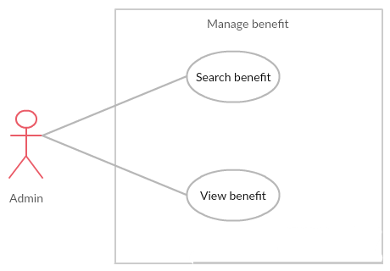

1. Manage Benefit Use case

###### UC031 – Search Benefit

|  |  |  |  |  |
| --- | --- | --- | --- | --- |
| **Use Case ID** | | UC031 | **Version** | 1.0 |
| **Use Case Name** | | Search blog | | |
| **Created by:** | | PhuongPTM | **Date Created:** | 28/09/2017 |
| **Primary Actor** | | Administrator(Admin) | **Secondary Actor** |  |
| **Description:** | | This function allows Administrator to search benefit | | |
| **Preconditions:** | | 1. BS website is available 2. Admin browsed BS website 3. Admin are viewing Login page for admin | | |
| **Trigger:** | | * Admin click Revenue * Choose date | | |
| **Post conditions:** | | Display list of searched bill | | |
| **Normal Flow** | | | | |
| **Step** | **Actor** | **Action** | | |
| 1 | Admin | Click on Revenue | | |
| 2 | BSO | List bill is displayed | | |
| 3 | Admin | Choose date | | |
| 4 | BSO | Display list of bill | | |
| **Alternative Flows: N/A** | | | | |
| **Exceptions: N/A** | | | | |
| **Priority** | | High | | |
| **Frequency of Use:** | | High | | |
| **Business Rules:** | | B1 | | |
| **Other Information:** | | N/A | | |

1. Search Benefit Use case

###### UC032 - View Benefit

|  |  |  |  |  |
| --- | --- | --- | --- | --- |
| **Use Case ID** | | UC032 | **Version** | 1.0 |
| **Use Case Name** | | View benefit | | |
| **Created by:** | | PhuongPTM | **Date Created:** | 28/09/2017 |
| **Primary Actor** | | Administrator(Admin) | **Secondary Actor** |  |
| **Description:** | | This function allows Administrator to check benefit of BS | | |
| **Preconditions:** | | 1. BS website is available 2. Admin browsed BS website 3. Admin are viewing Login page for admin | | |
| **Trigger:** | | Admin click on Manage Bill | | |
| **Post conditions:** | | Bill list is displayed | | |
| **Normal Flow** | | | | |
| **Step** | **Actor** | **Action** | | |
| 1 | Admin | Click on Manage bill | | |
| 2 | BSO | Display list of bill | | |
| **Alternative Flows: N/A** | | | | |
| **Exceptions: N/A** | | | | |
| **Priority** | | High | | |
| **Frequency of Use:** | | High | | |
| **Business Rules:** | | B1 | | |
| **Other Information:** | | N/A | | |

1. View Benefit Use case

##### Manage Categories

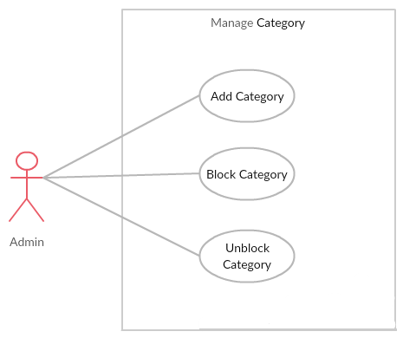

1. Manage Categories Use case

###### UC033 - Add Category

|  |  |  |  |  |
| --- | --- | --- | --- | --- |
| **Use Case ID** | | UC033 | **Version** | 1.0 |
| **Use Case Name** | | Add category | | |
| **Created by:** | | PhuongPTM | **Date Created:** | 28/09/2017 |
| **Primary Actor** | | Administrator(Admin) | **Secondary Actor** |  |
| **Description:** | | This function allows Administrator to add a new category | | |
| **Preconditions:** | | 1. BS website is available 2. Admin browsed BS website 3. Admin are viewing Login page for admin | | |
| **Trigger:** | | Admin click on Insert Category | | |
| **Post conditions:** | | Insert category page is displayed | | |
| **Normal Flow** | | | | |
| **Step** | **Actor** | **Action** | | |
| 1 | Admin | Click on Insert Category | | |
| 2 | BS | Insert category page is displayed | | |
| 3 | Admin | * Type category name * Click Post button | | |
| **Alternative Flows: N/A** | | | | |
| **Exceptions:** | | | | |
| **EC1** | At step 3 in the main flows, if user miss fill 1 or more information | | | |
| **Step** | **Actor** | **Action** | | |
| **3.1** | BSO | Display Dialog to remind user | | |
|  | | | | |
| **Priority** | | High | | |
| **Frequency of Use:** | | High | | |
| **Business Rules:** | | B1 | | |
| **Other Information:** | | N/A | | |

1. Add Category Use case

###### *UC034* – Block Category

|  |  |  |  |  |
| --- | --- | --- | --- | --- |
| **Use Case ID** | | UC034 | **Version** | 1.0 |
| **Use Case Name** | | Block category | | |
| **Created by:** | | PhuongPTM | **Date Created:** | 28/09/2017 |
| **Primary Actor** | | Administrator(Admin) | **Secondary Actor** |  |
| **Description:** | | This function allows Administrator to block category | | |
| **Preconditions:** | | * Admin is viewing Category List * Status of this category is Unlock | | |
| **Trigger:** | | Admin click on Lock button | | |
| **Post conditions:** | | Category is block | | |
| **Normal Flow** | | | | |
| **Step** | **Actor** | **Action** | | |
| 1 | Admin | Click on Lock button at Status column of the category what want to block | | |
| 2 | BSO | * Change displayed status from Unlock to Lock * Change status of this category to Lock on database | | |
| **Alternative Flows: N/A** | | | | |
| **Exceptions: N/A** | | | | |
| **Priority** | | High | | |
| **Frequency of Use:** | | High | | |
| **Business Rules:** | | B1 | | |
| **Other Information:** | | N/A | | |

1. Block Category Use case

###### UC035 – Unblock Category

|  |  |  |  |  |
| --- | --- | --- | --- | --- |
| **Use Case ID** | | UC035 | **Version** | 1.0 |
| **Use Case Name** | | Unblock category | | |
| **Created by:** | | PhuongPTM | **Date Created:** | 28/09/2017 |
| **Primary Actor** | | Administrator(Admin) | **Secondary Actor** |  |
| **Description:** | | This function allows Administrator to unblock category | | |
| **Preconditions:** | | * Admin is viewing Category List * Status of this category is Lock | | |
| **Trigger:** | | Admin click on Unlock button | | |
| **Post conditions:** | | Category is unblock | | |
| **Normal Flow** | | | | |
| **Step** | **Actor** | **Action** | | |
| 1 | Admin | Click on Unlock button at Status column of the category what want to unblock | | |
| 2 | BSO | * Change displayed status from Lock to Unlock * Change status of this category to Unlock on database | | |
| **Alternative Flows: N/A** | | | | |
| **Exceptions: N/A** | | | | |
| **Priority** | | High | | |
| **Frequency of Use:** | | High | | |
| **Business Rules:** | | B1 | | |
| **Other Information:** | | N/A | | |

1. Unblock Category Use case

#### Staff Group Function

##### Common Module

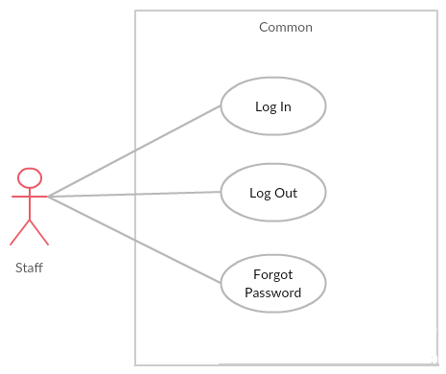

1. Register Use case

###### *UC036* – Staff login

|  |  |  |  |  |
| --- | --- | --- | --- | --- |
| **Use Case ID** | | UC036 | **Version** | 1.0 |
| **Use Case Name** | | Staff login | | |
| **Created by:** | | PhuongPTM | **Date Created:** | 28/09/2017 |
| **Primary Actor** | | Staff | **Secondary Actor** |  |
| **Description:** | | This function allows Staff logins into website | | |
| **Preconditions:** | | 1. BSO website is available 2. Staff browsed BSO website 3. Staff are viewing Login page for staff | | |
| **Trigger:** | | Staff clicks on Login button | | |
| **Post conditions:** | | 1. Log Staff into system 2. Redirect Staff to Staff home page | | |
| **Normal Flow** | | | | |
| **Step** | **Actor** | **Action** | | |
| 1 | BSO | Display Staff Login page. If Staff choose Remember Me function before, fill all needed information | | |
| 2 | Staff | Type email address and password if Staff does not choose Remember Me function before | | |
| 3 | BSO | Verify:  Email address  Password | | |
| 4 | BSO | * Log Staff into system * Redirect Staff to Staff home page | | |
| **Alternative Flows: N/A** | | | | |
| **Exceptions:** | | | | |
| **EC1** | At step 2 in main flow, if Staff entered wrong Email address or Password | | | |
| **Step** | **Actor** | **Action** | | |
| 2.1 | BSO | Display Login popup message point out error field | | |
| 2.2 | BSO | Mark error fields | | |
| **Priority** | | High | | |
| **Frequency of Use:** | | High | | |
| **Business Rules:** | | B1 | | |
| **Other Information:** | | N/A | | |

1. Staff login Use case

###### UC037 – Staff logout

|  |  |  |  |  |
| --- | --- | --- | --- | --- |
| **Use Case ID** | | UC037 | **Version** | 1.0 |
| **Use Case Name** | | Staff logout | | |
| **Created by:** | | PhuongPTM | **Date Created:** | 28/09/2017 |
| **Primary Actor** | | Staff | **Secondary Actor** |  |
| **Description:** | | This function allows Staff logout website | | |
| **Preconditions:** | | Staff logged website | | |
| **Trigger:** | | Staff clicks on Sign out button | | |
| **Post conditions:** | | Staff logged out from BS website | | |
| **Normal Flow** | | | | |
| **Step** | **Actor** | **Action** | | |
| 1 | Staff | Choose sign out button | | |
| 2 | BSO | Sign out Staff  Redirect to Staff Sign in page | | |
| **Alternative Flows: N/A** | | | | |
| **Exceptions: N/A** | | | | |
| **Priority** | | High | | |
| **Frequency of Use:** | | High | | |
| **Business Rules:** | | B1 | | |
| **Other Information:** | | N/A | | |

1. Staff logout Use case

###### *UC038* – Forgot Password

|  |  |  |  |  |
| --- | --- | --- | --- | --- |
| **Use Case ID** | | UC038 | **Version** | 1.0 |
| **Use Case Name** | | Staff forgot password | | |
| **Created by:** | | PhuongPTM | **Date Created:** | 28/09/2017 |
| **Primary Actor** | | Staff | **Secondary Actor** |  |
| **Description:** | | This function allows Staff receiving her/his password to mail | | |
| **Preconditions:** | | 1. BSO website is available 2. Staff browsed BSO website 3. Staff are viewing Sign in page for staff | | |
| **Trigger:** | | Click Forgot password in Sign in page | | |
| **Post conditions:** | | Staff get new password on her/his email | | |
| **Normal Flow** | | | | |
| **Step** | **Actor** | **Action** | | |
| 1 | Staff | Click Forgot password in Sign in page | | |
| 2 | BSO | Display Email text box | | |
| 3 | Staff | Enter registered email | | |
| 4 | Staff | Click Forgot Password | | |
| **Alternative Flows: N/A** | | | | |
| **Exceptions: N/A** | | | | |
| **Priority** | | High | | |
| **Frequency of Use:** | | High | | |
| **Business Rules:** | | B1 | | |
| **Other Information:** | | N/A | | |

1. Forgot Password Use case

##### Manage Order

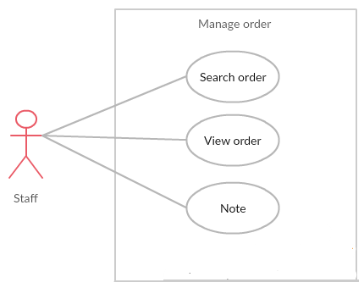

1. Manage Order Use case

###### UC039 – Search Order

|  |  |  |  |  |
| --- | --- | --- | --- | --- |
| **Use Case ID** | | UC039 | **Version** | 1.0 |
| **Use Case Name** | | Search order | | |
| **Created by:** | | PhuongPTM | **Date Created:** | 28/09/2017 |
| **Primary Actor** | | Staff | **Secondary Actor** |  |
| **Description:** | | This function allows Staff to search order by date | | |
| **Preconditions:** | | Staff is viewing Manage Bills | | |
| **Trigger:** | | Staff choose date | | |
| **Post conditions:** | | Display list of searched order | | |
| **Normal Flow** | | | | |
| **Step** | **Actor** | **Action** | | |
| 1 | Staff | Click on Manage Bills | | |
| 2 | BSO | List order is displayed | | |
| 3 | Staff | Staff choose date | | |
| 4 | BSO | Display list of order what have the date is choose | | |
| **Alternative Flows: N/A** | | | | |
| **Exceptions: N/A** | | | | |
| **Priority** | | High | | |
| **Frequency of Use:** | | High | | |
| **Business Rules:** | | B1 | | |
| **Other Information:** | | N/A | | |

1. Search Order Use case

###### UC040 – Confirm Order

|  |  |  |  |  |
| --- | --- | --- | --- | --- |
| **Use Case ID** | | UC040 | **Version** | 1.0 |
| **Use Case Name** | | Confirm order | | |
| **Created by:** | | PhuongPTM | **Date Created:** | 28/09/2017 |
| **Primary Actor** | | Staff | **Secondary Actor** |  |
| **Description:** | | This function allows Staff to confirm order when order was completed | | |
| **Preconditions:** | | * Staff is viewing Manage Bills * Status of this order is Uncofirm | | |
| **Trigger:** | | Staff click Confirm button | | |
| **Post conditions:** | | Display order is confirm | | |
| **Normal Flow** | | | | |
| **Step** | **Actor** | **Action** | | |
| 1 | Staff | Click on Confirm button at Status column of the order what want to confirm | | |
| 2 | BSO | * Change displayed status from Unconfirm to Confirm * Change status of this cake to Confirm on database | | |
| **Alternative Flows: N/A** | | | | |
| **Exceptions: N/A** | | | | |
| **Priority** | | High | | |
| **Frequency of Use:** | | High | | |
| **Business Rules:** | | B1 | | |
| **Other Information:** | | N/A | | |

1. Confirm Order Use case

###### UC041 – Note

|  |  |  |  |  |
| --- | --- | --- | --- | --- |
| **Use Case ID** | | UC041 | **Version** | 1.0 |
| **Use Case Name** | | Note | | |
| **Created by:** | | PhuongPTM | **Date Created:** | 28/09/2017 |
| **Primary Actor** | | Staff | **Secondary Actor** |  |
| **Description:** | | This function allows Staff can note information important (For example: wrong telephone number….) | | |
| **Preconditions:** | | * Staff is viewing Manage Bills | | |
| **Trigger:** | | Staff click Update | | |
| **Post conditions:** | | Display information updated | | |
| **Normal Flow** | | | | |
| **Step** | **Actor** | **Action** | | |
| 1 | Staff | Fill information in “Note ” textbox | | |
| 2 | Staff | Click Update button | | |
| 3 | BSO | Change status of this cake to Note on database | | |
| **Alternative Flows: N/A** | | | | |
| **Exceptions: N/A** | | | | |
| **Priority** | | High | | |
| **Frequency of Use:** | | High | | |
| **Business Rules:** | | B1 | | |
| **Other Information:** | | N/A | | |

1. Note Use case

##### Manage Introduction

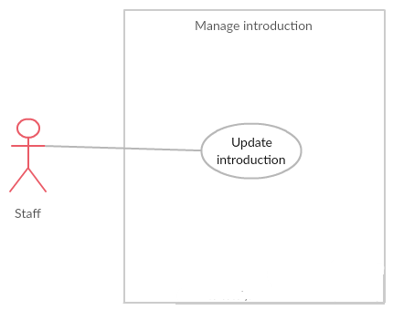

1. Manage Introduction Use case

###### UC042 – Create Introduction

|  |  |  |  |  |
| --- | --- | --- | --- | --- |
| **Use Case ID** | | UC042 | **Version** | 1.0 |
| **Use Case Name** | | Create introduction | | |
| **Created by:** | | PhuongPTM | **Date Created:** | 28/09/2017 |
| **Primary Actor** | | Staff | **Secondary Actor** |  |
| **Description:** | | This function allows Staff to add information about BS website | | |
| **Preconditions:** | | 1. BSO website is available 2. Staff browsed BSO website 3. Staff are viewing Sign in page for staff | | |
| **Trigger:** | | Staff click on Create Introduction | | |
| **Post conditions:** | | Create introduction page is displayed | | |
| **Normal Flow** | | | | |
| **Step** | **Actor** | **Action** | | |
| 1 | Staff | Click on Create Introduction | | |
| 2 | BSO | Create Introduction page is displayed | | |
| 3 | Staff | * Type Address * Type Phone number * Choose image * Click Save button | | |
| **Alternative Flows: N/A** | | | | |
| **Exceptions:** | | | | |
| **EC1** | At step 3 in the main flows, if user miss fill 1 or more information | | | |
| **Step** | **Actor** | **Action** | | |
| **3.1** | BSO | Display Dialog to remind user | | |
|  | | | | |
| **Priority** | | High | | |
| **Frequency of Use:** | | High | | |
| **Business Rules:** | | B1 | | |
| **Other Information:** | | N/A | | |

1. Create Introduction Use case

###### UC043 – Update Introduction

|  |  |  |  |  |
| --- | --- | --- | --- | --- |
| **Use Case ID** | | UC043 | **Version** | 1.0 |
| **Use Case Name** | | Create introduction | | |
| **Created by:** | | PhuongPTM | **Date Created:** | 28/09/2017 |
| **Primary Actor** | | Staff | **Secondary Actor** |  |
| **Description:** | | This function allows Staff to update information about BS website | | |
| **Preconditions:** | | 1. BSO website is available 2. Staff browsed BSO website 3. Staff are viewing Sign in page for staff | | |
| **Trigger:** | | Staff click on Update Introduction | | |
| **Post conditions:** | | Update introduction page is displayed | | |
| **Normal Flow** | | | | |
| **Step** | **Actor** | **Action** | | |
| 1 | Staff | Click on Update Introduction | | |
| 2 | Staff | Update information | | |
| 3 | Staff | Click on Save button | | |
| 4 | BSO | Save change | | |
| **Alternative Flows: N/A** | | | | |
| **Exceptions:** | | | | |
| **EC1** | At step 3 in the main flows, if user miss fill 1 or more information | | | |
| **Step** | **Actor** | **Action** | | |
| **3.1** | BSO | Display Dialog to remind user | | |
|  | | | | |
| **Priority** | | High | | |
| **Frequency of Use:** | | High | | |
| **Business Rules:** | | B1 | | |
| **Other Information:** | | N/A | | |

1. Update Introduction Use case

##### Manage Cake

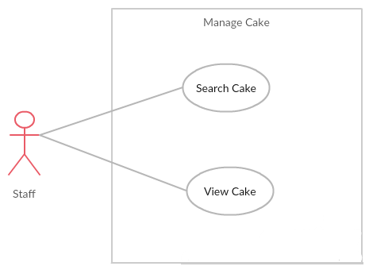

1. Manage Cake Use case

###### UC044 – View Cake

|  |  |  |  |  |
| --- | --- | --- | --- | --- |
| **Use Case ID** | | UC044 | **Version** | 1.0 |
| **Use Case Name** | | View cake | | |
| **Created by:** | | PhuongPTM | **Date Created:** | 28/09/2017 |
| **Primary Actor** | | Staff | **Secondary Actor** |  |
| **Description:** | | This function allows Staff to check information about cake | | |
| **Preconditions:** | | 1. BSO website is available 2. Staff browsed BSO website 3. Staff are viewing Sign in page for staff | | |
| **Trigger:** | | Staff click on Manage Cake | | |
| **Post conditions:** | | Cake list is displayed | | |
| **Normal Flow** | | | | |
| **Step** | **Actor** | **Action** | | |
| 1 | Staff | Click on Manage Cake | | |
| 2 | BSO | Display list of cake | | |
| **Alternative Flows: N/A** | | | | |
| **Exceptions: N/A** | | | | |
| **Priority** | | High | | |
| **Frequency of Use:** | | High | | |
| **Business Rules:** | | B1 | | |
| **Other Information:** | | N/A | | |

1. – View Cake Use case

###### UC045 – Search Cake

|  |  |  |  |  |
| --- | --- | --- | --- | --- |
| **Use Case ID** | | UC045 | **Version** | 1.0 |
| **Use Case Name** | | Search cake | | |
| **Created by:** | | PhuongPTM | **Date Created:** | 28/09/2017 |
| **Primary Actor** | | Staff | **Secondary Actor** |  |
| **Description:** | | This function allows Staff to search cake | | |
| **Preconditions:** | | Staff is viewing Cake List | | |
| **Trigger:** | | Staff types name of cake at Search textbox | | |
| **Post conditions:** | | Display list of searched cake | | |
| **Normal Flow** | | | | |
| **Step** | **Actor** | **Action** | | |
| 1 | Staff | Click on Manage Cake | | |
| 2 | BSO | List cake is displayed | | |
| 3 | Staff | Type name of cake what admin want to search | | |
| 4 | BSO | Display list of cake what have the name is typed | | |
| **Alternative Flows: N/A** | | | | |
| **Exceptions: N/A** | | | | |
| **Priority** | | High | | |
| **Frequency of Use:** | | High | | |
| **Business Rules:** | | B1 | | |
| **Other Information:** | | N/A | | |

1. Search Cake Use case

##### Personal Information

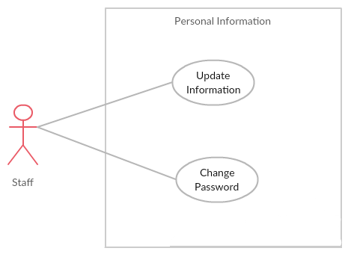

1. Personal Information Use case

###### UC046 – Update Information

|  |  |  |  |  |
| --- | --- | --- | --- | --- |
| **Use Case ID** | | UC046 | **Version** | 1.0 |
| **Use Case Name** | | Update information | | |
| **Created by:** | | PhuongPTM | **Date Created:** | 28/09/2017 |
| **Primary Actor** | | Staff | **Secondary Actor** |  |
| **Description:** | | This function allows Staff to update profile | | |
| **Preconditions:** | | 1. BSO website is available 2. Staff browsed BSO website 3. Staff are viewing Sign in page for staff | | |
| **Trigger:** | | Staff click on Update Information | | |
| **Post conditions:** | | Update information page is displayed | | |
| **Normal Flow** | | | | |
| **Step** | **Actor** | **Action** | | |
| 1 | Staff | Click on Update Information | | |
| 2 | Staff | Update information | | |
| 3 | Staff | Click on Save button | | |
| 4 | BSO | Save change | | |
| **Alternative Flows: N/A** | | | | |
| **Exceptions:** | | | | |
| **EC1** | At step 3 in the main flows, if user miss fill 1 or more information | | | |
| **Step** | **Actor** | **Action** | | |
| **3.1** | BSO | Display Dialog to remind user | | |
|  | | | | |
| **Priority** | | High | | |
| **Frequency of Use:** | | High | | |
| **Business Rules:** | | B1 | | |
| **Other Information:** | | N/A | | |

1. Update Information

###### UC047 – Change Password

|  |  |  |  |  |
| --- | --- | --- | --- | --- |
| **Use Case ID** | | UC047 | **Version** | 1.0 |
| **Use Case Name** | | Change password | | |
| **Created by:** | | PhuongPTM | **Date Created:** | 28/09/2017 |
| **Primary Actor** | | Staff | **Secondary Actor** |  |
| **Description:** | | This function allows Staff to want change new password | | |
| **Preconditions:** | | 1. BSO website is available 2. Staff browsed BSO website 3. Staff are viewing Sign in page for staff | | |
| **Trigger:** | | Staff click on Change password | | |
| **Post conditions:** | | Change password page is displayed | | |
| **Normal Flow** | | | | |
| **Step** | **Actor** | **Action** | | |
| 1 | Staff | Click on Change password | | |
| 2 | Staff | Fill information:   * Old password * New password * Repeat password | | |
| 3 | Staff | Click on Save button | | |
| 4 | BSO | Save change | | |
| **Alternative Flows: N/A** | | | | |
| **Exceptions:** | | | | |
| **EC1** | At step 3 in the main flows, if user miss fill 1 or more information | | | |
| **Step** | **Actor** | **Action** | | |
| **3.1** | BSO | Display Dialog to remind user | | |
|  | | | | |
| **Priority** | | High | | |
| **Frequency of Use:** | | High | | |
| **Business Rules:** | | B1 | | |
| **Other Information:** | | N/A | | |

1. Change Password

#### Customer Group Function

##### Common module

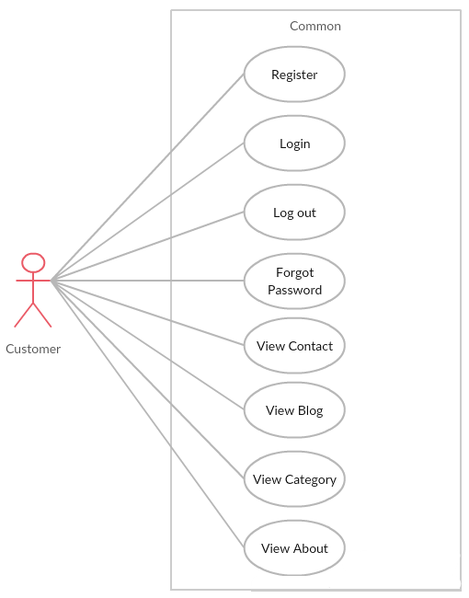

1. Registered common use case

###### UC048 – Register

|  |  |  |  |  |
| --- | --- | --- | --- | --- |
| **Use Case ID** | | UC048 | **Version** | 1.0 |
| **Use Case Name** | | Register | | |
| **Created by:** | | PhuongPTM | **Date Created:** | 28/09/2017 |
| **Primary Actor** | | Customer | **Secondary Actor** |  |
| **Description:** | | Visitor can create new account to use more function | | |
| **Preconditions:** | | * BSO must be connected to the Internet * User browsed BSO website | | |
| **Trigger:** | | Click on sign up link on the website | | |
| **Post conditions:** | | 1. Add account information to database 2. Send confirm email 3. Logs user into system 4. Redirect user to Homepage and display as Member | | |
| **Normal Flow** | | | | |
| **Step** | **Actor** | **Action** | | |
| 1 | Customer | Click Sign up in header | | |
| 2 | Customer | Display Register page includes:   * User name text box * Password text box * Repeat Password text box * Email address text box * Sign up button | | |
| 3 | Customer | Enter data in fields | | |
| 4 | Customer | Click on Sign up button | | |
| 5 | BSO | Send confirm email | | |
| 6 | BSO | Logs user into system | | |
| 7 | BSO | Display Homepage as Member | | |
| **Alternative Flows: N/A** | | | | |
| **Exceptions:** | | | | |
| **EC1** | At step 3, required fields are not entered | | | |
| **Step** | **Actor** | **Action** | | |
| **3.1** | BSO | Display Dialog to remind user | | |
|  | | | | |
| **Priority** | | High | | |
| **Frequency of Use:** | | High | | |
| **Business Rules:** | | B1 | | |
| **Other Information:** | | N/A | | |

1. Register Use case

###### UC049 – Log In

|  |  |  |  |  |
| --- | --- | --- | --- | --- |
| **Use Case ID** | | UC049 | **Version** | 1.0 |
| **Use Case Name** | | Login | | |
| **Created by:** | | PhuongPTM | **Date Created:** | 28/09/2017 |
| **Primary Actor** | | Customer | **Secondary Actor** |  |
| **Description:** | | This function allows Customer logins into website | | |
| **Preconditions:** | | 1. BSO must be connected to the Internet 2. User browsed BSO website | | |
| **Trigger:** | | Customer click sign in button | | |
| **Post conditions:** | | 1. Log Customer into system 2. Redirect Customer to home page | | |
| **Normal Flow** | | | | |
| **Step** | **Actor** | **Action** | | |
| 1 | BSO | Display Customer Login page. If Customer choose Remember Me function before, fill all needed information | | |
| 2 | Customer | Type email address and password if Customer does not choose Remember Me function before | | |
| 3 | BSO | Verify:  Email address  Password | | |
| 4 | BSO | * Log Customer into system * Redirect Customer to home page | | |
| **Alternative Flows: N/A** | | | | |
| **Exceptions:** | | | | |
| **EC1** | At step 2 in main flow, if Customer entered wrong Email address or Password | | | |
| **Step** | **Actor** | **Action** | | |
| 2.1 | BSO | Display Login popup message point out error field | | |
| 2.2 | BSO | Mark error fields | | |
| **Priority** | | High | | |
| **Frequency of Use:** | | High | | |
| **Business Rules:** | | B1 | | |
| **Other Information:** | | N/A | | |

1. Log In Use case

###### UC050 – Log Out

|  |  |  |  |  |
| --- | --- | --- | --- | --- |
| **Use Case ID** | | UC050 | **Version** | 1.0 |
| **Use Case Name** | | Logout | | |
| **Created by:** | | PhuongPTM | **Date Created:** | 28/09/2017 |
| **Primary Actor** | | Customer | **Secondary Actor** |  |
| **Description:** | | This function allows Customer logout website | | |
| **Preconditions:** | | Customer logged website | | |
| **Trigger:** | | Customer clicks on Sign out button | | |
| **Post conditions:** | | Customer logged out from BSO website | | |
| **Normal Flow** | | | | |
| **Step** | **Actor** | **Action** | | |
| 1 | Customer | Choose sign out button | | |
| 2 | BSO | Sign out Customer  Redirect to Homepage | | |
| **Alternative Flows: N/A** | | | | |
| **Exceptions: N/A** | | | | |
| **Priority** | | High | | |
| **Frequency of Use:** | | High | | |
| **Business Rules:** | | B1 | | |
| **Other Information:** | | N/A | | |

1. Log Out Use case

###### UC051 – Forgot Password

|  |  |  |  |  |
| --- | --- | --- | --- | --- |
| **Use Case ID** | | UC051 | **Version** | 1.0 |
| **Use Case Name** | | Forgot password | | |
| **Created by:** | | PhuongPTM | **Date Created:** | 28/09/2017 |
| **Primary Actor** | | Customer | **Secondary Actor** |  |
| **Description:** | | This function allows Customer receiving her/his password to mail | | |
| **Preconditions:** | | 1. BSO must be connected to the Internet 2. User browsed BSO website | | |
| **Trigger:** | | Click Forgot password in Sign in page | | |
| **Post conditions:** | | Customer get new password on her/his email | | |
| **Normal Flow** | | | | |
| **Step** | **Actor** | **Action** | | |
| 1 | Customer | Click Forgot password in Sign in page | | |
| 2 | BSO | Display Email text box | | |
| 3 | Customer | Enter registered email | | |
| 4 | Customer | Click Forgot Password | | |
| **Alternative Flows: N/A** | | | | |
| **Exceptions: N/A** | | | | |
| **Priority** | | High | | |
| **Frequency of Use:** | | High | | |
| **Business Rules:** | | B1 | | |
| **Other Information:** | | N/A | | |

1. Forgot Password Out Use case

###### UC052 – View Blog

|  |  |  |  |  |
| --- | --- | --- | --- | --- |
| **Use Case ID** | | UC052 | **Use Case ID** | UC051 |
| **Use Case Name** | | View blog | | |
| **Created by:** | | PhuongPTM | **Created by:** | PhuongPTM |
| **Primary Actor** | | Customer | **Secondary Actor** |  |
| **Description:** | | This function allows Customer can view blog | | |
| **Preconditions:** | | 1. BSO must be connected to the Internet 2. User browsed BSO website | | |
| **Trigger:** | | Click on the blog button on menu bar | | |
| **Post conditions:** | | User will go to Detail Blog page | | |
| **Normal Flow** | | | | |
| **Step** | **Actor** | **Action** | | |
| 1 | Customer | Click on the blog button on menu bar | | |
| 2 | BSO | Display Blog page | | |
| **Alternative Flows: N/A** | | | | |
| **Exceptions: N/A** | | | | |
| **Priority** | | High | | |
| **Frequency of Use:** | | High | | |
| **Business Rules:** | | B1 | | |
| **Other Information:** | | N/A | | |

1. View Blog Use case

###### UC053 – View Category

|  |  |  |  |  |
| --- | --- | --- | --- | --- |
| **Use Case ID** | | UC053 | **Use Case ID** | UC051 |
| **Use Case Name** | | View category | | |
| **Created by:** | | PhuongPTM | **Created by:** | PhuongPTM |
| **Primary Actor** | | Customer | **Secondary Actor** |  |
| **Description:** | | This function allows Customer can view category | | |
| **Preconditions:** | | 1. BSO must be connected to the Internet 2. User browsed BSO website | | |
| **Trigger:** | | Click on the category button on menu bar | | |
| **Post conditions:** | | User will go to category page | | |
| **Normal Flow** | | | | |
| **Step** | **Actor** | **Action** | | |
| 1 | Customer | Click on the category button on menu bar | | |
| 2 | BSO | Display Category page | | |
| **Alternative Flows: N/A** | | | | |
| **Exceptions: N/A** | | | | |
| **Priority** | | High | | |
| **Frequency of Use:** | | High | | |
| **Business Rules:** | | B1 | | |
| **Other Information:** | | N/A | | |

1. View Category Use case

###### UC054 – View Contact

|  |  |  |  |  |
| --- | --- | --- | --- | --- |
| **Use Case ID** | | UC053 | **Use Case ID** | UC051 |
| **Use Case Name** | | View contact | | |
| **Created by:** | | PhuongPTM | **Created by:** | PhuongPTM |
| **Primary Actor** | | Customer | **Secondary Actor** |  |
| **Description:** | | This function allows Customer can view contact of BS website | | |
| **Preconditions:** | | 1. BSO must be connected to the Internet 2. User browsed BSO website | | |
| **Trigger:** | | Click on the contact button on menu bar | | |
| **Post conditions:** | | User will go to contact page | | |
| **Normal Flow** | | | | |
| **Step** | **Actor** | **Action** | | |
| 1 | Customer | Click on the contact button on menu bar | | |
| 2 | BSO | Display contact page | | |
| **Alternative Flows: N/A** | | | | |
| **Exceptions: N/A** | | | | |
| **Priority** | | High | | |
| **Frequency of Use:** | | High | | |
| **Business Rules:** | | B1 | | |
| **Other Information:** | | N/A | | |

1. View Contact Use case

###### UC055 – View About

|  |  |  |  |  |
| --- | --- | --- | --- | --- |
| **Use Case ID** | | UC055 | **Use Case ID** | UC051 |
| **Use Case Name** | | View about | | |
| **Created by:** | | PhuongPTM | **Created by:** | PhuongPTM |
| **Primary Actor** | | Customer | **Secondary Actor** |  |
| **Description:** | | This function allows Customer can view information aout BS website | | |
| **Preconditions:** | | 1. BSO must be connected to the Internet 2. User browsed BSO website | | |
| **Trigger:** | | Click on the about button on menu bar | | |
| **Post conditions:** | | User will go to about page | | |
| **Normal Flow** | | | | |
| **Step** | **Actor** | **Action** | | |
| 1 | Customer | Click on the about button on menu bar | | |
| 2 | BSO | Display about page | | |
| **Alternative Flows: N/A** | | | | |
| **Exceptions: N/A** | | | | |
| **Priority** | | High | | |
| **Frequency of Use:** | | High | | |
| **Business Rules:** | | B1 | | |
| **Other Information:** | | N/A | | |

1. – View About Use case

##### Order

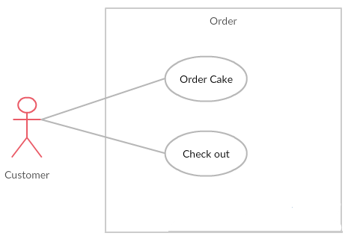

1. Order use cases

###### UC056 – Order Cake

|  |  |  |  |  |
| --- | --- | --- | --- | --- |
| **Use Case ID** | | UC056 | **Use Case ID** | UC051 |
| **Use Case Name** | | Order Cake | | |
| **Created by:** | | PhuongPTM | **Created by:** | PhuongPTM |
| **Primary Actor** | | Customer | **Secondary Actor** |  |
| **Description:** | | This function allows Customer can order cake | | |
| **Preconditions:** | | 1. BSO must be connected to the Internet 2. User browsed BSO website | | |
| **Trigger:** | | Click on Add to cart | | |
| **Post conditions:** | | Display screen order | | |
| **Normal Flow** | | | | |
| **Step** | **Actor** | **Action** | | |
| 1 | Customer | Choose a cake | | |
| 2 | Customer | Click Add to cart | | |
| 3 | BSO | Display screen order | | |
| **Alternative Flows: N/A** | | | | |
| **Exceptions: N/A** | | | | |
| **Priority** | | High | | |
| **Frequency of Use:** | | High | | |
| **Business Rules:** | | B1 | | |
| **Other Information:** | | N/A | | |

1. Order Cake Use case

###### UC057 – Check Out

|  |  |  |  |  |
| --- | --- | --- | --- | --- |
| **Use Case ID** | | UC057 | **Use Case ID** | UC051 |
| **Use Case Name** | | Check Out | | |
| **Created by:** | | PhuongPTM | **Created by:** | PhuongPTM |
| **Primary Actor** | | Customer | **Secondary Actor** |  |
| **Description:** | | This function allows Customer can check information about order | | |
| **Preconditions:** | | 1. BSO must be connected to the Internet 2. User browsed BSO website | | |
| **Trigger:** | | Click on shopping cart | | |
| **Post conditions:** | | Display shopping cart screen | | |
| **Normal Flow** | | | | |
| **Step** | **Actor** | **Action** | | |
| 1 | Customer | Click Cart | | |
| 2 | BSO | Display shopping cart screen | | |
| **Alternative Flows: N/A** | | | | |
| **Exceptions: N/A** | | | | |
| **Priority** | | High | | |
| **Frequency of Use:** | | High | | |
| **Business Rules:** | | B1 | | |
| **Other Information:** | | N/A | | |

1. Check Out Use case

##### Personal Information

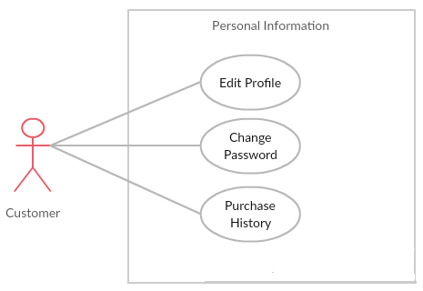

1. Personal Information use cases

###### UC058 – Edit Profile

|  |  |  |  |  |
| --- | --- | --- | --- | --- |
| **Use Case ID** | | UC058 | **Version** | 1.0 |
| **Use Case Name** | | Update information | | |
| **Created by:** | | PhuongPTM | **Date Created:** | 28/09/2017 |
| **Primary Actor** | | Customer | **Secondary Actor** |  |
| **Description:** | | This function allows Customer to update profile | | |
| **Preconditions:** | | 1. BSO must be connected to the Internet 2. User browsed BSO website | | |
| **Trigger:** | | Click to Account Information | | |
| **Post conditions:** | | Update information page is displayed | | |
| **Normal Flow** | | | | |
| **Step** | **Actor** | **Action** | | |
| 1 | Customer | Click to Account Information | | |
| 2 | Customer | Update information | | |
| 3 | Customer | Click on Save button | | |
| 4 | BSO | Save change | | |
| **Alternative Flows: N/A** | | | | |
| **Exceptions:** | | | | |
| **EC1** | At step 3 in the main flows, if user miss fill 1 or more information | | | |
| **Step** | **Actor** | **Action** | | |
| **3.1** | BSO | Display Dialog to remind user | | |
|  | | | | |
| **Priority** | | High | | |
| **Frequency of Use:** | | High | | |
| **Business Rules:** | | B1 | | |
| **Other Information:** | | N/A | | |

1. Edit Profile Use case

###### UC059 – Change Password

|  |  |  |  |  |
| --- | --- | --- | --- | --- |
| **Use Case ID** | | UC059 | **Version** | 1.0 |
| **Use Case Name** | | Change password | | |
| **Created by:** | | PhuongPTM | **Date Created:** | 28/09/2017 |
| **Primary Actor** | | Customer | **Secondary Actor** |  |
| **Description:** | | This function allows Staff to want change new password | | |
| **Preconditions:** | | 1. BSO must be connected to the Internet 2. User browsed BSO website | | |
| **Trigger:** | | Customer click on Change password | | |
| **Post conditions:** | | Change password page is displayed | | |
| **Normal Flow** | | | | |
| **Step** | **Actor** | **Action** | | |
| 1 | Customer | Click on Change password | | |
| 2 | Customer | Fill information:   * Old password * New password * Repeat password | | |
| 3 | Customer | Click on Save button | | |
| 4 | BSO | Save change | | |
| **Alternative Flows: N/A** | | | | |
| **Exceptions:** | | | | |
| **EC1** | At step 3 in the main flows, if user miss fill 1 or more information | | | |
| **Step** | **Actor** | **Action** | | |
| **3.1** | BSO | Display Dialog to remind user | | |
|  | | | | |
| **Priority** | | High | | |
| **Frequency of Use:** | | High | | |
| **Business Rules:** | | B1 | | |
| **Other Information:** | | N/A | | |

1. Change Password use case

###### UC060 – Purchase History

|  |  |  |  |  |
| --- | --- | --- | --- | --- |
| **Use Case ID** | | UC060 | **Version** | 1.0 |
| **Use Case Name** | | Change password | | |
| **Created by:** | | PhuongPTM | **Date Created:** | 28/09/2017 |
| **Primary Actor** | | Customer | **Secondary Actor** |  |
| **Description:** | | This function allows Staff to want change new password | | |
| **Preconditions:** | | 1. BSO must be connected to the Internet 2. User browsed BSO website | | |
| **Trigger:** | | Customer click on Purchase History | | |
| **Post conditions:** | | Purchase History page is displayed | | |
| **Normal Flow** | | | | |
| **Step** | **Actor** | **Action** | | |
| 1 | Customer | Click on Purchase History | | |
| 2 | Customer | Purchase History page is displayed | | |
| 3 | BSO | User can view all the has bought. | | |
| **Alternative Flows: N/A** | | | | |
| **Exceptions:N/A** | | | | |
| **Priority** | | High | | |
| **Frequency of Use:** | | High | | |
| **Business Rules:** | | B1 | | |
| **Other Information:** | | N/A | | |

1. Purchase History Use case

### Non-Functional Specification

#### Reliability

* Mean time between failures: The mean time between each failure is expected to be about 480 hours of using.
* The maximum bugs per function are 2 bugs/a function when user uses software within 2 months. The average number of bugs in the software during system testing is about to be around 1 bugs/KLOC.
* The database must be backed up daily and can be recovered if necessary

#### Performance Requirements

##### Availability

The application must be available 95% of time. Users can access to it everywhere from their Web browser with internet connection.

##### Response time

In term of response time, waiting time of processing will be 8 to 10 seconds; time to process any functions will not exceed 15 seconds.

##### Maintainability

* **Coding standards and naming conventions:**
  + Output of the project must include coding standards and naming conventions documentations. Implementation code must be easy to maintain.
  + If some components are reused, the documentations of those components must also be included.
* **Design:**
  + The design of the system must be loosely coupled that chances on some module will not affect others.
* **Logging:**
  + All the errors should be logged, supporting for bug fixing and maintenance.
  + All strange or sensitive situations should also be logged.
* **Mean time to repair**:
  + Immediately when Administrator finds out problem or website is attacked/ hacked by someone. Average 1 day.

##### Usability

* Usability Requirements support the following from the perspective of its primary users: Efficiency of use: user can complete each function in less than 12 actions
* Intuitiveness: User can understand approximately 90% help/ error messages

##### Security Requirements

In order to avoid unwanted access by strangers, the security implemented in various ways:

* **User authorize**: Each function must be distributed system access and manipulate the individual parts. To edit information, user must declare their username and password before the operation. Functions will be show after users login dependencies user’s role and permission of each user.
* **Manage Data Layer**: Only Administrator can modify database system.

##### Hardware/Software Requirements

* **Hardware requirement:** 
  + Server: Azure server, IIS8 or higher
  + Client: PC/Laptop (window 7, window 8, window 10)
* **Software requirements:** 
  + Web browser (Chrome 40.0, Firefox 30.0) with internet connection

# SOFTWARE DESIGN

## Introduction

### Purpose

This chapter provides a guideline for the development team of what the system’s architect, how to implement functions.

This section of document is the software design of the project in order to develop the software, it includes four main parts:

* Architecture Design.
* Detail Design.
* Database design.
* Screen design.

### Definitions, Acronyms, Abbreviations

|  |  |  |
| --- | --- | --- |
| **Acronym** | **Definition** | **Note** |
| BSO | Bakery Store Online |  |
| DB | Database |  |
| MVC | Model view control |  |
| IDE | Integrated development environment |  |
| Q&A | Question and answer |  |
| GUI | Graphic user interface |  |
| FU | FPT University |  |

1. Definitions and Acronyms

## Architecture design

### Choice of Architecture Design

#### MVC Model

##### MVC Model Overview

The A very popular approach for web sites & web apps – and the one we’ll be working with – is MVC, which stands for model, view, controller. This makes distinctions between the model (data), view (presentation) and controllers (logic).

The diagram below shows how a standard MVC request/response loop looks:

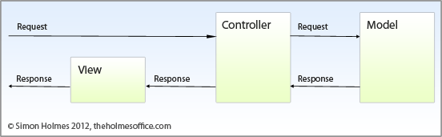

1. MVC Model

In addition to dividing the application into three kinds of components, the MVC design defines the interactions between them:

* **Controllers** Controller is a level which acts like a brain of the entire MVC system.. A controller also acts as a link between a user and the system. It provides the user with input by providing appropriate views to present it appropriately on the screen. The controller understands user output, converts it into the appropriate messages and passesthe same to views.
* **Models:** This level is very important as it represents the data to the user. This level defines where the application’s data objects are stored. The model doesn’t know anything about views and controllers. So, whenever there are changes done in the model it will automatically notify observers that the changes are made. The model may be a single object or a structure of objects.
* **Views:** A view is a visual representation of the MVC model. This level creates an interface to show the actual output to the user. However, a view will not display anything itself. It is the controller or model that tells view what to display to the user. It also handles requests from the user and informs controller. A view is connected to its model and gets the data necessary for the presentation by asking certain questions. Sometimes, it also updates the model by sending appropriate messages. All these questions and messages aresent back to the model in such an easy terminology that it can easily understand the information sent by model or a controller.

##### Advantages and disadvantages of MVC Model

* **Advantage:**
  + **Simultaneous development – Multiple developers can work simultaneously on the model, controller and views..**
  + **Modification does not affect the entire model:** Modification does not affect the entire model beca.use model part does not depend on the views part. Therefore, any changes in the Model will not affect the entire architecture..
  + **MVC model returns the data without formatting:** MVC pattern returns data without applying any formatting so the same components can be used and called for use with any interface
  + **Ease of modification :** Because of the separation of responsibilities, future development or modification is easier.
* **Disadvantage:**
  + For small projects that apply MVC model caused cumbersome, time consuming in development process.
  + Time consuming to transits data between components.
  + The MVC model takes time to learn and apply properly.

##### The reasons for choosing MVC Model

* Better support for test-driven development (TDD)
* Helps to maintain, move, and organize applications more easily.
* Allow modification of code without affecting much of the other parts.

.

#### Node.js

##### Node.js Overview

Node.js is a platform built on [Chrome's JavaScript runtime](https://code.google.com/p/v8/) for easily building fast and scalable network applications. Node.js uses an event-driven, non-blocking I/O model that makes it lightweight and efficient, perfect for data-intensive real-time applications that run across distributed devices.

Node.js is an open source, cross-platform runtime environment for developing server-side and networking applications. Node.js applications are written in JavaScript, and can be run within the Node.js runtime on OS X, Microsoft Windows, and Linux.

Node.js also provides a rich library of various JavaScript modules which simplifies the development of web applications using Node.js to a great extent.

##### Advantages and disadvantages of Node.js

* Advantages:
* Node.js is an open-source framework under MIT license. (MIT license is a free software license originating at the Massachusetts Institute of Technology (MIT).)
* Uses JavaScript to build entire server side application.
* Lightweight framework that includes bare minimum modules. Other modules can be included as per the need of an application.
* Asynchronous by default. So it performs faster than other frameworks.
* Cross-platform framework that runs on Windows, MAC or Linux
* Disadvantages:
* It doesn’t support multi-threaded programming.
* It doesn’t support very high computational intensive tasks. When it executes long running task, it will queue all the incoming requests towait for execution, since it follows JavaScript event loop which is single threaded.
* Node good for executing synchronous and CPU intensive tasks.

##### The reasons for choosing Node.js

* **Very Fast** − Being built on Google Chrome's V8 JavaScript Engine, Node.js library is very fast in code execution.
* **Single Threaded but Highly Scalable** − Node.js uses a single threaded model with event looping.Node.js uses a single threaded program and the same program can provide service to a much larger number of requests than traditional servers like Apache HTTP Server.
* **No Buffering** − Node.js applications never buffer any data. These applications simply output the data in chunks.
* **License** − Node.js is released under the [MIT license](https://raw.githubusercontent.com/joyent/node/v0.12.0/LICENSE)

### Architecture Representation

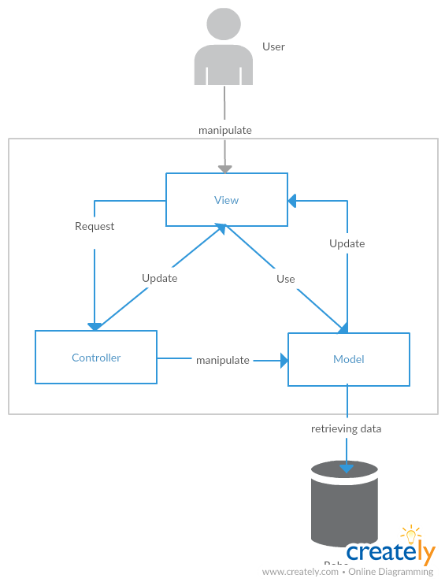

1. System Overview

We follow MVC architecture to implement the BSO Project. MVC offers architectural benefits over standard Jquery and AngularJS — it helps us write better-organized and therefore more maintainable code.

* **DTO Model (data transfer object model)** is an object that defines how the data will be sent over the network to remove circular references from data model, Hide particular properties that clients are not supposed to view, omit some properties in order to reduce payload size, flatten object graphs that contain nested objects, to make them more convenient for clients, avoid “over-posting” vulnerabilities and decouple your service layer from your database layer.
* **View** is what is presented to the users and how users interact with the system. The view is expected to render the model in a meaningful way to the user. In BSO, the view is made with .cshtml file including css, AngularJS and jQuery, it sends user gestures to controller and allows controller to select view.
* **Controller** is the decision maker and the glue between the model and view; it handles user actions and gestures, and responds to user events. For example, in CMS, when a user clicks the “Create” button to create a new contract, the controller for that action is invoked. The controller will then make changes to the contract model. The view will then render the modified contract model to the display so that user can view the new contract he added in the contract list.
* **Data Model** is where the application’s data objects are stored. A model object is in charge of encapsulating application state and one object could be related to other objects establishing a one-to-one or one-to-many relationship.
* **Repository** is intermediate layer which used to separate the controller and the data access layer (database context). It queries the data source for data, maps it to DTO models, processes data and returns data to controller.

### Architectural Goals and Constraints

* **Availability:**
* The application must be available 95% of time. Users can access to it everywhere from there .Web browser with internet connection.
* **Maintainability:**
  + Coding standards and naming conventions:
    - Output of the project must include coding standards and naming conventions documentations. Implementation code must be easy to maintain.
    - All code must be clearly commented, including class, method documentations.
    - If some components are reused, the documentations of those components must also be included.
* Design:
  + - The design of the system must be loosely coupled that chances on some module will not affect others.
* Logging:
  + - All the errors should be logged, supporting for bug fixing and maintenance.
    - All strange or sensitive situations should also be logged.
* **Usability:**
  + Intuitiveness: all help/error messages are simple to understand; user can know exactly how to do each feature after one time using it.
* **Capacity and scalability:**
  + Throughput, storage and growth requirements.

### Logical View

#### Overview

Logical View includes Package diagram and Class diagram. Package diagram describes the organization of packages and elements. Class Diagram provides an overview of the target system by describing the objects and classes inside the system and the relationships between them. It provides a wide variety of usages; from modeling the domain-specific data structure to detailed design of the target system

* + Controller contain the interface between:
    - Associated models
    - Associated views
    - The input devices (e.g., keyboard, pointing device, time).
    - Send commands to the model to update the model's state.
  + Model is:
    - the domain-specific software simulation
    - Or implementation of the application's central structure.
  + View: deal with everything graphical:
    - Requests data from their model
    - Display the data.
  + Repository:
    - Create queries to DB.
    - Process data.
    - Return to controller.

#### Architecturally Significant Design Packages

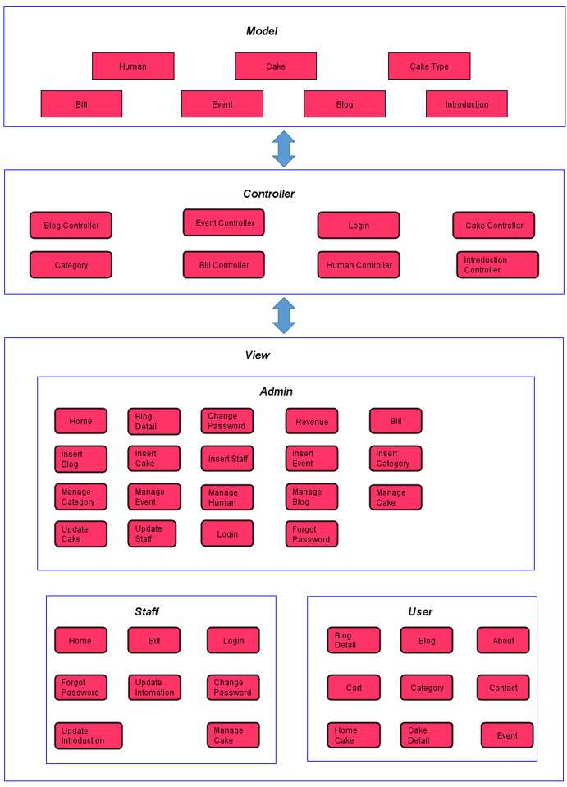

1. Package Diagram

* **Model:**

|  |  |  |
| --- | --- | --- |
| No | Model class | Role |
|  | Human | Description entity of User in database |
|  | CakeType | Description entity of Category in database |
|  | Cake | Description entity of Cake in database |
|  | Event | Description entity of Event in database |
|  | Blog | Description entity of Blog in database |
|  | Bill | Description entity of Bill in database |
|  | Introduction | Description entity of Introduction in database |

1. Model Package

* **Controller:**

|  |  |  |
| --- | --- | --- |
| No | Controller class | Role |
|  | LoginController | * Receive request login, logout from client. * Call method login, logout. * Respond login view and login, logout status. |
|  | HomeController | * Receive request to home page from client. * Handle request from client and call methods to get all data of home page. * Respond data back to Home View. |
|  | AccountAdminController | * Receive requests (get, post, push, update) about Project from admin. * Respond status, message and data to client. |
|  | CakeAdminController | * Receive requests (get, post, push,update) about Project from admin. * Respond status, message and data to client. |
|  | BillController | * Receive request get admin partial views of from client. * Generate partial views and respond to client. |
|  | RevenueController | * Receive request get admin partial views of from client. * Generate partial views and respond to client. |
|  | ForgorPasswordController | * Receive requests from client and send email for client and respond message |
|  | OrderCakeController | * Receive requests from client and respond message |

1. Controller Package

* **Repository:**

|  |  |  |
| --- | --- | --- |
| No | Repository class | Role |
|  | BSDataContext | * Connect to DB, create queries to select, update, deletes data. |
|  | UserRepository | * Process user data and return to controller. |
|  | CakeRepository | * Process cake data and return to controller. |
|  | BlogResponsitory | * Process blog data and return to controller. |
|  | EventRepository | * Process event data and return to controller. |
|  | RevenueRepository | * Process revenue data and return to controller. |
|  | BSDataContext | * Connect to DB, create queries to select, update, deletes data. |

1. Repository Package

### Process view

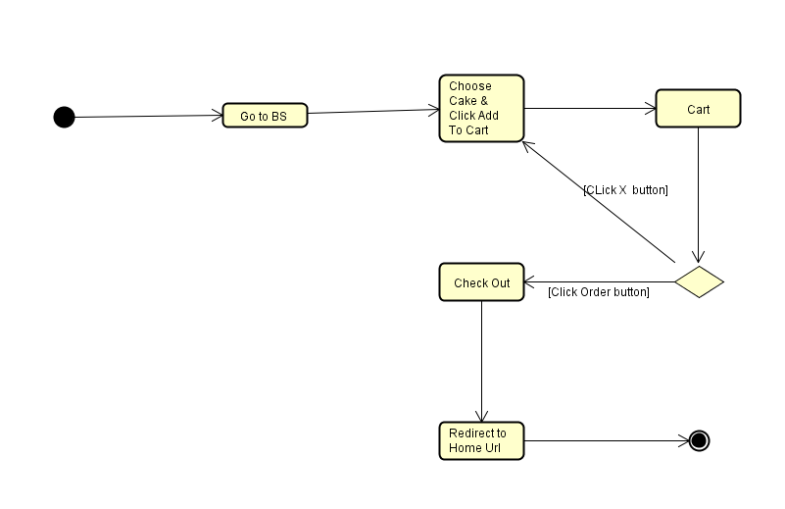

1. Check Out activity diagram

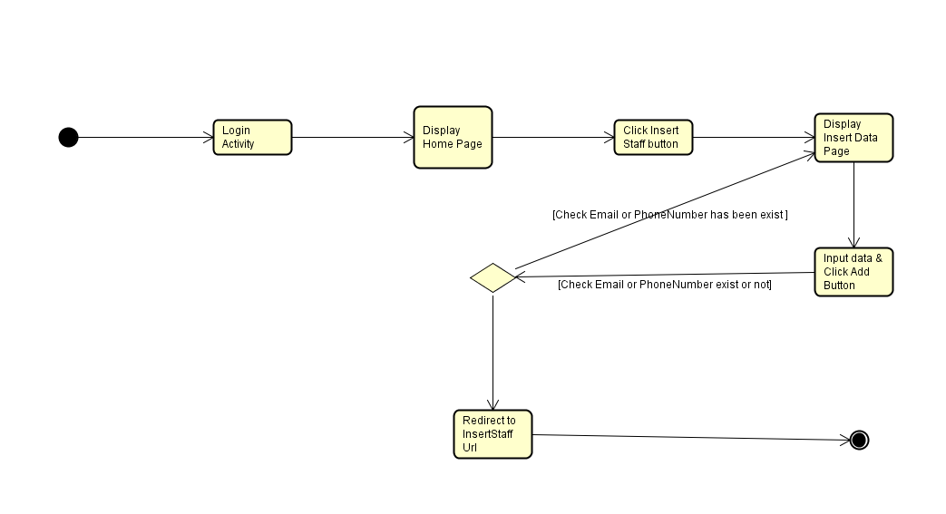

1. Insert staff activity diagram

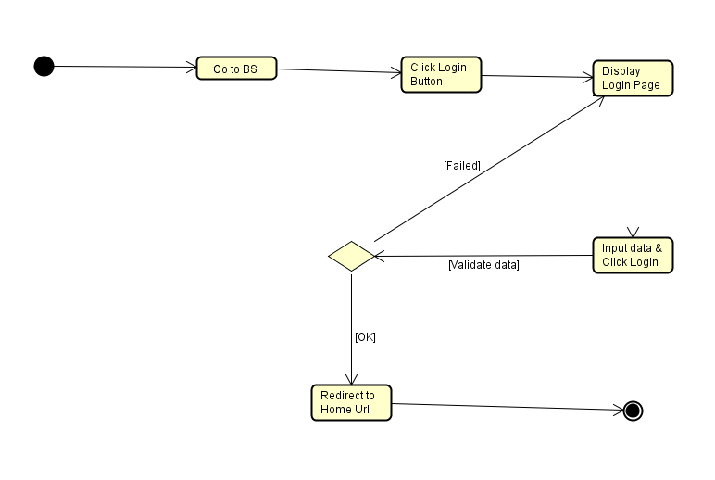

1. Log In activity diagram

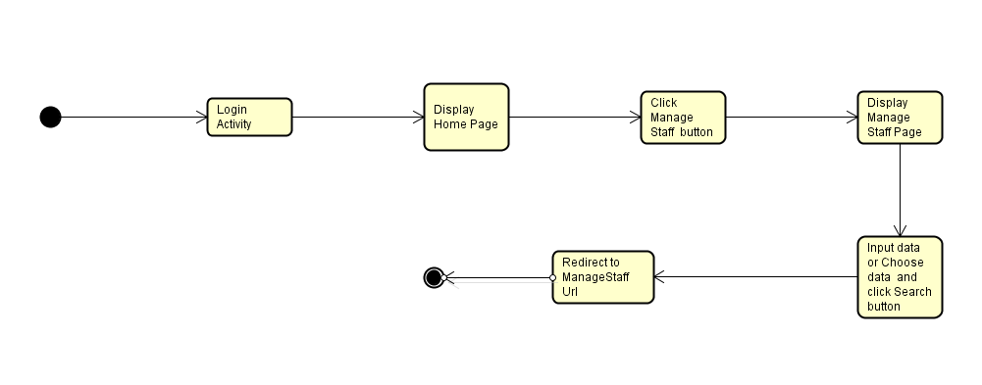

1. Search Staff activity diagram

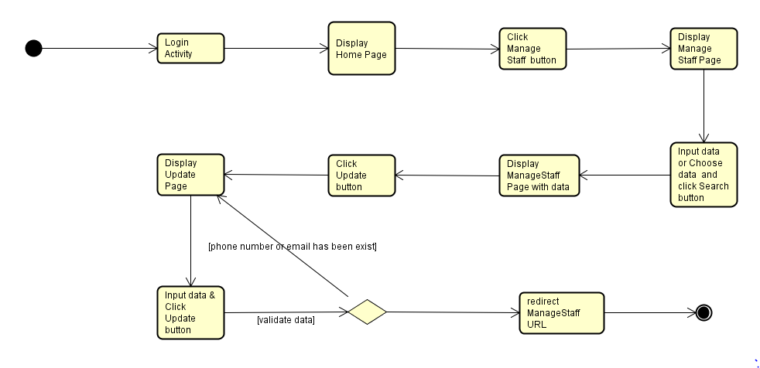

1. Update Staff activity diagram

### Deployment View

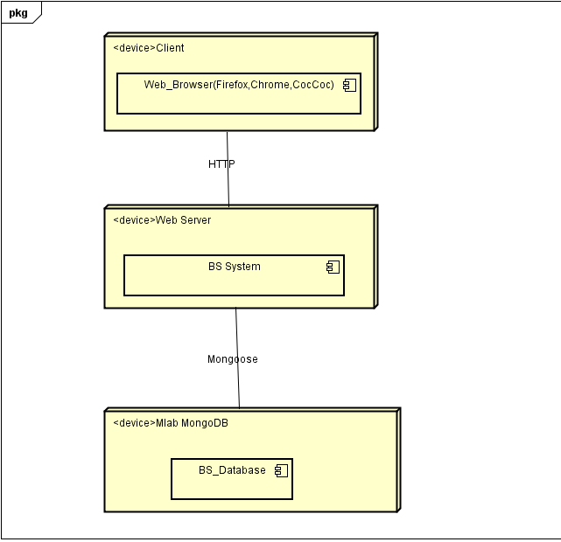

1. Deployment Diagram

|  |  |  |
| --- | --- | --- |
| **No** | **Name** | **Description** |
| 1 | MongoDB | SQL Server use to store system’s data.  Using SQL Server 2010 or higher. |
| 2 | Client | Client is web browser to use system. Firefox 30, Chrome 40 or higher. |
| 3 | Web Server | Web server is hosted by… |

1. Deployment Diagram Description

## Detail Design

### Package

#### Package Diagram

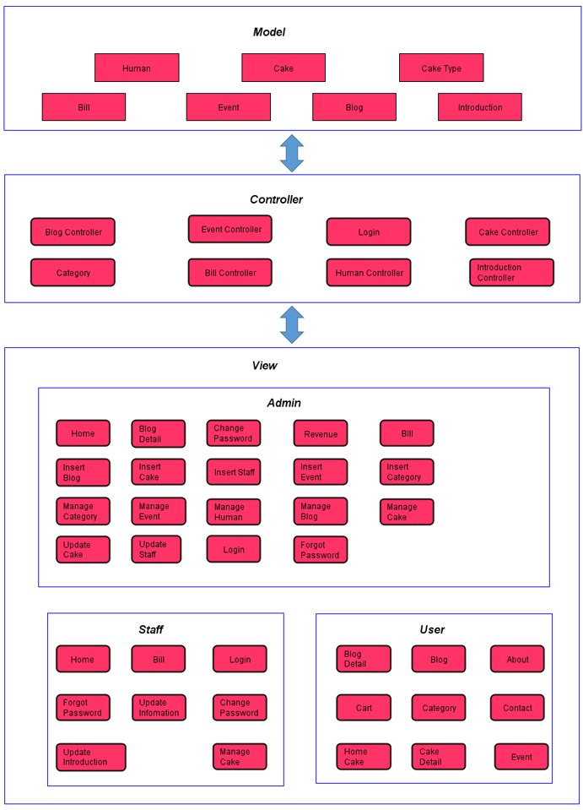

1. Package Diagram

#### Package Description

##### Model

###### Bill

|  |  |  |  |  |
| --- | --- | --- | --- | --- |
| No | Field Name | Type | Allow Null | Description |
| 1 | _id | ObjectId | No | id of Bill |
| 2 | cake_id | ObjectId |  | id of Cake |
| 3 | name_id | ObjectId |  | id of Customer |
| 4 | name | String | No | name of Customer |
| 5 | phone | String | No | phone number of Customer |
| 6 | address | String | No | shipping address for Cusomer |
| 7 | email | String |  | email of Customer |
| 8 | confirm | Boolean |  | confirm has been shipped |
| 9 | time | Date | No | time order cake |
| 10 | Note | String |  | note for staff |
| 11 | cake | Array | No | information of order detail |

1. Bill model

###### Blog

|  |  |  |  |  |
| --- | --- | --- | --- | --- |
| No | Field Name | Type | Allow Null | Description |
| 1 | _id | ObjectId | No | id of Blog |
| 2 | title | String | No | title of Blog |
| 3 | content | String | No | content of Blog |
| 4 | link | String | No | image link of content's Blog |
| 5 | date_create | Date | No | time create blog |
| 6 | ImagePanel | String | NO | imge link of panel's Blog |

1. Blog model

###### Cake

|  |  |  |  |  |
| --- | --- | --- | --- | --- |
| No | Field Name | Type | Allow Null | Description |
| 1 | _id | ObjectId | No | id of Cake |
| 2 | cake_type_ids | ObjectId | No | id of Category |
| 3 | name_cake | String | No | name of Cake |
| 4 | price | String | No | price of Cake |
| 5 | name_size | String | No | size of Cake |
| 6 | linkImage | String | No | link Image of Cake |
| 7 | quantity | String | No | quantity of Cake exist |
| 8 | description | String | No | description about Cake |
| 9 | status | Boolean | No | status of Cake sell |
| 10 | date_create | Date | No | time create Cake |
| 11 | material | Array | No | material of Cake |

1. Cake model

###### CakeType

|  |  |  |  |  |
| --- | --- | --- | --- | --- |
| No | Field Name | Type | Allow Null | Description |
| 1 | _id | ObjectId | No | id of Category |
| 2 | cake_type | String | No | name of Category |
| 3 | Blocked | Boolean | No | status of Category |

1. CakeTpye Model

###### Event

|  |  |  |  |  |
| --- | --- | --- | --- | --- |
| No | Field Name | Type | Allow Null | Description |
| 1 | _id | ObjectId | No | id of event |
| 2 | title | String | No | title of event |
| 3 | content | String | No | content of event |
| 4 | link | String | No | link image of event |
| 5 | date_create | Date | No | time create event |
| 6 | lock | Boolean | No | status of event |

1. Event Model

###### Human

|  |  |  |  |  |
| --- | --- | --- | --- | --- |
| No | Field Name | Type | Allow Null | Description |
| 1 | _id | ObjectId | No | id of User |
| 2 | name | String | No | name of User |
| 3 | phone | String | No | phone number of User |
| 4 | password | String | No | password of User |
| 5 | email | String | No | email of User |
| 6 | address | String | No | address of User |
| 7 | role | Int | No | role of User |
| 8 | note | String |  | note for Manage |
| 9 | linkImage | String | No | link Image of User |
| 10 | date_create | Date | No | time create Account |
| 11 | date_update | Date | No | time update Account |
| 12 | black_list | Boolean | No | blocked Account |

1. Human Model

###### Introduction

|  |  |  |  |  |
| --- | --- | --- | --- | --- |
| No | Field Name | Type | Allow Null | Description |
| 1 | _id | ObjectId | No | id of store |
| 2 | address | String | No | name of store |
| 3 | phone | String | No | phone number of store |
| 4 | email | String | No | password of store |
| 5 | linkImage | String | No | linkImage map of store |
| 10 | date_update | Date | No | time update Introduction |

1. Introduction Model

##### View

Contain many .ejs files to display user interface.

##### Controller

###### LoginController

|  |  |  |  |  |
| --- | --- | --- | --- | --- |
| No | Method | Parameter | Return | Description |
|  | Logout | Object | ActionResult | Log out Account |
|  | adminLocal | Object | ActionResult | Check email and password of Admin login to website and save to session |
|  | staffLocal | Object | ActionResult | Check email and password of Staff login to website and save to session |
|  | userLocal |  | ActionResult | Check email and password of User login to website and save to session |
|  | CheckLOginStaff |  | ActionResult | Check Status Login of Staff |
|  | CheckLoginUser |  | ActionResult | Check Status Login of User |
|  | CheckLoginAdmin |  | ActionResult | Check Status Login of Admin |

1. Login Controller

###### HumanController

|  |  |  |  |  |
| --- | --- | --- | --- | --- |
| No | Method | Parameter | Return | Description |
|  | View |  | ActionResult | Show all details of account had exist for admin. |
|  | Search | Object | ActionResult | Search information about Staff or Customer by email or role |
|  | Insert | Object | ActionResult | User sign up or admin add new a Staff |
|  | Update | Object |  | update information for account |
|  | Block | String |  | Admin can lock account of customer and staff |
|  | unBlock | String |  | Admin can unlock account of customer and staff |
|  | changePassword | String |  | Change Password of Account |
|  | sendEMail | String |  | Email will send one new password with String Random to User |

1. Home Controller

###### CakeController

|  |  |  |  |  |
| --- | --- | --- | --- | --- |
| No | Method | Parameter | Return | Description |
| 1 | Insert | Object |  | Add new cake |
| 2 | View |  | ActionResult | View information of Cakes |
| 3 | Search | Object | ActionResult | Search cake by name or category |
| 4 | Update | Object |  | Update information cake |
| 5 | Lock | String |  | Update Status cake not sell |
| 6 | Unlock | String |  | Update status of cake (sell again ) |

1. CakeController

###### categoryController

|  |  |  |  |  |
| --- | --- | --- | --- | --- |
| No | Method | Parameter | Return | Description |
| 1 | Insert | Object |  | Insert new category |
| 2 | View |  | ActionResult | View all category |
| 3 | Unlock | String |  | Update status of category |
| 4 | Lock | String |  | Update status of category |

1. categoryController

###### Event Controller

|  |  |  |  |  |
| --- | --- | --- | --- | --- |
| No | Method | Parameter | Return | Description |
| 1 | Insert | Object |  | Insert new event |
| 2 | View |  | ActionResult | View all event exist |
| 3 | Lock | String |  | Update status of event (close) |
| 4 | unLock | String |  | Update status of event (open) |
| 5 | Search | String | ActionResult | Find information an event |

1. Event Controller

###### BlogController

|  |  |  |  |  |
| --- | --- | --- | --- | --- |
| No | Method | Parameter | Return | Description |
| 1 | Create | Object |  | Insert new blog |
| 2 | View |  | ActionResult | View all blog |
| 3 | Search | String |  | Search blog by title |
| 4 | blogDetail | String | ActionResult | Show detail information of blog |
| 5 | Lock | String |  | Update status of blog(lock) |
| 6 | unLock | String |  | Update status of blog(open) |

1. BlogController

###### BillController

|  |  |  |  |  |
| --- | --- | --- | --- | --- |
| No | Method | Parameter | Return | Description |
| 1 | newBill | Object |  | Insert new bill |
| 2 | Search | String | ActionResult | Find bill |
| 3 | View |  | ActionResult | View information of bill |
| 4 | confirmBill | String |  | Confirm bill (bill has been transported) |
| 5 | unConfirmBill | String |  | Unconfirm Bill |
| 6 | Note | String |  | Note information of bill |

1. BillController

###### IntroductionController

|  |  |  |  |  |
| --- | --- | --- | --- | --- |
| No | Method | Parameter | Return | Description |
| 1 | add | Object |  | Add new information about website |
| 2 | update | Object |  | Update information about website |

1. IntroductionController

#### Class Diagram

##### Admin Login

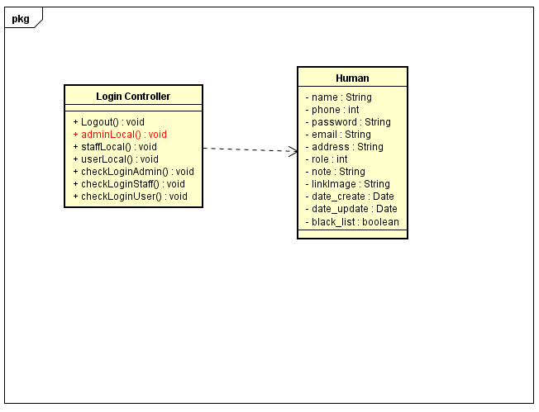

1. Admin Login

|  |  |  |
| --- | --- | --- |
| **Class** | LoginController | |
| **Description** | Admin Login | |
| **Base Class** | Controller | |
| **Source File** | LoginController.js | |
| **Namespace** | Controllers | |
| **Attributes** | **N/A** | |
| **Methods** | **Name** | **Description** |
| adminLocal() | Admin login to website |

1. Admin login

##### Staff Login

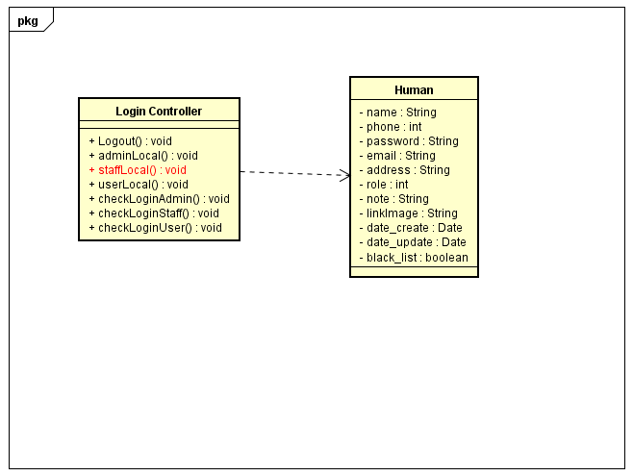

1. Staff Login

|  |  |  |
| --- | --- | --- |
| **Class** | LoginController | |
| **Description** | Staff Login | |
| **Base Class** | Controller | |
| **Source File** | LoginController.js | |
| **Namespace** | Controllers | |
| **Attributes** | **N/A** | |
| **Methods** | **Name** | **Description** |
| staffLocal() | Staff login to website |

1. Staff Login

##### User Login

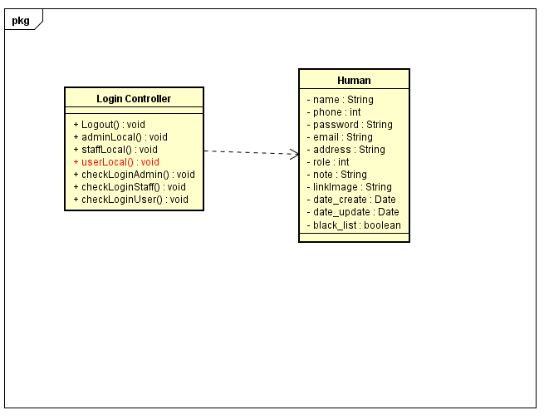

1. User Login

|  |  |  |
| --- | --- | --- |
| **Class** | LoginController | |
| **Description** | User Login | |
| **Base Class** | Controller | |
| **Source File** | LoginController.js | |
| **Namespace** | Controllers | |
| **Attributes** | **N/A** | |
| **Methods** | **Name** | **Description** |
| userLocal() | User normal login to website |

1. User Login

##### Check Login Admin

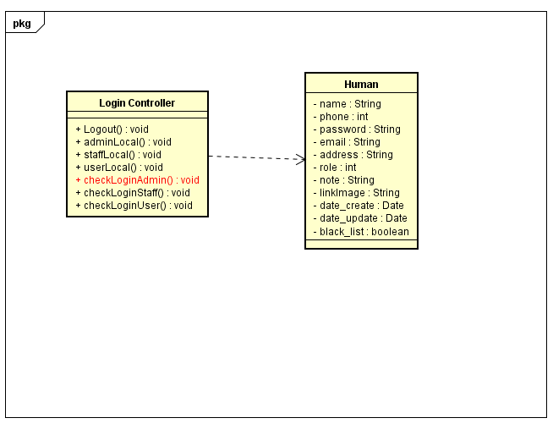

1. Check Login Admin

|  |  |  |
| --- | --- | --- |
| **Class** | LoginController | |
| **Description** | Check Status Login of Admin | |
| **Base Class** | Controller | |
| **Source File** | LoginController.js | |
| **Namespace** | Controllers | |
| **Attributes** | **N/A** | |
| **Methods** | **Name** | **Description** |
| isLoggedAdmin() | Check Status Login of Admin |

1. Check Login Admin

##### Check Login Staff

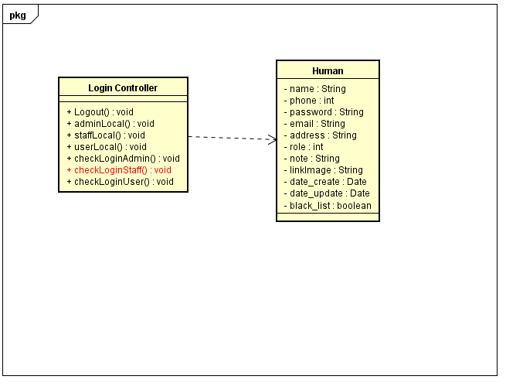

1. Check Login Staff

|  |  |  |
| --- | --- | --- |
| **Class** | LoginController | |
| **Description** | Check Status Login of Staff | |
| **Base Class** | Controller | |
| **Source File** | LoginController.js | |
| **Namespace** | Controllers | |
| **Attributes** | **N/A** | |
| **Methods** | **Name** | **Description** |
| isLoggedStaff() | Check Status Login of Staff |

1. Check Login Staff

##### Check Login User

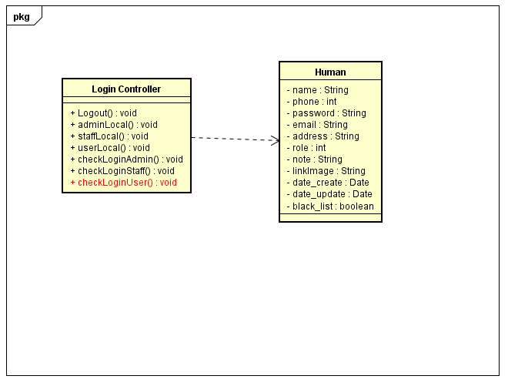

1. Check Login User

|  |  |  |
| --- | --- | --- |
| **Class** | LoginController | |
| **Description** | Check Status Login of User | |
| **Base Class** | Controller | |
| **Source File** | LoginController.js | |
| **Namespace** | Controllers | |
| **Attributes** | **N/A** | |
| **Methods** | **Name** | **Description** |
| isLoggedUser() | Check Status Login of User |

1. Check Login User

##### Logout

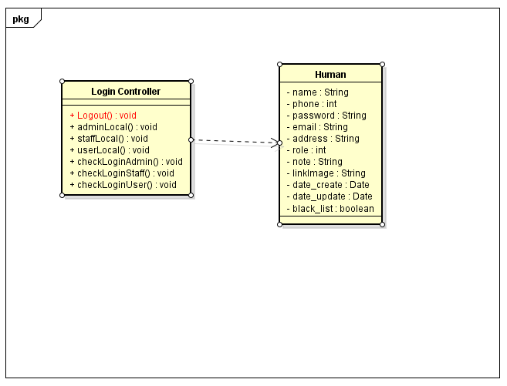

1. Logout

|  |  |  |
| --- | --- | --- |
| **Class** | LoginController | |
| **Description** | Log Out Account | |
| **Base Class** | Controller | |
| **Source File** | LoginController.js | |
| **Namespace** | Controllers | |
| **Attributes** | **N/A** | |
| **Methods** | **Name** | **Description** |
| Logout() | Log out Account |

1. Logout

##### View Account

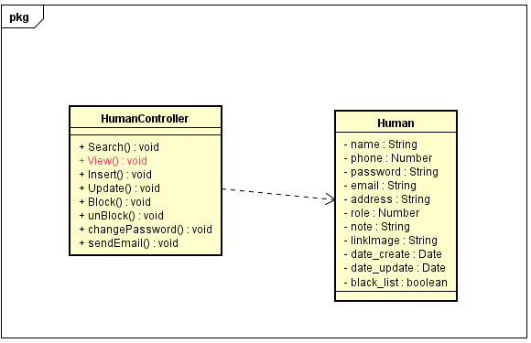

1. View Account

|  |  |  |
| --- | --- | --- |
| **Class** | HumanController | |
| **Description** | Show all details of account had exist for admin | |
| **Base Class** | Controller | |
| **Source File** | HumanController.js | |
| **Namespace** | Controllers | |
| **Attributes** | **N/A** | |
| **Methods** | **Name** | **Description** |
| View() | Show all details of account had exist for Admin |

1. View Account

##### Update Account

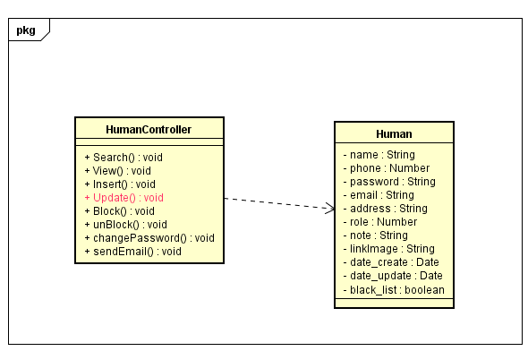

1. Update Account

|  |  |  |
| --- | --- | --- |
| **Class** | HumanController | |
| **Description** | update information for account | |
| **Base Class** | Controller | |
| **Source File** | HumanController.js | |
| **Namespace** | Controllers | |
| **Attributes** | **N/A** | |
| **Methods** | **Name** | **Description** |
| Update() | Update information for account |

1. Update Account

##### Insert Account

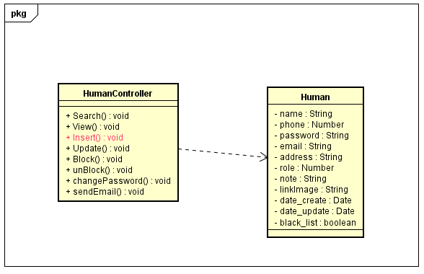

1. Insert Account

|  |  |  |
| --- | --- | --- |
| **Class** | HumanController | |
| **Description** | Insert new account | |
| **Base Class** | Controller | |
| **Source File** | HumanController.js | |
| **Namespace** | Controllers | |
| **Attributes** | **N/A** | |
| **Methods** | **Name** | **Description** |
| Insert() | User sign up or admin add new a Staff |

1. Insert Account

##### Search Human

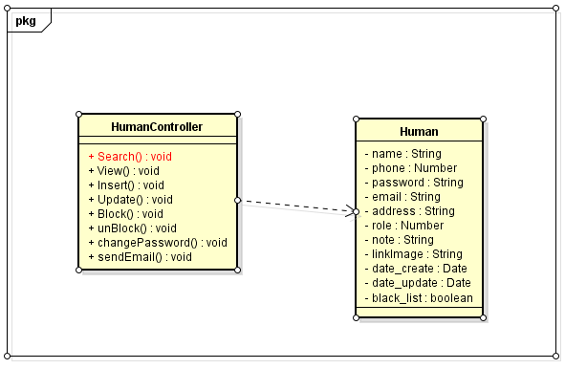

1. Search Human

|  |  |  |
| --- | --- | --- |
| **Class** | HumanController | |
| **Description** | Search information of Account | |
| **Base Class** | Controller | |
| **Source File** | HumanController.js | |
| **Namespace** | Controllers | |
| **Attributes** | **N/A** | |
| **Methods** | **Name** | **Description** |
| Search() | Search information of Account |

1. Search Human

##### Change Password

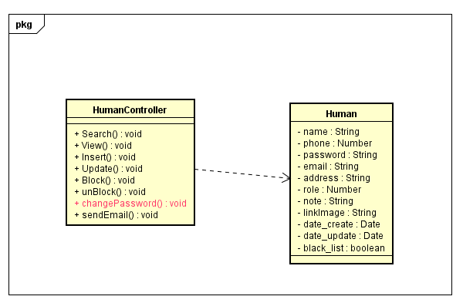

1. Change Password

|  |  |  |
| --- | --- | --- |
| **Class** | HumanController | |
| **Description** | Change Password of Account | |
| **Base Class** | Controller | |
| **Source File** | HumanController.js | |
| **Namespace** | Controllers | |
| **Attributes** | **N/A** | |
| **Methods** | **Name** | **Description** |
| changePassword() | Change Password of Account |

1. Change Password

##### Forgot Password

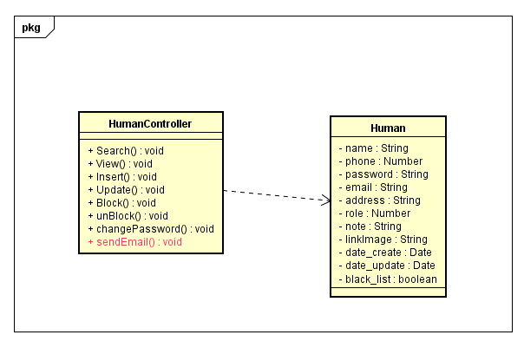

1. Forgot Password

|  |  |  |
| --- | --- | --- |
| **Class** | HumanController | |
| **Description** | Send new Password to Email | |
| **Base Class** | Controller | |
| **Source File** | HumanController.js | |
| **Namespace** | Controllers | |
| **Attributes** | **N/A** | |
| **Methods** | **Name** | **Description** |
| sendEmail() | Send new password to email when forgot password |

1. Forgot Password

##### Lock Account

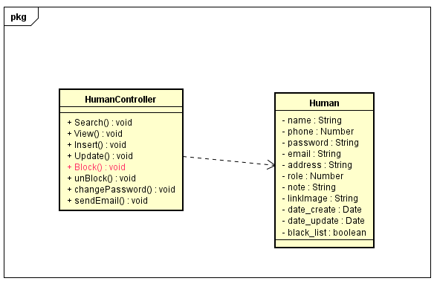

1. Lock Account

|  |  |  |
| --- | --- | --- |
| **Class** | HumanController | |
| **Description** | Admin can lock account of customer and staff | |
| **Base Class** | Controller | |
| **Source File** | HumanController.js | |
| **Namespace** | Controllers | |
| **Attributes** | **N/A** | |
| **Methods** | **Name** | **Description** |
| Block() | Admin can lock account of customer and staff |

1. Lock Account

##### Unlock Account

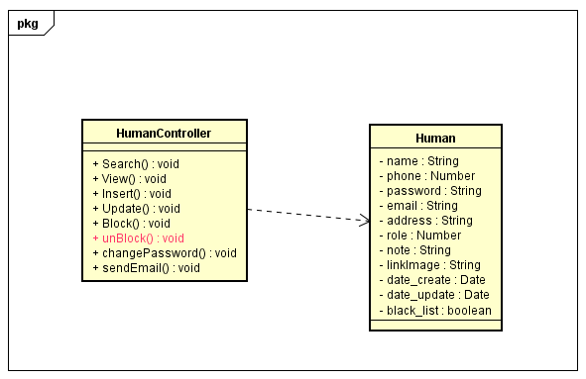

1. Unlock Account

|  |  |  |
| --- | --- | --- |
| **Class** | HumanController | |
| **Description** | Admin can unlock account of customer and staff | |
| **Base Class** | Controller | |
| **Source File** | HumanController.js | |
| **Namespace** | Controllers | |
| **Attributes** | **N/A** | |
| **Methods** | **Name** | **Description** |
| unBlock() | Admin can lock account of customer and staff |

1. Unlock Account

##### Add Cake

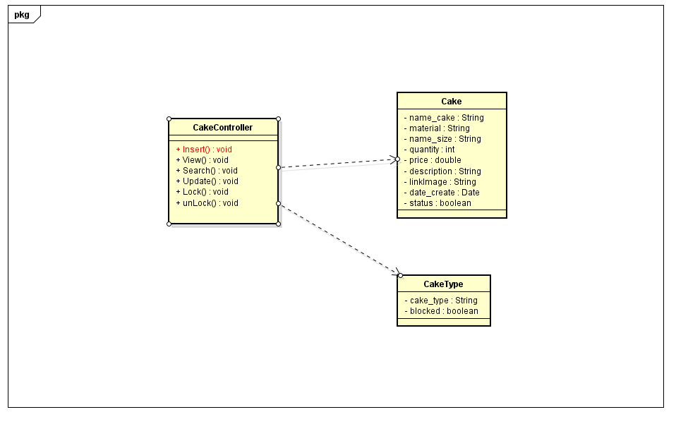

1. Add Cake

|  |  |  |
| --- | --- | --- |
| **Class** | CakeController | |
| **Description** | Add new Cake | |
| **Base Class** | Controller | |
| **Source File** | CakeController.js | |
| **Namespace** | Controllers | |
| **Attributes** | **N/A** | |
| **Methods** | **Name** | **Description** |
| Insert() | Add new cake |

1. Add Cake

##### View Cake

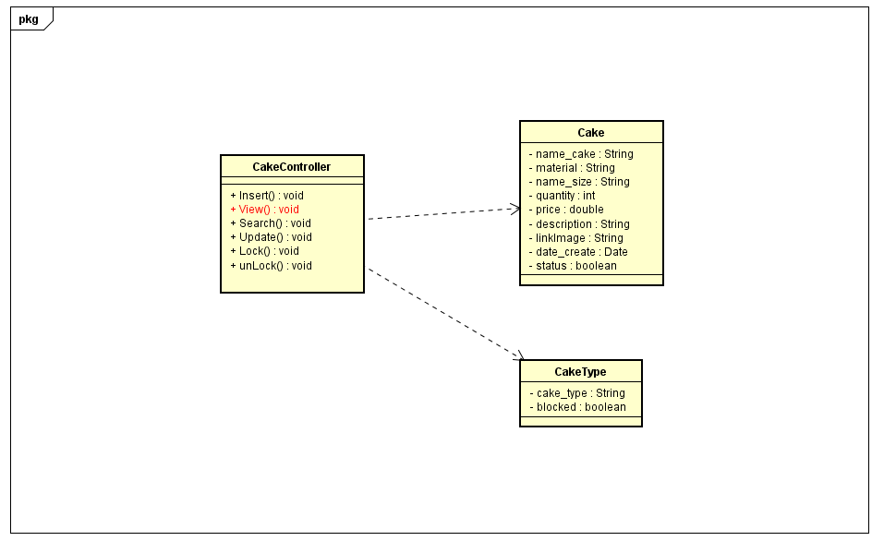

1. View Cake

|  |  |  |
| --- | --- | --- |
| **Class** | CakeController | |
| **Description** | View information of Cakes | |
| **Base Class** | Controller | |
| **Source File** | CakeController.js | |
| **Namespace** | Controllers | |
| **Attributes** | **N/A** | |
| **Methods** | **Name** | **Description** |
| Insert() | View information of Cake |

1. View Cake

##### Search Cake

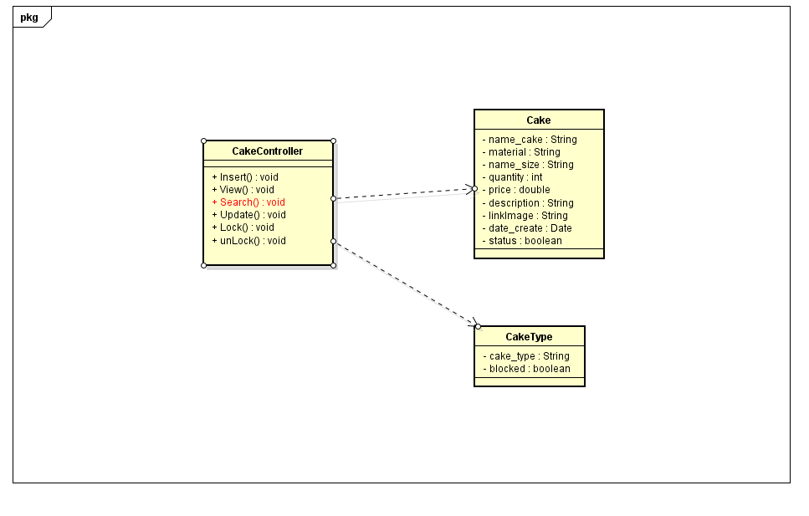

1. Search Cake

|  |  |  |
| --- | --- | --- |
| **Class** | CakeController | |
| **Description** | Search cake by name or category | |
| **Base Class** | Controller | |
| **Source File** | CakeController.js | |
| **Namespace** | Controllers | |
| **Attributes** | **N/A** | |
| **Methods** | **Name** | **Description** |
| Search() | Search cake by name or category |

1. Search Cake

##### Update Cake

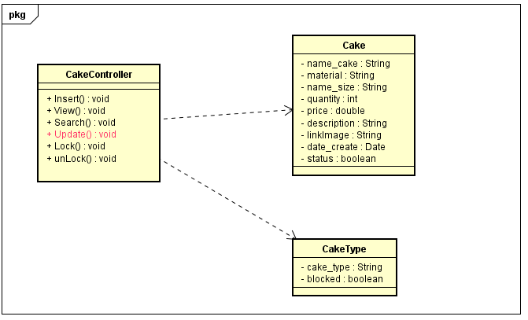

1. Update Cake

|  |  |  |
| --- | --- | --- |
| **Class** | CakeController | |
| **Description** | Update information cake | |
| **Base Class** | Controller | |
| **Source File** | CakeController.js | |
| **Namespace** | Controllers | |
| **Attributes** | **N/A** | |
| **Methods** | **Name** | **Description** |
| Update() | Update information cake |

1. Update Cake

##### Lock Cake

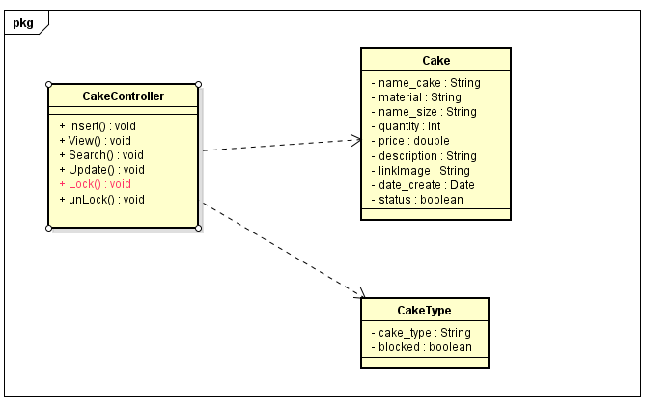

1. Lock Cake

|  |  |  |
| --- | --- | --- |
| **Class** | CakeController | |
| **Description** | Update Status of cake not sell | |
| **Base Class** | Controller | |
| **Source File** | CakeController.js | |
| **Namespace** | Controllers | |
| **Attributes** | **N/A** | |
| **Methods** | **Name** | **Description** |
| Lock() | Update Status cake not sell |

1. Lock Cake

##### Unlock cake

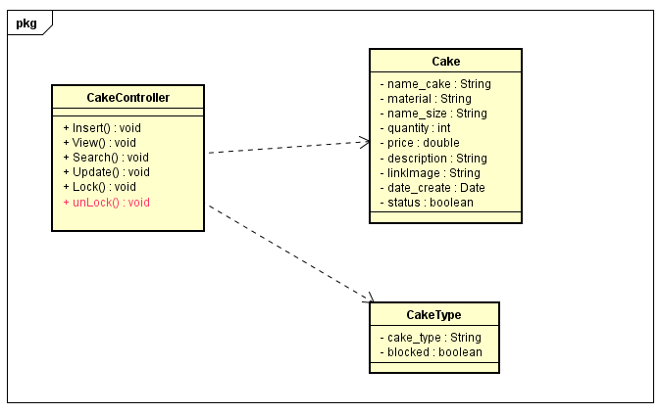

1. Unlock cake

|  |  |  |
| --- | --- | --- |
| **Class** | CakeController | |
| **Description** | Update status of cake (sell again ) | |
| **Base Class** | Controller | |
| **Source File** | CakeController.js | |
| **Namespace** | Controllers | |
| **Attributes** | **N/A** | |
| **Methods** | **Name** | **Description** |
| unLock() | Update status of cake (sell again ) |

1. Unlock cake

##### Insert category

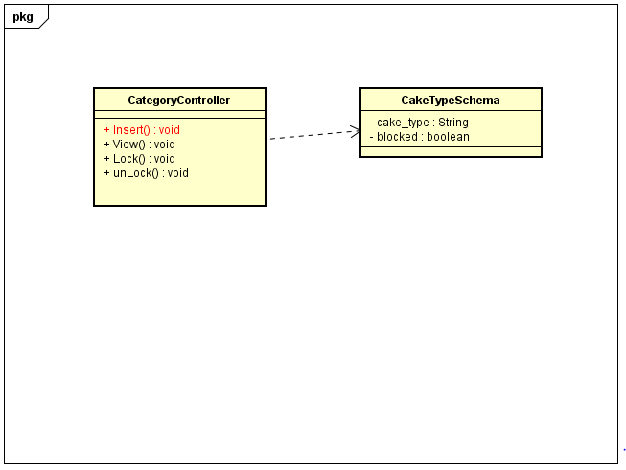

1. Insert category

|  |  |  |
| --- | --- | --- |
| **Class** | CategoryController | |
| **Description** | Insert new category | |
| **Base Class** | Controller | |
| **Source File** | CategoryController.js | |
| **Namespace** | Controllers | |
| **Attributes** | **N/A** | |
| **Methods** | **Name** | **Description** |
| Insert() | Insert new category |

1. Insert category

##### View Category

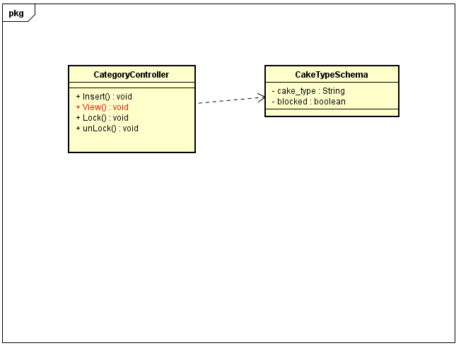

1. View Category

|  |  |  |
| --- | --- | --- |
| **Class** | CategoryController | |
| **Description** | View all category | |
| **Base Class** | Controller | |
| **Source File** | CategoryController.js | |
| **Namespace** | Controllers | |
| **Attributes** | **N/A** | |
| **Methods** | **Name** | **Description** |
| View() | View all category |

1. View Category

##### Lock Category

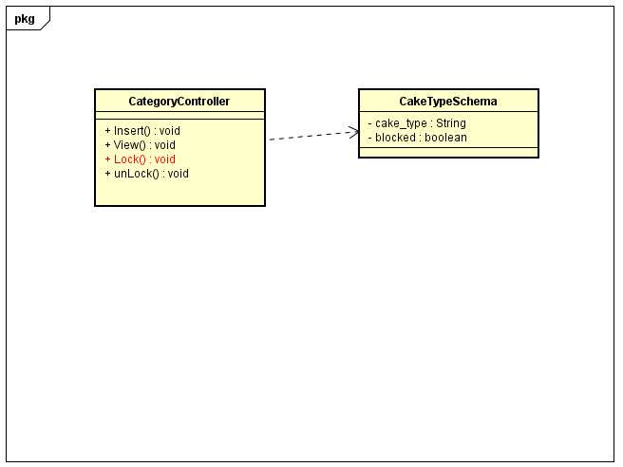

1. Lock Category

|  |  |  |
| --- | --- | --- |
| **Class** | CategoryController | |
| **Description** | Update status of category | |
| **Base Class** | Controller | |
| **Source File** | CategoryController.js | |
| **Namespace** | Controllers | |
| **Attributes** | **N/A** | |
| **Methods** | **Name** | **Description** |
| Lock() | Update status of category |

1. Lock Category

##### Unlock Category

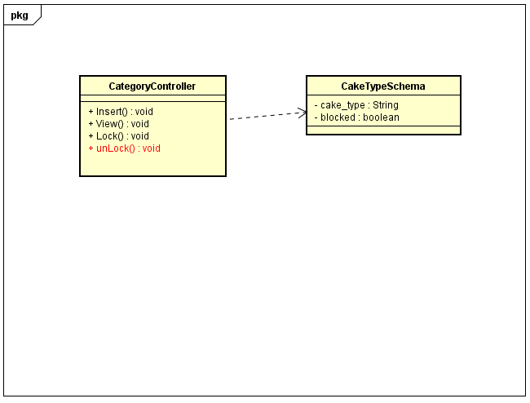

1. Unlock Category

|  |  |  |
| --- | --- | --- |
| **Class** | CategoryController | |
| **Description** | Update status of category | |
| **Base Class** | Controller | |
| **Source File** | CategoryController.js | |
| **Namespace** | Controllers | |
| **Attributes** | **N/A** | |
| **Methods** | **Name** | **Description** |
| unLock() | Update status of category |

1. Unlock Category

##### Insert Event

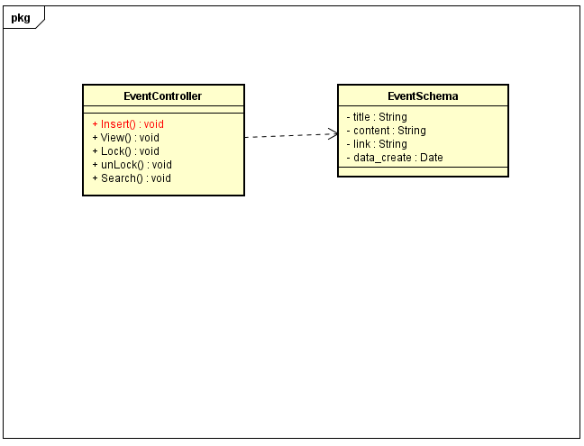

1. Insert Event

|  |  |  |
| --- | --- | --- |
| **Class** | EventController | |
| **Description** | Insert new event | |
| **Base Class** | Controller | |
| **Source File** | EventController.js | |
| **Namespace** | Controllers | |
| **Attributes** | **N/A** | |
| **Methods** | **Name** | **Description** |
| Insert() | Insert new event |

1. Insert Event

##### View Event

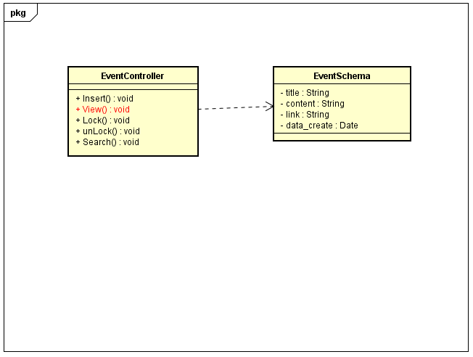

1. View Event

|  |  |  |
| --- | --- | --- |
| **Class** | EventController | |
| **Description** | View all Event | |
| **Base Class** | Controller | |
| **Source File** | EventController.js | |
| **Namespace** | Controllers | |
| **Attributes** | **N/A** | |
| **Methods** | **Name** | **Description** |
| View() | View all event exist |

1. View Event

##### Lock Event

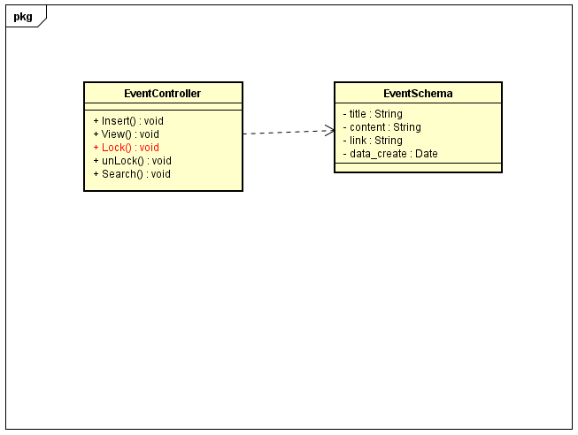

1. Lock Event

|  |  |  |
| --- | --- | --- |
| **Class** | EventController | |
| **Description** | Update status of event (close) | |
| **Base Class** | Controller | |
| **Source File** | EventController.js | |
| **Namespace** | Controllers | |
| **Attributes** | **N/A** | |
| **Methods** | **Name** | **Description** |
| Lock() | Update status of event (close) |

1. Lock Event

##### Unlock Event

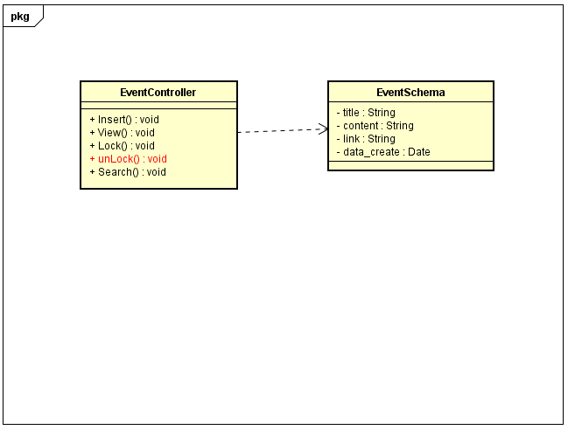

1. Unlock Event

|  |  |  |
| --- | --- | --- |
| **Class** | EventController | |
| **Description** | Update status of event (open) | |
| **Base Class** | Controller | |
| **Source File** | EventController.js | |
| **Namespace** | Controllers | |
| **Attributes** | **N/A** | |
| **Methods** | **Name** | **Description** |
| Unlock() | Update status of event (open) |

1. Unlock Event

##### Search Event

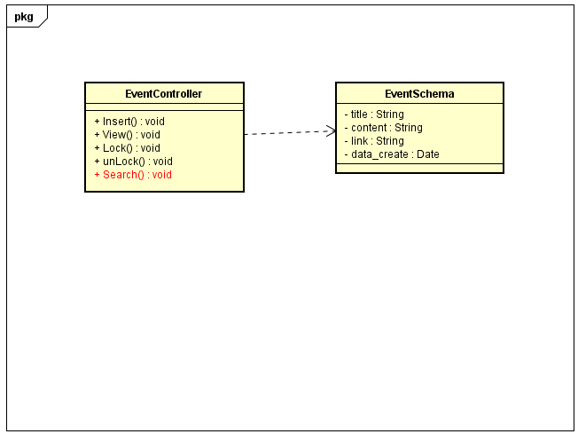

1. Search Event

|  |  |  |
| --- | --- | --- |
| **Class** | EventController | |
| **Description** | Find information an event | |
| **Base Class** | Controller | |
| **Source File** | EventController.js | |
| **Namespace** | Controllers | |
| **Attributes** | **N/A** | |
| **Methods** | **Name** | **Description** |
| Search() | Find information an event |

1. Search Event

##### Insert Blog

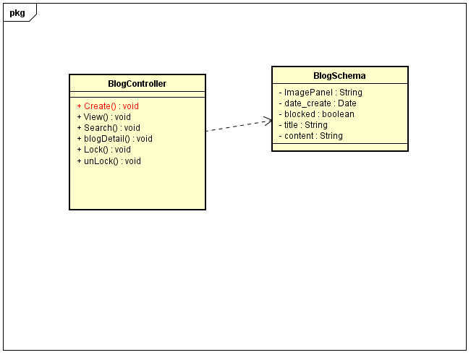

1. Insert Blog

|  |  |  |
| --- | --- | --- |
| **Class** | BlogController | |
| **Description** | Insert new blog | |
| **Base Class** | Controller | |
| **Source File** | BlogController.js | |
| **Namespace** | Controllers | |
| **Attributes** | **N/A** | |
| **Methods** | **Name** | **Description** |
| Create() | Insert new blog |

1. Insert Blog

##### View Blog

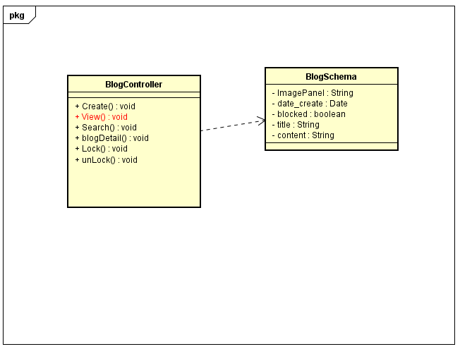

1. View Blog

|  |  |  |
| --- | --- | --- |
| **Class** | BlogController | |
| **Description** | View all blog | |
| **Base Class** | Controller | |
| **Source File** | BlogController.js | |
| **Namespace** | Controllers | |
| **Attributes** | **N/A** | |
| **Methods** | **Name** | **Description** |
| View() | View all blog |

1. View Blog

##### Search Blog

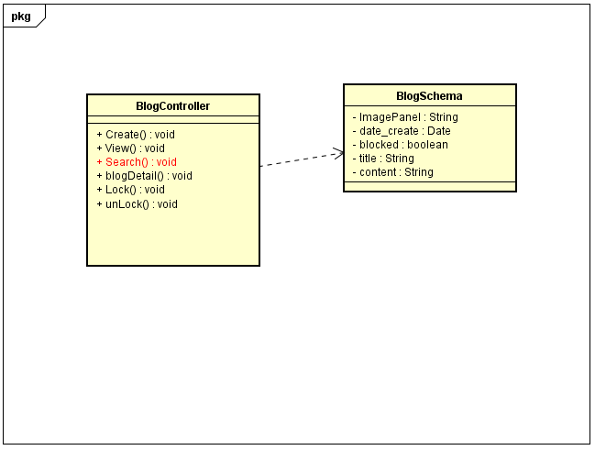

1. Search Blog

|  |  |  |
| --- | --- | --- |
| **Class** | BlogController | |
| **Description** | Seach blog by title | |
| **Base Class** | Controller | |
| **Source File** | BlogController.js | |
| **Namespace** | Controllers | |
| **Attributes** | **N/A** | |
| **Methods** | **Name** | **Description** |
| Search() | Search blog by title |

1. Search Blog

##### Blog Detail

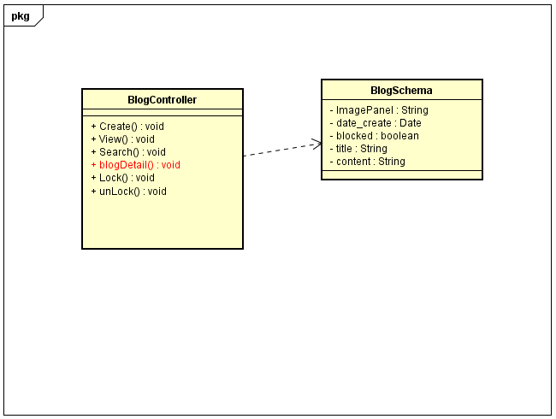

1. Blog Detail

|  |  |  |
| --- | --- | --- |
| **Class** | BlogController | |
| **Description** | Show detail information of blog | |
| **Base Class** | Controller | |
| **Source File** | BlogController.js | |
| **Namespace** | Controllers | |
| **Attributes** | **N/A** | |
| **Methods** | **Name** | **Description** |
| blogDetail() | Show detail information of blog |

1. Blog Detail

##### Lock Blog

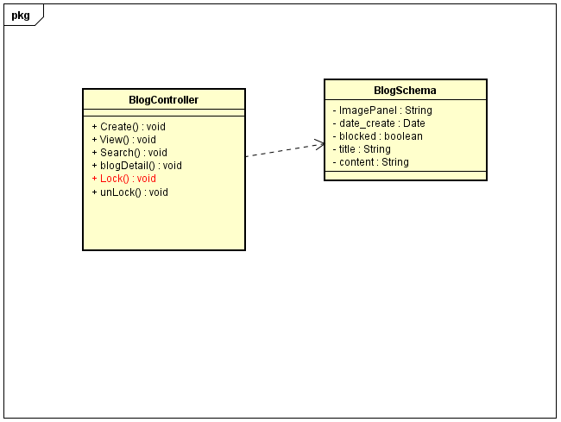

1. Lock Blog

|  |  |  |
| --- | --- | --- |
| **Class** | BlogController | |
| **Description** | Update status of blog (lock) | |
| **Base Class** | Controller | |
| **Source File** | BlogController.js | |
| **Namespace** | Controllers | |
| **Attributes** | **N/A** | |
| **Methods** | **Name** | **Description** |
| Lock() | Update status of blog(lock) |

1. Lock Blog

##### UnLock Blog

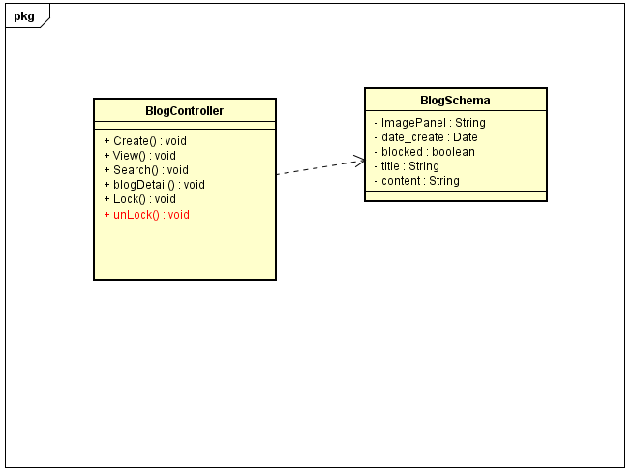

1. UnLock Blog

|  |  |  |
| --- | --- | --- |
| **Class** | BlogController | |
| **Description** | Update status of blog(open) | |
| **Base Class** | Controller | |
| **Source File** | BlogController.js | |
| **Namespace** | Controllers | |
| **Attributes** | **N/A** | |
| **Methods** | **Name** | **Description** |
| unLock() | Update status of blog(open) |

1. UnLock Blog

##### Insert Bill

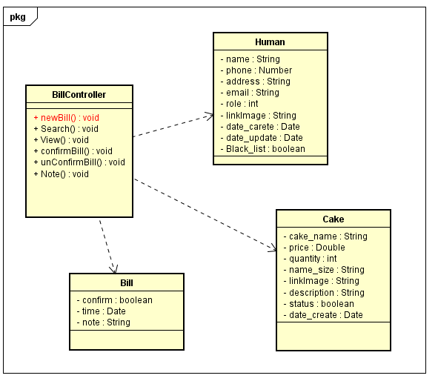

1. Insert Bill

|  |  |  |
| --- | --- | --- |
| **Class** | BillController | |
| **Description** | Insert new bill | |
| **Base Class** | Controller | |
| **Source File** | BillController.js | |
| **Namespace** | Controllers | |
| **Attributes** | **N/A** | |
| **Methods** | **Name** | **Description** |
| newBill() | Insert new bill |

1. Insert Bill

##### Seach Bill

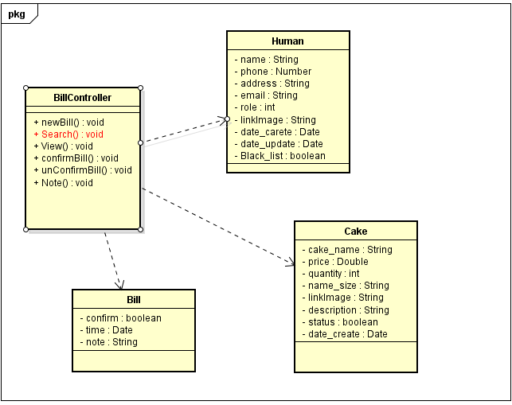

1. Seach Bill

|  |  |  |
| --- | --- | --- |
| **Class** | BillController | |
| **Description** | Find bill | |
| **Base Class** | Controller | |
| **Source File** | BillController.js | |
| **Namespace** | Controllers | |
| **Attributes** | **N/A** | |
| **Methods** | **Name** | **Description** |
| Search() | Find bill |

1. Seach Bill

##### View Bill

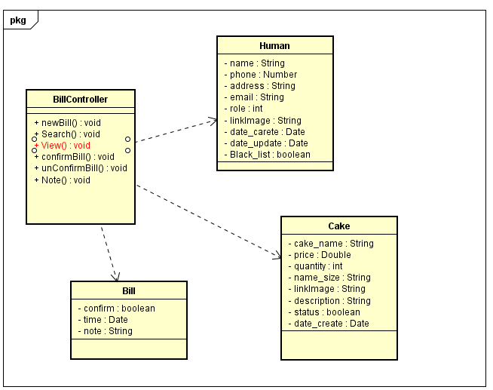

1. View Bill

|  |  |  |
| --- | --- | --- |
| **Class** | BillController | |
| **Description** | View information of bill | |
| **Base Class** | Controller | |
| **Source File** | BillController.js | |
| **Namespace** | Controllers | |
| **Attributes** | **N/A** | |
| **Methods** | **Name** | **Description** |
| View() | View information of bill |

1. View Bill

##### Confirm Bill

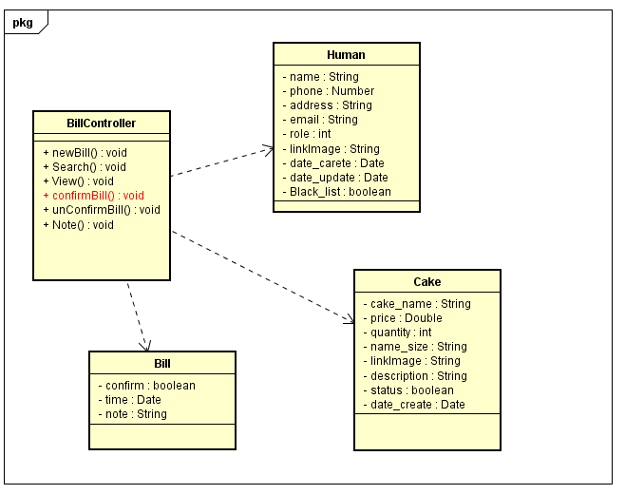

1. Confirm Bill

|  |  |  |
| --- | --- | --- |
| **Class** | BillController | |
| **Description** | Confirm bill | |
| **Base Class** | Controller | |
| **Source File** | BillController.js | |
| **Namespace** | Controllers | |
| **Attributes** | **N/A** | |
| **Methods** | **Name** | **Description** |
| confirmBill() | Confirm bill |

1. Confirm Bill

##### Unconfirm Bill

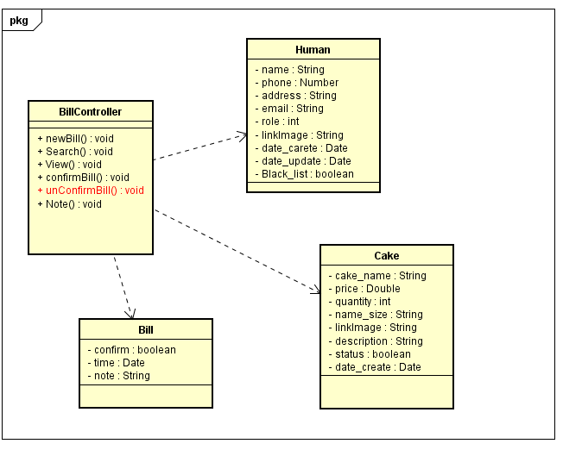

1. Unconfirm Bill

|  |  |  |
| --- | --- | --- |
| **Class** | BillController | |
| **Description** | Unconfirm bill | |
| **Base Class** | Controller | |
| **Source File** | BillController.js | |
| **Namespace** | Controllers | |
| **Attributes** | **N/A** | |
| **Methods** | **Name** | **Description** |
| unconfirmBill() | Unconfirm bill |

1. Unconfirm Bill

##### Note

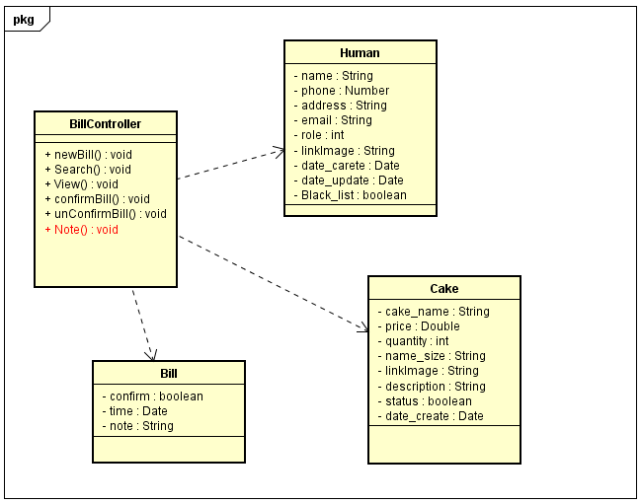

1. Note

|  |  |  |
| --- | --- | --- |
| **Class** | BillController | |
| **Description** | Note information of bill | |
| **Base Class** | Controller | |
| **Source File** | BillController.js | |
| **Namespace** | Controllers | |
| **Attributes** | **N/A** | |
| **Methods** | **Name** | **Description** |
| Note() | Note information of bill |

1. Note

#### Sequence diagram

##### Login

###### Login Admin

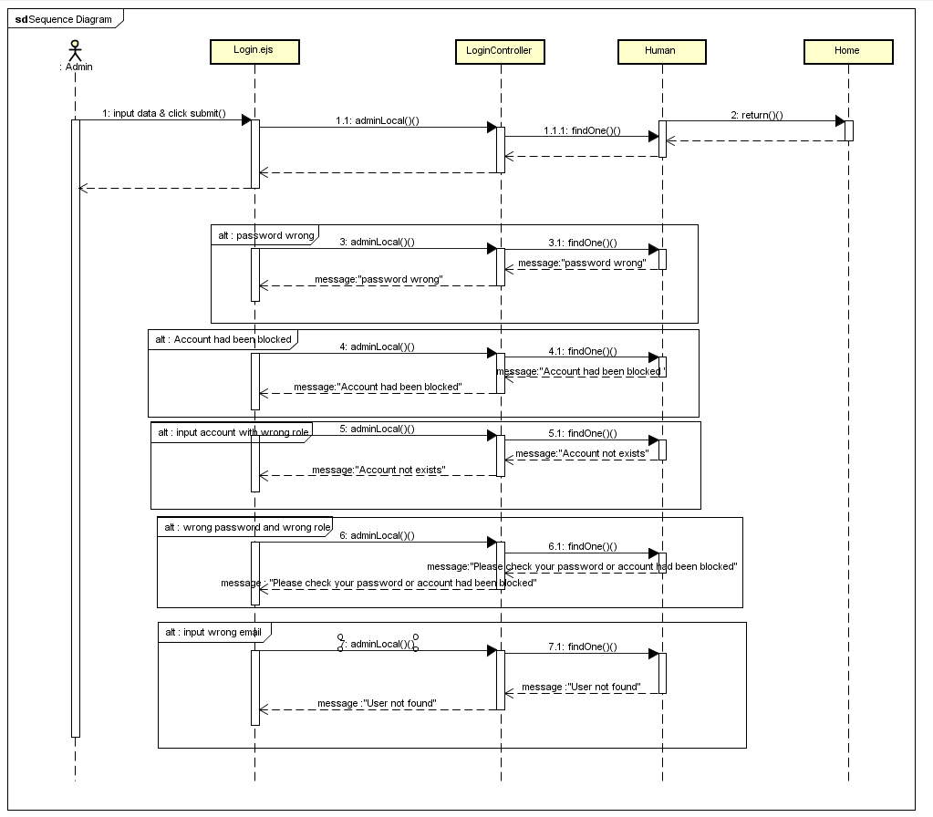

1. Login Admin

###### Login Staff

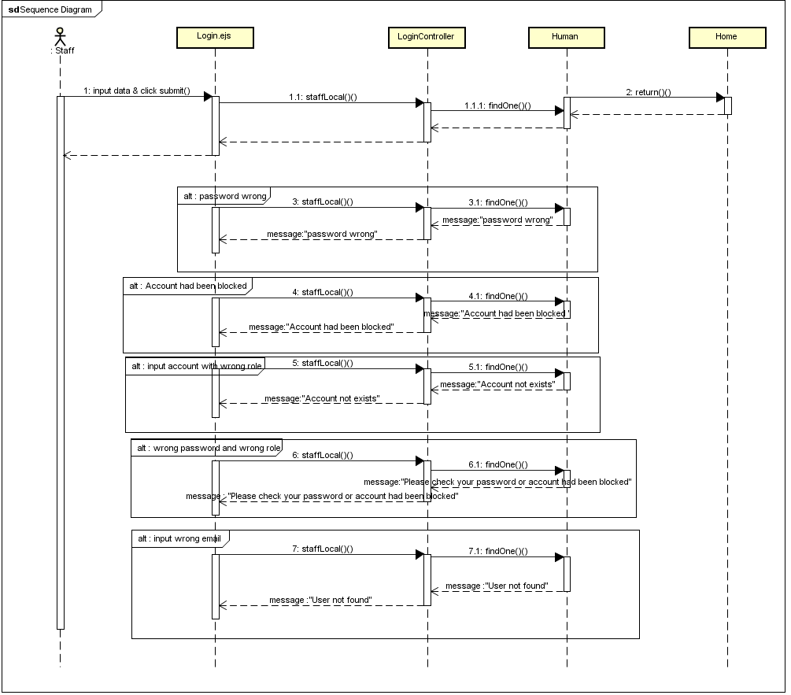

1. Login Staff

###### Login User

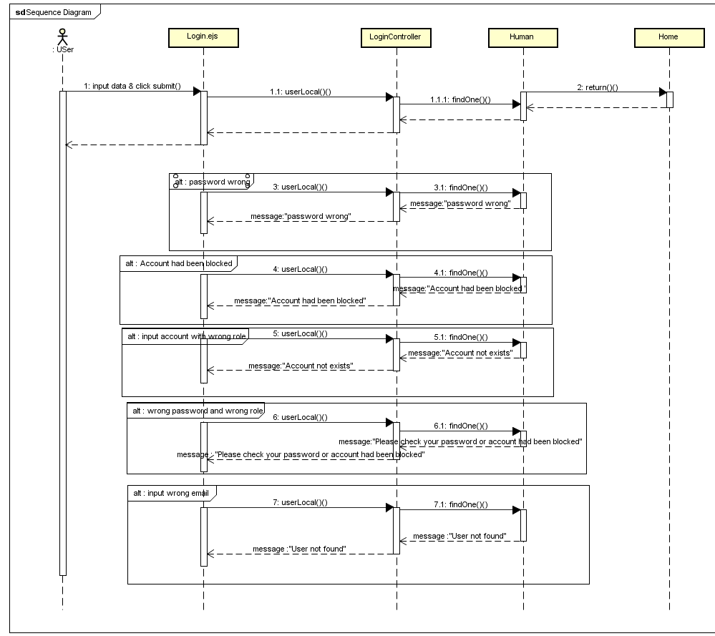

1. Login User

###### Logout

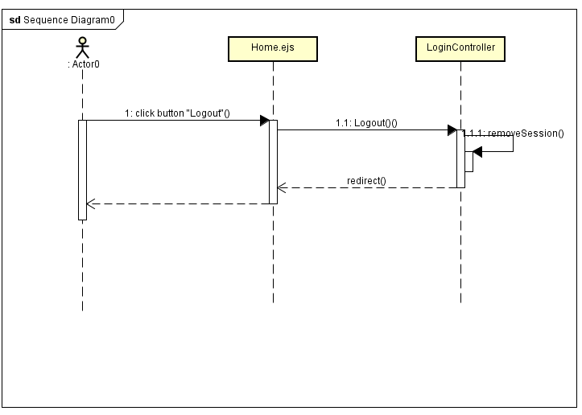

1. Logout

###### Login Register

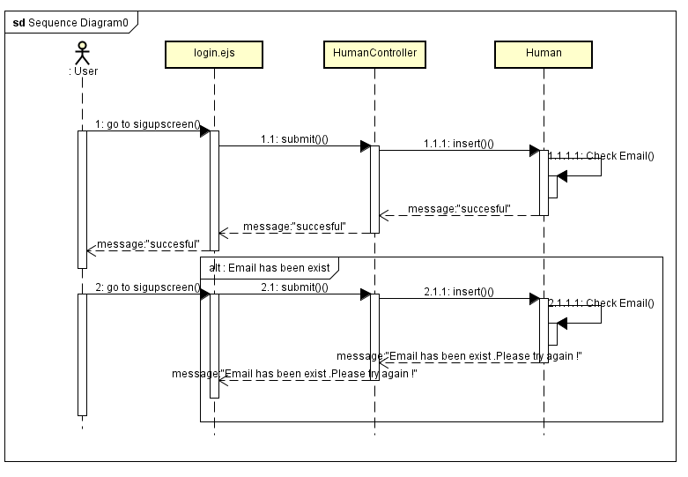

1. Login Register

###### Forgot Password

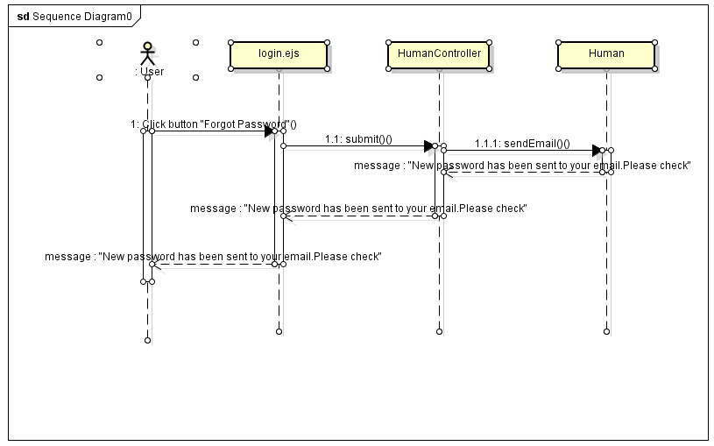

1. Forgot Password

##### Manage Account

###### Insert Staff

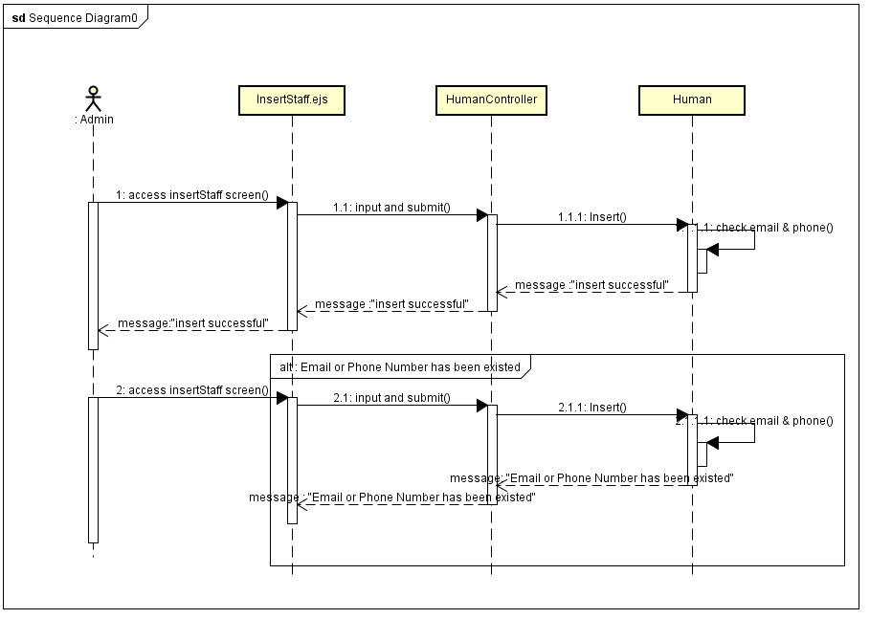

1. Insert Staff

###### Update Staff

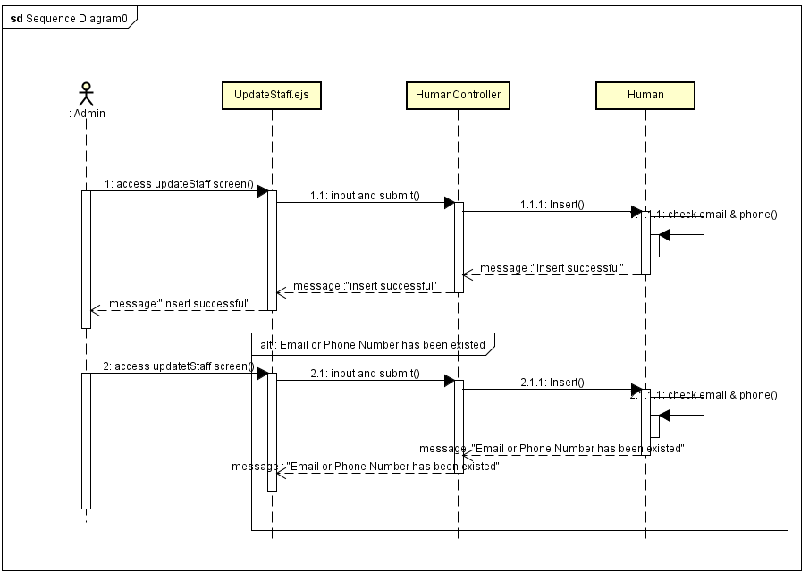

1. Update Staff

###### Lock Account

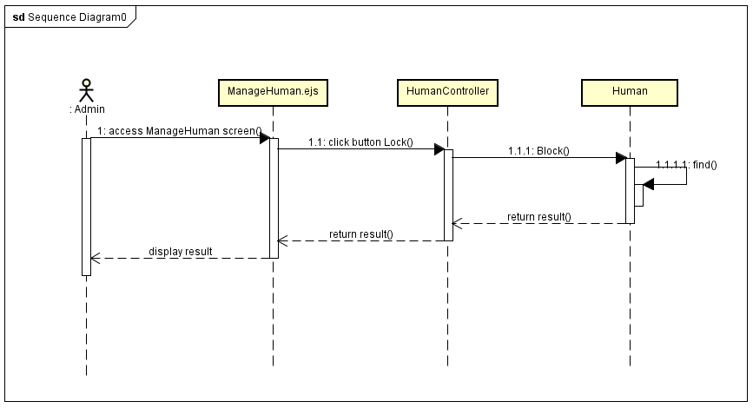

1. Lock Account

###### UnLock Account

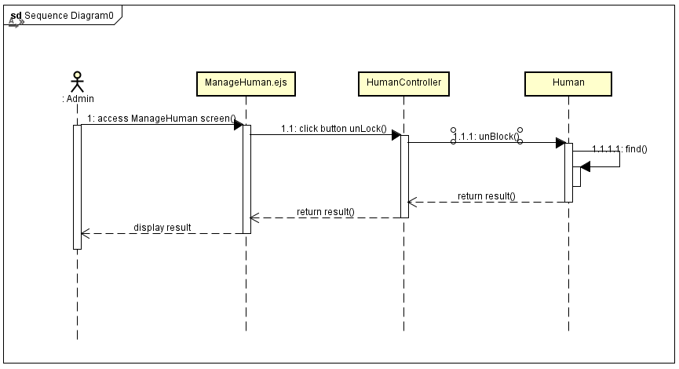

1. UnLock Account

##### Manage Cake

###### Insert Cake

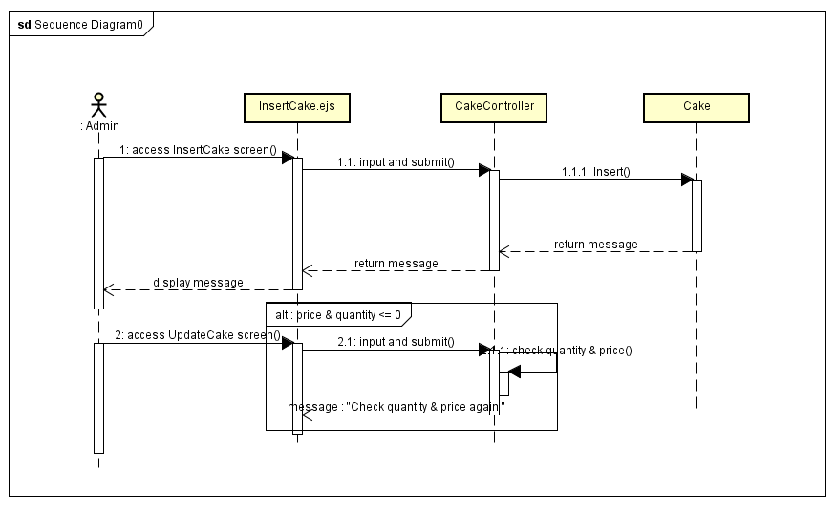

1. Insert Cake

###### Search Cake

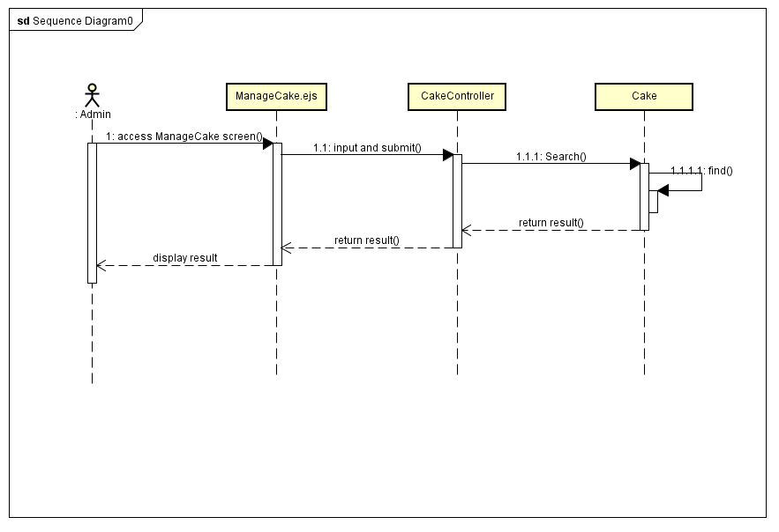

1. Search Cake

###### Update Cake

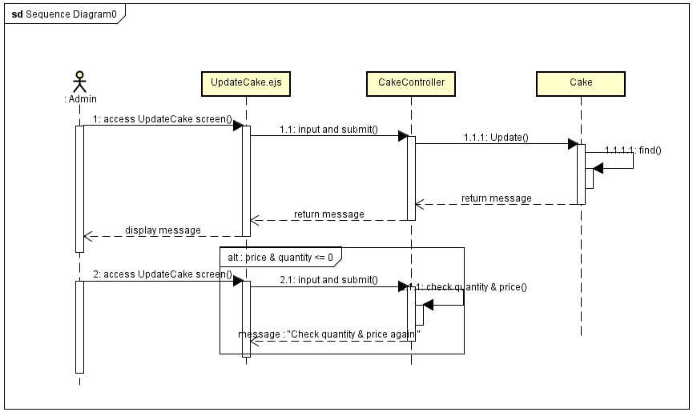

1. Update Cake

###### Lock Cake

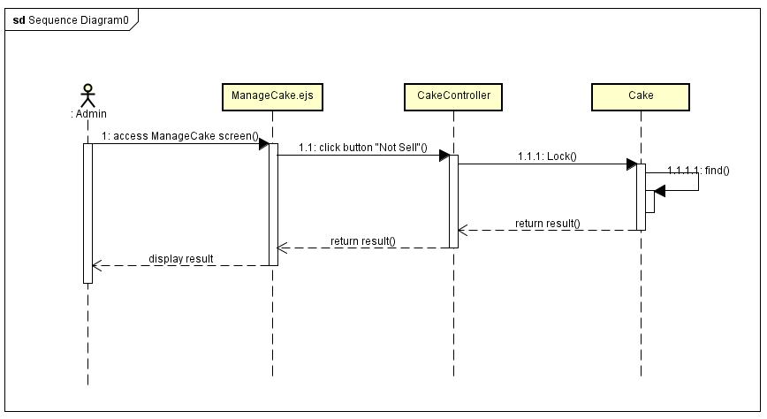

1. Lock Cake

###### UnLock Cake

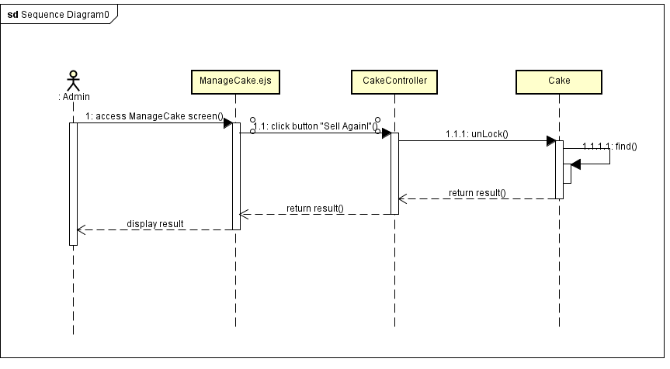

1. UnLock Cake

##### Manage Blog

###### Insert Blog

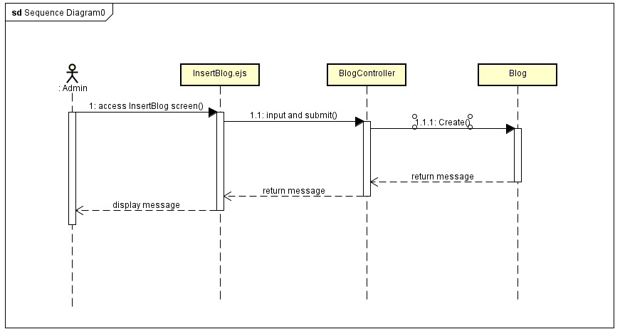

1. Insert Blog

###### Search Blog

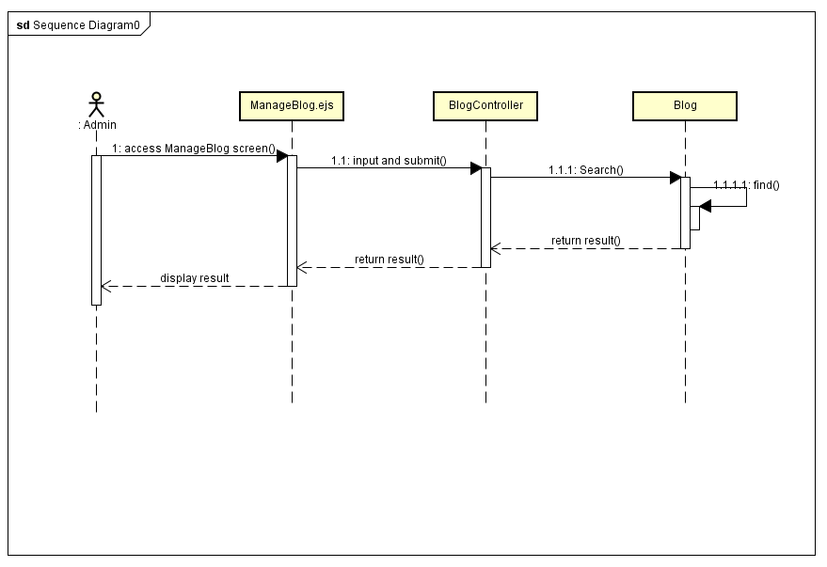

1. Search Blog

###### Lock Blog

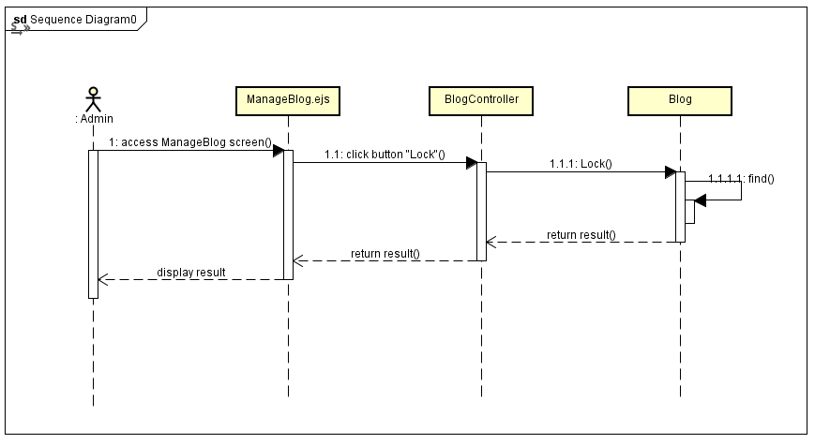

1. Lock Blog

###### UnLock Blog

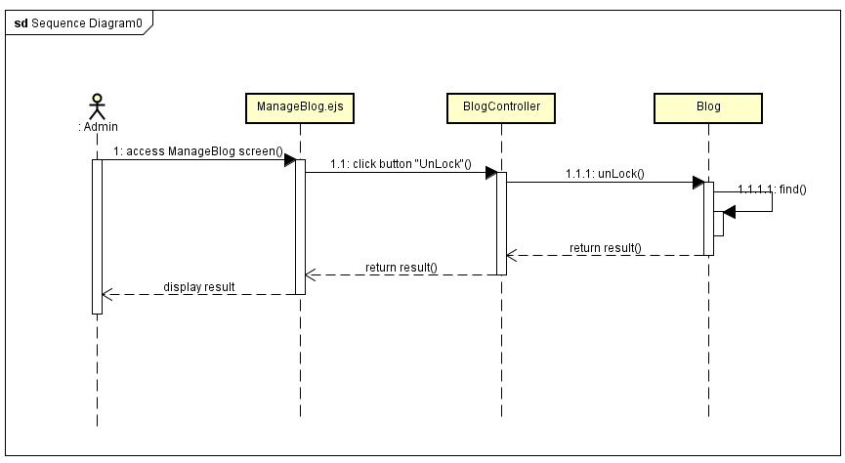

1. UnLock Blog

##### Manage Event

###### Insert Event

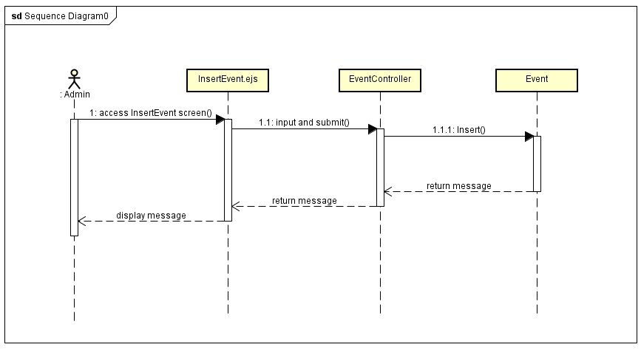

1. Insert Event

###### Search Event

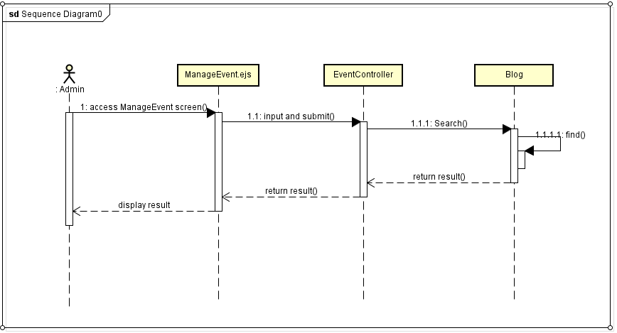

1. Search Event

###### Lock Event

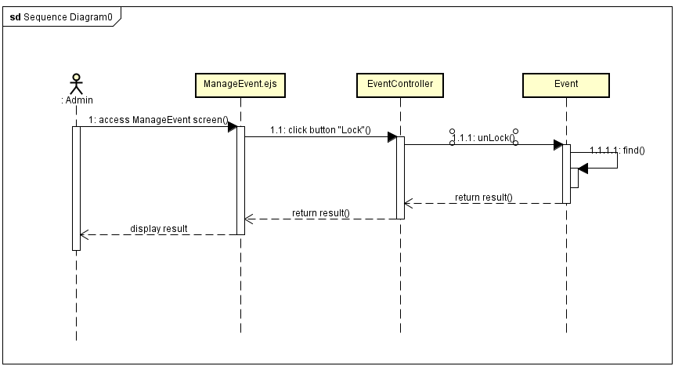

1. Lock Event

###### Unlock Event

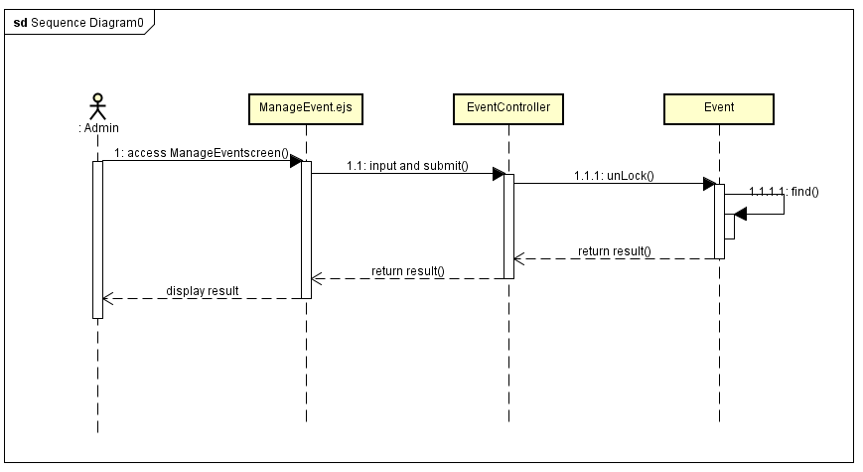

1. Unlock Event

##### Manage Category

###### Insert Category

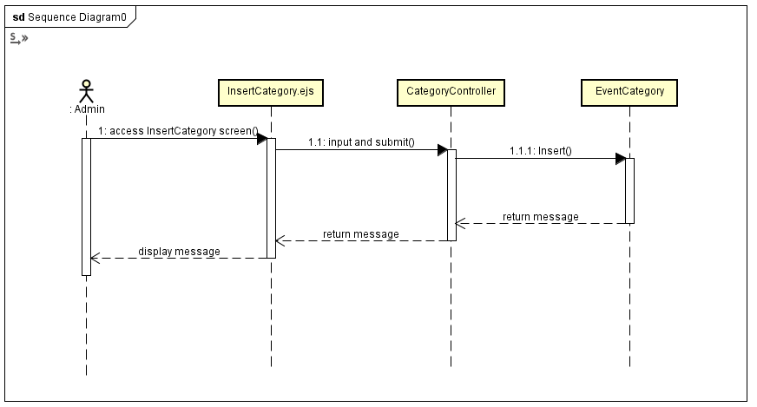

1. Insert Category

###### Lock Category

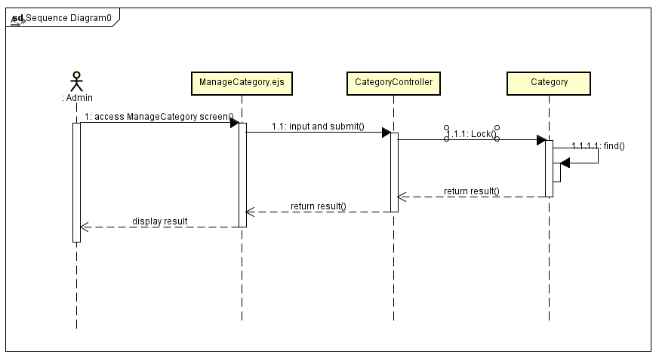

1. Lock Category

###### UnLock Category

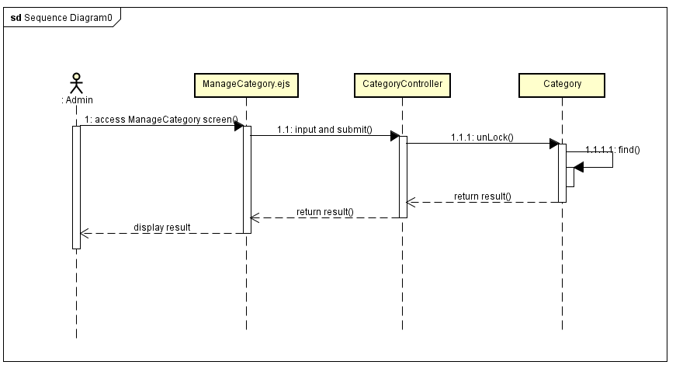

1. UnLock Category

##### Check Out

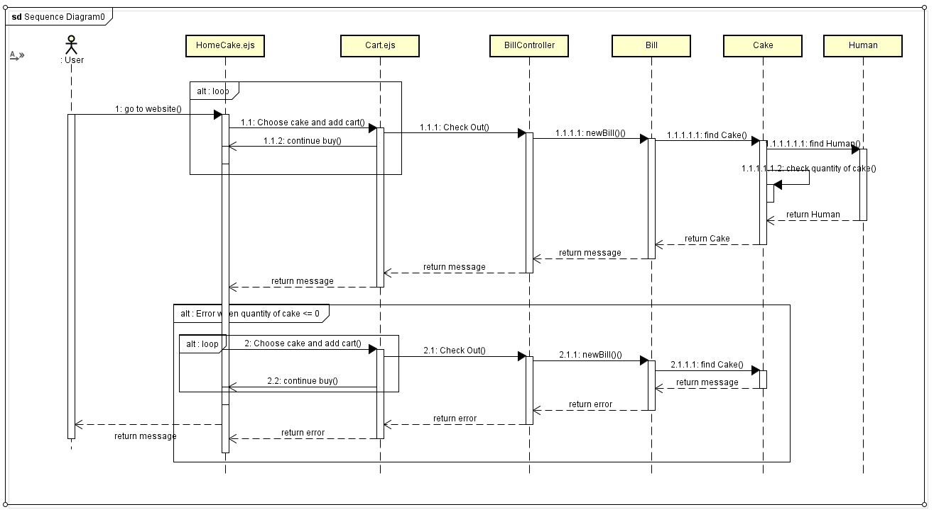

1. Check Out

##### Manage Bill

###### Search Bill

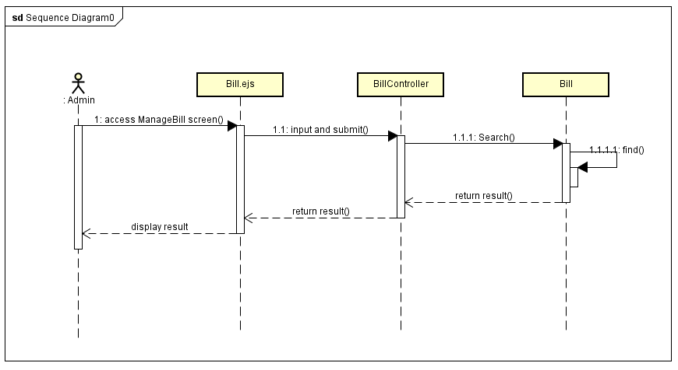

1. Search Bill

###### Confirm Bill

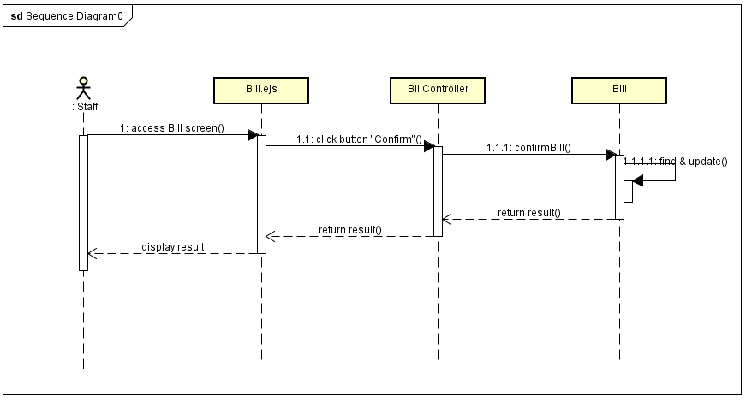

1. Confirm Bill

###### Unconfirm Bill

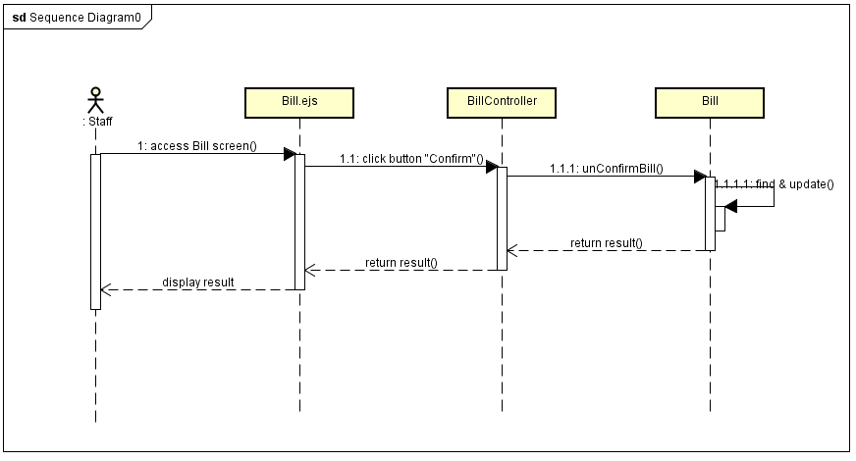

1. Unconfirm Bill

##### Search revenue

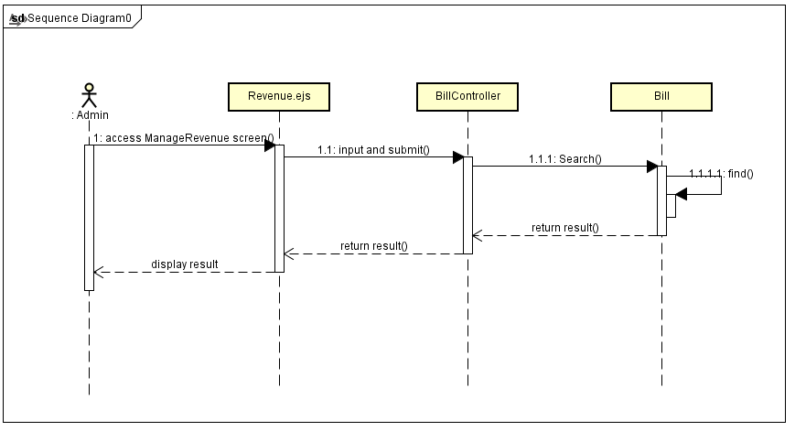

1. Search revenue

##### Change Password

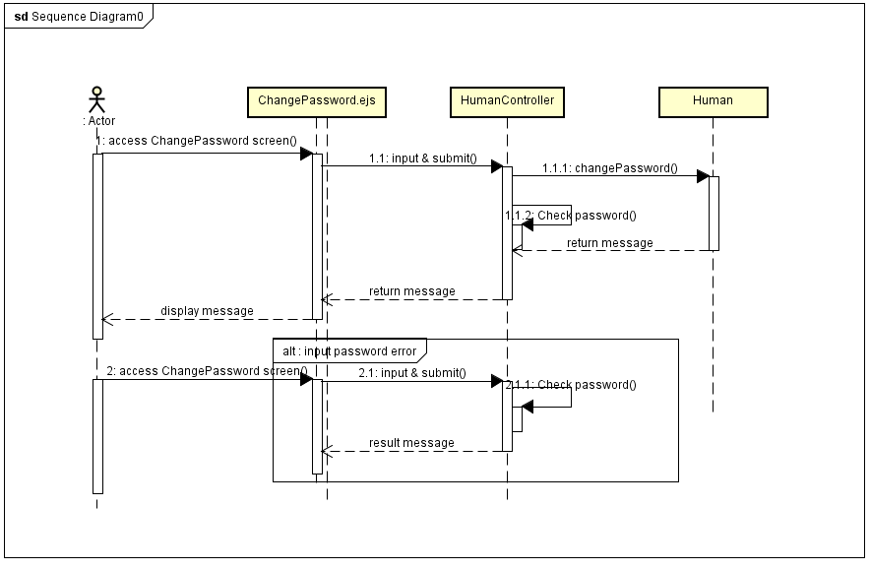

1. Change Password

##### Update Information

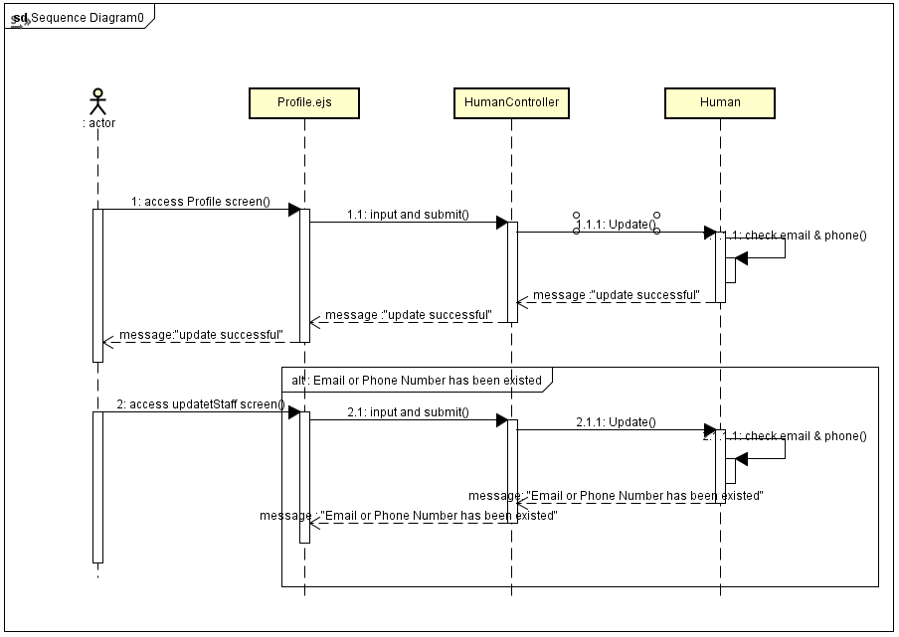

1. Update Information

## Data design

### Entity Relationship Diagram - ER図

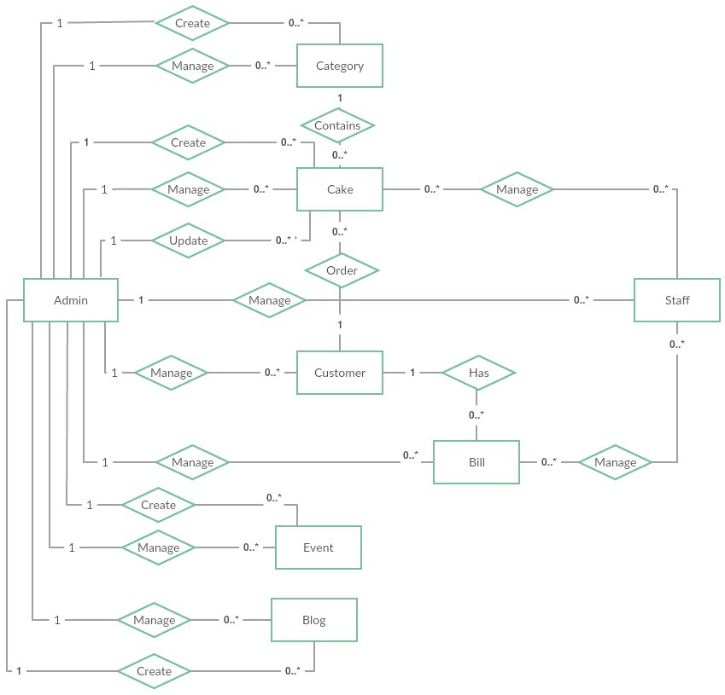

1. Entity Relationship Diagram

#### Entity description

|  |  |  |
| --- | --- | --- |
| No | Entity | Description |
|  | Admin | Manager of the store |
|  | Staff | Shop staff |
|  | Customer | Customer is all people who using BSO |
|  | Event | An event created by the manager includes the image content to describe |
|  | Cake | Cake is a kind of item |
|  | Blog | An blog created by the manager includes the image content to describe |
|  | Category | A category which customer use to filter cake |
|  | Bill | Managers and Customer use to review transaction history |

1. Entity description

#### Relationship

|  |  |  |  |  |  |
| --- | --- | --- | --- | --- | --- |
| No | Relation | Properties | From | To | Description |
|  | CONTAINS | None | Category | Cake | A category contains many cakes |
|  | MANAGE | None | Staff | Cake | The staff used to check information about the cake |
|  | MANAGE | None | Staff | Bill | Staff to check their order |
|  | MANAGE | None | Admin | Category | The manager used to manage information about the category |
|  | MANAGE | None | Admin | Staff | The manager used to manage information about the staff |
|  | MANAGE | None | Admin | Cake | The manager used to manage information about the cake |
|  | MANAGE | None | Admin | Customer | The manager used to check information about the user |
|  | MANAGE | None | Admin | Bill | The manager used to manage information about the bill |
|  | MANAGE | None | Admin | Event | The manager used to manage information about the event |
|  | MANAGE | None | Admin | Blog | The manager used to manage information about the blog |
|  | CREATE |  | Admin | Category | Manager adds new category |
|  | CREATE |  | Admin | Cake | Manager adds new cake |
|  | CREATE |  | Admin | Event | Manager adds new event |
|  | CREATE |  | Admin | Blog | Manager adds new blog |
|  | UPDATE |  | Admin | Cake | Manager update information of cake |
|  | ORDER |  | Customer | Cake | Customer use to order cake |
|  | HAS |  | Customer | Bill | Customer to view transaction history |

1. Relationship description

### Table Diagram

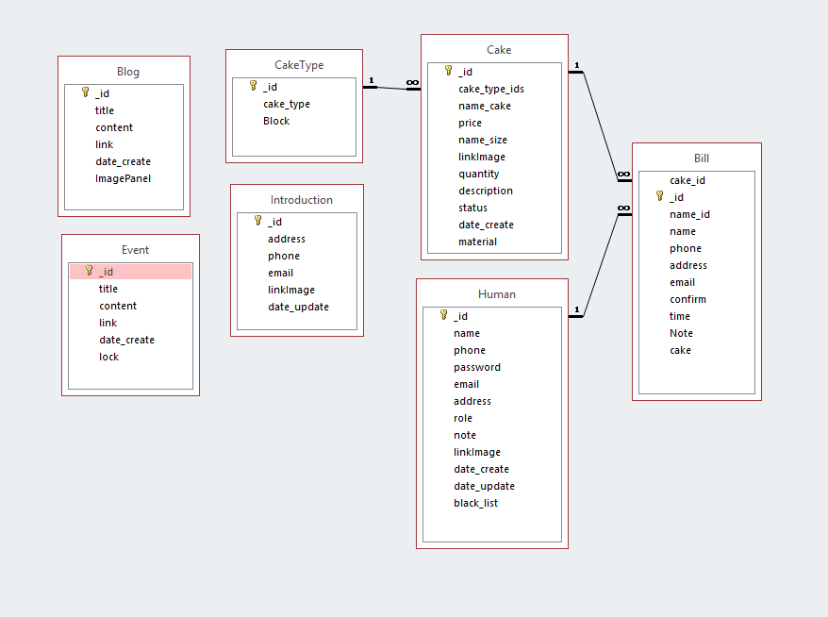

1. Table Diagram

#### Bill table

|  |  |  |  |  |
| --- | --- | --- | --- | --- |
| No | Field Name | Type | Allow Null | Description |
| 1 | _id | ObjectId | No | id of Bill |
| 2 | cake_id | ObjectId |  | id of Cake |
| 3 | name_id | ObjectId |  | id of Customer |
| 4 | name | String | No | name of Customer |
| 5 | phone | String | No | phone number of Customer |
| 6 | address | String | No | shipping address for Cusomer |
| 7 | email | String |  | email of Customer |
| 8 | confirm | Boolean |  | confirm has been shipped |
| 9 | time | Date | No | time order cake |
| 10 | Note | String |  | note for staff |
| 11 | cake | Array | No | information of order detail |

1. Bill table

#### Blog table

|  |  |  |  |  |
| --- | --- | --- | --- | --- |
| No | Field Name | Type | Allow Null | Description |
| 1 | _id | ObjectId | No | id of Blog |
| 2 | title | String | No | title of Blog |
| 3 | content | String | No | content of Blog |
| 4 | link | String | No | image link of content's Blog |
| 5 | date_create | Date | No | time create blog |
| 6 | ImagePanel | String | NO | imge link of panel's Blog |

1. Blog table

#### Cake table

|  |  |  |  |  |
| --- | --- | --- | --- | --- |
| No | Field Name | Type | Allow Null | Description |
| 1 | _id | ObjectId | No | id of Cake |
| 2 | cake_type_ids | ObjectId | No | id of Category |
| 3 | name_cake | String | No | name of Cake |
| 4 | price | String | No | price of Cake |
| 5 | name_size | String | No | size of Cake |
| 6 | linkImage | String | No | link Image of Cake |
| 7 | quantity | String | No | quantity of Cake exist |
| 8 | description | String | No | description about Cake |
| 9 | status | Boolean | No | status of Cake sell |
| 10 | date_create | Date | No | time create Cake |
| 11 | material | Array | No | material of Cake |

1. Cake table

#### CakeType table

|  |  |  |  |  |
| --- | --- | --- | --- | --- |
| No | Field Name | Type | Allow Null | Description |
| 1 | _id | ObjectId | No | id of Category |
| 2 | cake_type | String | No | name of Category |
| 3 | Blocked | Boolean | No | status of Category |

1. CakeType table

#### Event table

|  |  |  |  |  |
| --- | --- | --- | --- | --- |
| No | Field Name | Type | Allow Null | Description |
| 1 | _id | ObjectId | No | id of event |
| 2 | title | String | No | title of event |
| 3 | content | String | No | content of event |
| 4 | link | String | No | link image of event |
| 5 | date_create | Date | No | time create event |
| 6 | lock | Boolean | No | status of event |

1. Event table

#### Human table

|  |  |  |  |  |
| --- | --- | --- | --- | --- |
| No | Field Name | Type | Allow Null | Description |
| 1 | _id | ObjectId | No | id of User |
| 2 | name | String | No | name of User |
| 3 | phone | String | No | phone number of User |
| 4 | password | String | No | password of User |
| 5 | email | String | No | email of User |
| 6 | address | String | No | address of User |
| 7 | role | Int | No | role of User |
| 8 | note | String |  | note for Manage |
| 9 | linkImage | String | No | link Image of User |
| 10 | date_create | Date | No | time create Account |
| 11 | date_update | Date | No | time update Account |
| 12 | black_list | Boolean | No | blocked Account |

1. Human table

#### Introduction table

|  |  |  |  |  |
| --- | --- | --- | --- | --- |
| No | Field Name | Type | Allow Null | Description |
| 1 | _id | ObjectId | No | id of store |
| 2 | address | String | No | name of store |
| 3 | phone | String | No | phone number of store |
| 4 | email | String | No | password of store |
| 5 | linkImage | String | No | linkImage map of store |
| 10 | date_update | Date | No | time update Introduction |

1. Introduction table

## Screen Design

### User

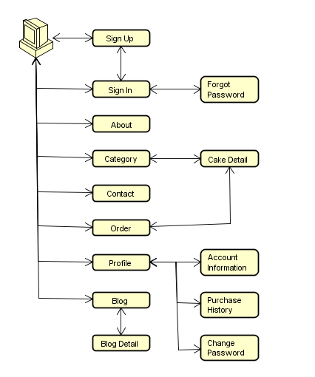

1. User screen flow

#### Sign In

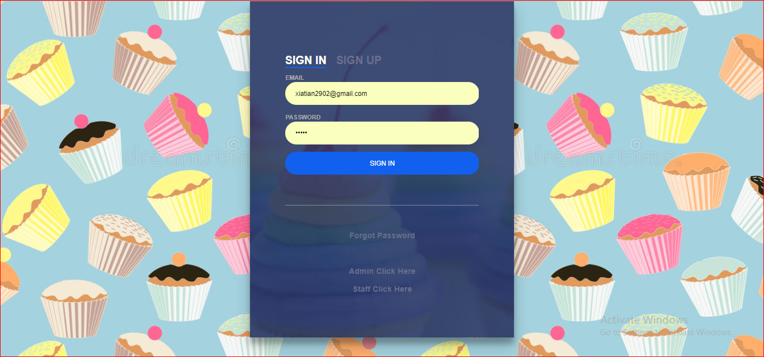

1. Login **screen**

|  |  |  |  |  |  |  |
| --- | --- | --- | --- | --- | --- | --- |
| No | Field name | Type | Require | Mandatory | Max-Length | Description |
| 1 | Sign in | Label | Click | Y |  | From Sign in |
| 2 | Sign up | Label | Click | Y |  | From Sign up |
| 3 | Email | Text box | Email | Y |  | Email of User |
| 4 | Password | Text box | Type | Y |  | Password |
| 5 | Sign in | Button | Click | Y |  | Login |
| 6 | Forgot Pasword | Link | Click | Y |  | Forgot Password |
| 7 | Admin click here | Link | Click | Y |  | Go to Admin |
| 8 | Staff click here | Link | Click | Y |  | Go to Staff |

1. R**egister** screen

#### Sign up

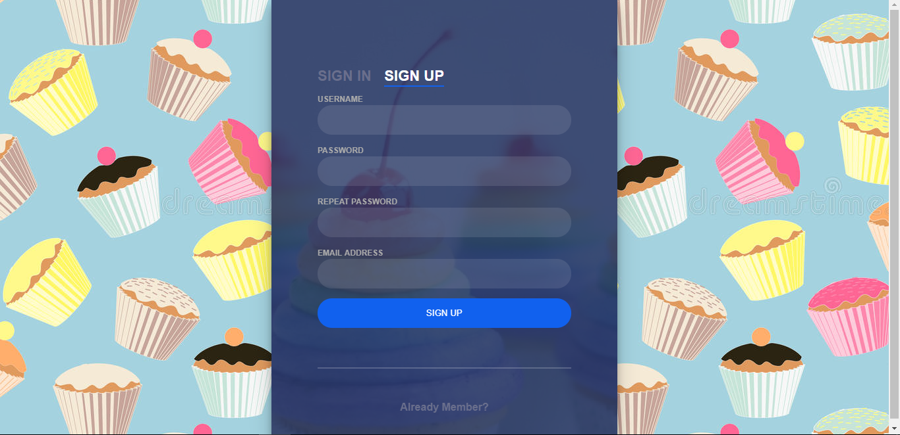

1. Sign up Screen

|  |  |  |  |  |  |  |
| --- | --- | --- | --- | --- | --- | --- |
| No | Field name | Type | Require | Mandatory | Max-Length | Description |
| 1 | Sign in | Label | Click | Y |  | From Sign in |
| 2 | Sign up | Label | Click | Y |  | From Sign up |
| 3 | UserName | Text |  | Y |  | User Name |
| 4 | Password | Text | Password | Y |  | Password |
| 5 | Repeat Password | Text | Pass word |  |  | Repeat Password |
| 6 | Email | Text | Email | Y |  | Email of User |
| 7 | Sign up | Button | Click | Y |  | Sign up |
| 8 | Already Member | Link | Click | Y |  | Back to Sign In |

1. Sign Up Screen

#### Forgot Password

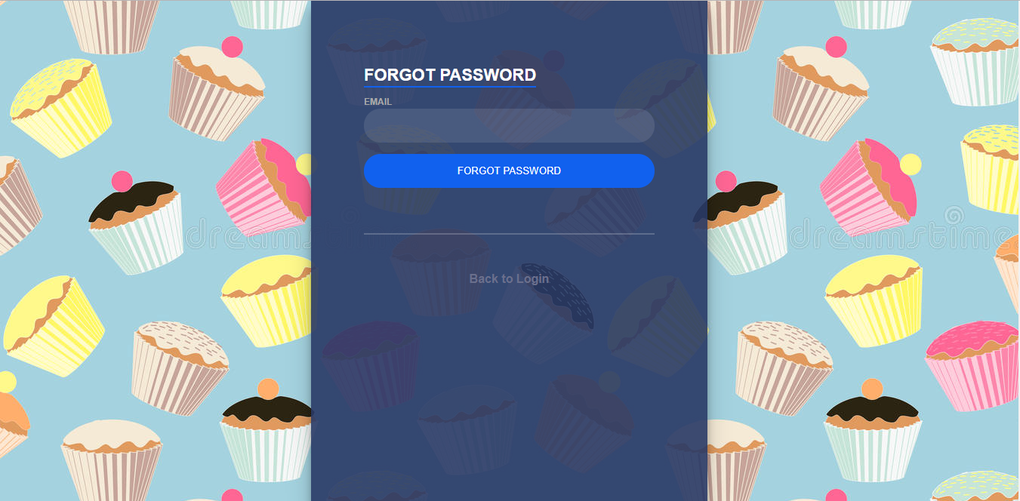

1. Forgot Password

|  |  |  |  |  |  |  |
| --- | --- | --- | --- | --- | --- | --- |
| No | Field name | Type | Require | Mandatory | Max-Length | Description |
| 1 | Email | Text box | Email | Y |  | Email |
| 2 | Forgot Password | Button | Click | Y |  | Forgot Password |
| 3 | Back to login | Link | Click | Y |  | Back to login |

1. Forgot Password

#### Home

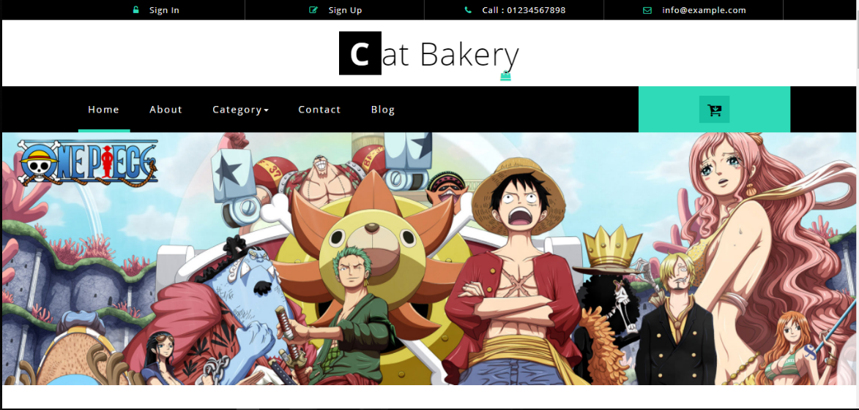

1. Home screen 1

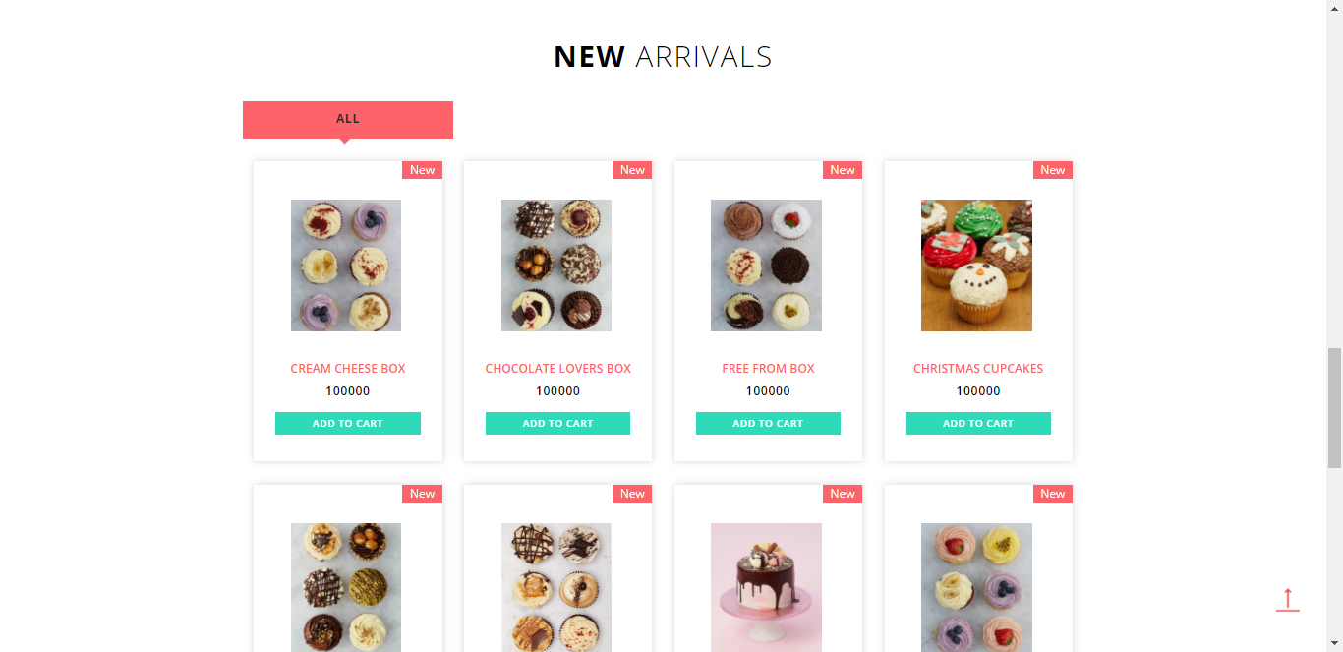

1. Home screen 2

|  |  |  |  |  |  |  |
| --- | --- | --- | --- | --- | --- | --- |
| No | Field name | Type | Require | Mandatory | Max-Length | Description |
| 1 | Home | Tab | Click | Y |  | Home Page |
| 2 | About | Tab | Click | Y |  | About Shop |
| 3 | Category | Drowdownlist | Click | Y |  | Display category of cake |
| 4 | Contact | Tab | Click | Y |  | Contact of shop |
| 5 | Icon shopping cart | Button | Click | Y |  | Display shopping cart |
| 6 | Event | Panel | Click | Y |  | Display event detail |
| 7 | List new arrival |  | Click | Y |  | Display cake detail |
| 8 | Add to cart | Button | Click | Y |  | Add to shopping cart |

1. Home Screen 2

#### About

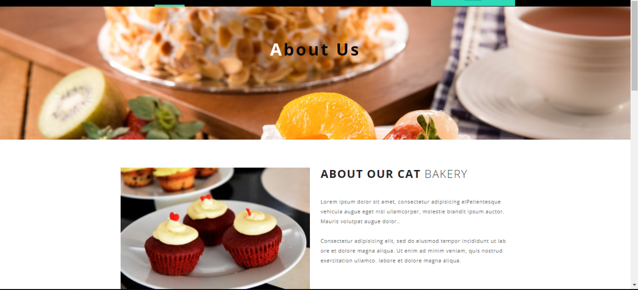

1. About Us screen

|  |  |  |  |  |  |  |
| --- | --- | --- | --- | --- | --- | --- |
| No | Field name | Type | Require | Mandatory | Max-Length | Description |
| 1 | Home | Tab | Click | Y |  | Home Page |
| 2 | About | Tab | Click | Y |  | About Shop |
| 3 | Category | Drowdownlist | Click | Y |  | Display category of cake |
| 4 | Contact | Tab | Click | Y |  | Contact of shop |
| 5 | Icon shopping cart | Button | Click | Y |  | Display shopping cart |
| 6 | About our cat bakery | Label |  | Y |  | About us |

1. About Us

#### Category

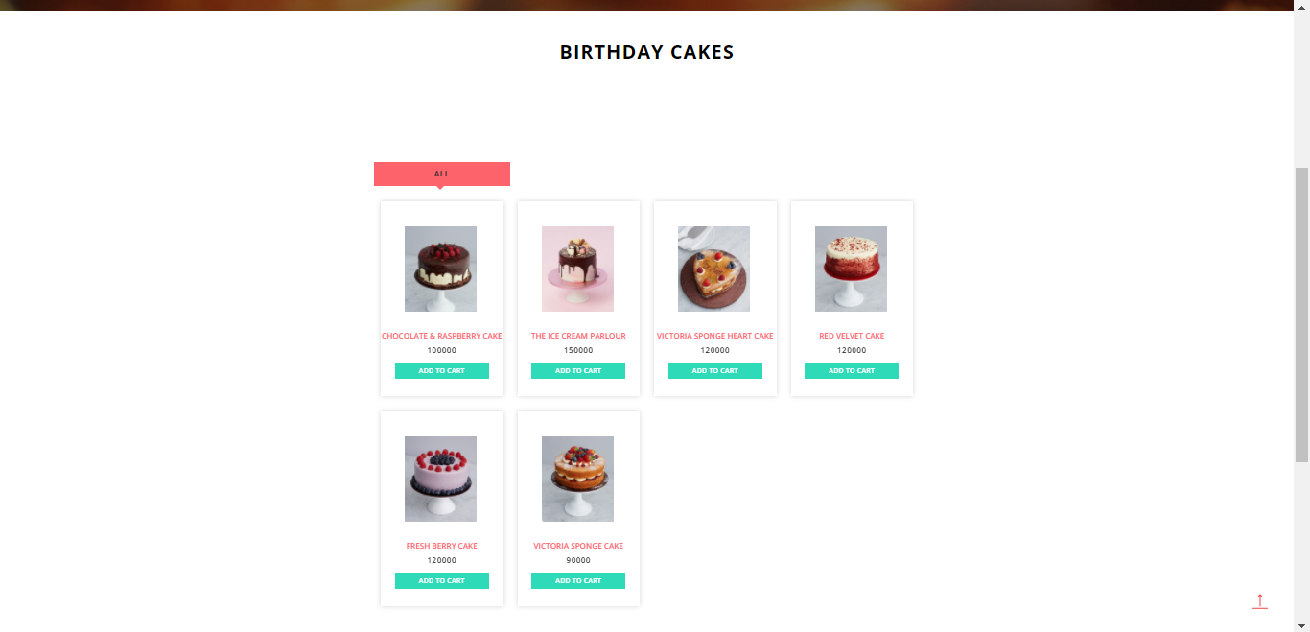

1. Category screen

|  |  |  |  |  |  |  |
| --- | --- | --- | --- | --- | --- | --- |
| No | Field name | Type | Require | Mandatory | Max-Length | Description |
| 1 | Home | Tab | Click | Y |  | Home Page |
| 2 | About | Tab | Click | Y |  | About Shop |
| 3 | Category | Drowdownlist | Click | Y |  | Display category of cake |
| 4 | Contact | Tab | Click | Y |  | Contact of shop |
| 5 | Icon shopping card | Button | Click | Y |  | Display shopping card |
| 6 | Event | Panel | Click | Y |  | Display event detail |
| 7 | List new arrival |  | Click | Y |  | Display cake detail |
| 8 | Add to cart | Button | Click | Y |  | Add to shopping cart |

1. Category

#### Contact

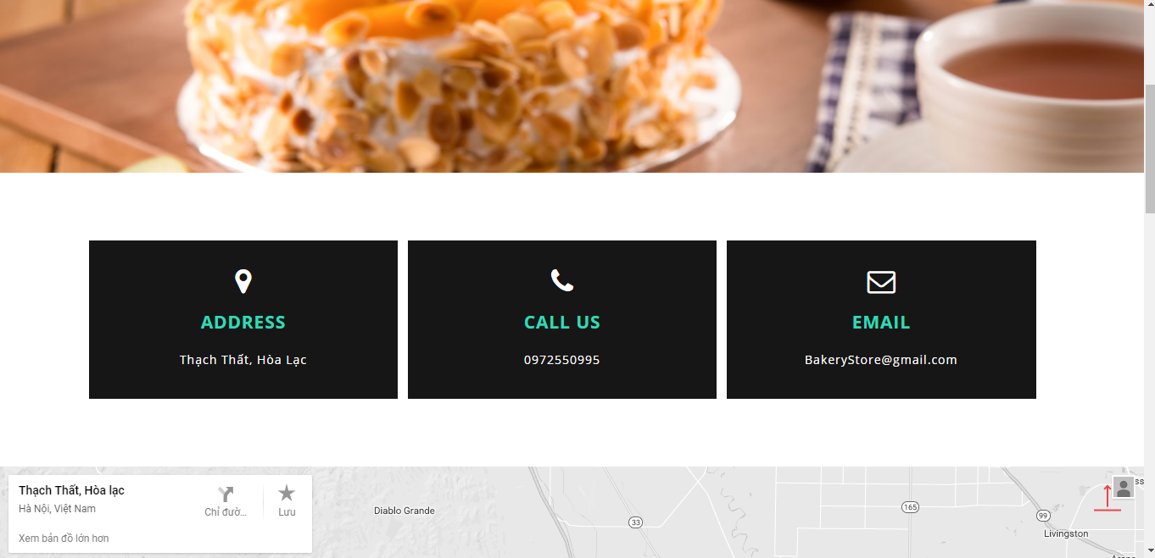

1. Contact Screen

|  |  |  |  |  |  |  |
| --- | --- | --- | --- | --- | --- | --- |
| No | Field name | Type | Require | Mandatory | Max-Length | Description |
| 1 | Home | Tab | Click | Y |  | Home Page |
| 2 | About | Tab | Click | Y |  | About Shop |
| 3 | Category | Drowdownlist | Click | Y |  | Display category of cake |
| 4 | Contact | Tab | Click | Y |  | Contact of shop |
| 5 | Icon shopping cart | Button | Click | Y |  | Display shopping cart |
| 6 | Contact Us | Label |  | Y |  | Contact Us |

1. Contact

#### Order

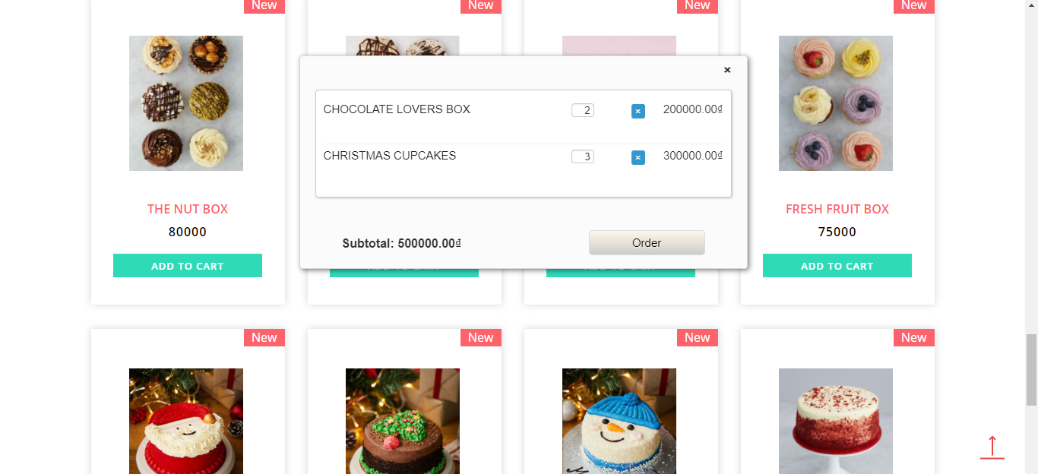

1. Shopping Cart Screen

|  |  |  |  |  |  |  |
| --- | --- | --- | --- | --- | --- | --- |
| No | Field name | Type | Require | Mandatory | Max-Length | Description |
| 1 | List cake | Table |  | Y |  | List cake |
| 2 | Text box | Text |  | Y |  | Input quantiry of cake |
| 3 | Icon (x) | Button | Click | Y |  | Remove Cake |
| 4 | Subtotal | Text |  | Y |  | Price total |
| 5 | Order | Button | Click | Y |  | Order |

1. Shopping Cart

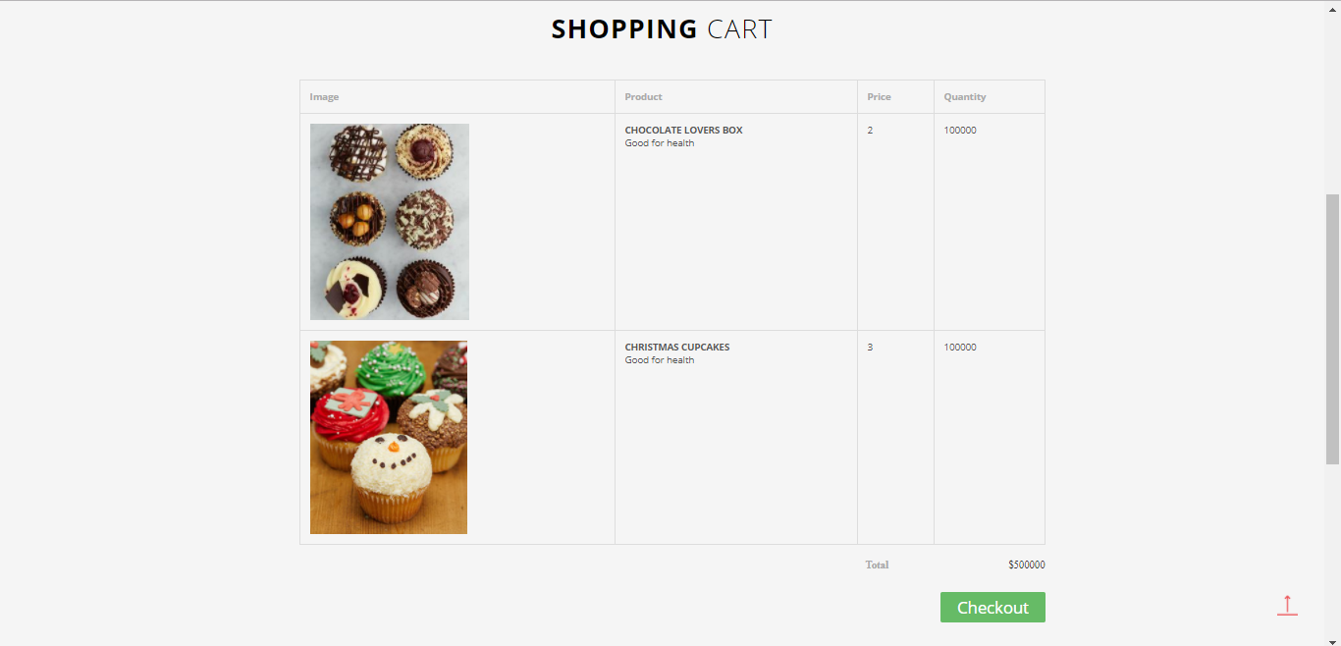

1. Shopping Cart Detail Screen

|  |  |  |  |  |  |  |
| --- | --- | --- | --- | --- | --- | --- |
| No | Field name | Type | Require | Mandatory | Max-Length | Description |
| 1 | Home | Tab | Click | Y |  | Home Page |
| 2 | About | Tab | Click | Y |  | About Shop |
| 3 | Category | Drowdownlist | Click | Y |  | Display category of cake |
| 4 | Contact | Tab | Click | Y |  | Contact of shop |
| 5 | Icon shopping cart | Button | Click | Y |  | Display shopping cart |
| 6 | List Cake | Table |  | Y |  | List Cake |
| 7 | Total | Text |  | Y |  | Price total |
| 8 | Checkout | Button | Click | Y |  | Check out |

1. Shopping Cart Detail

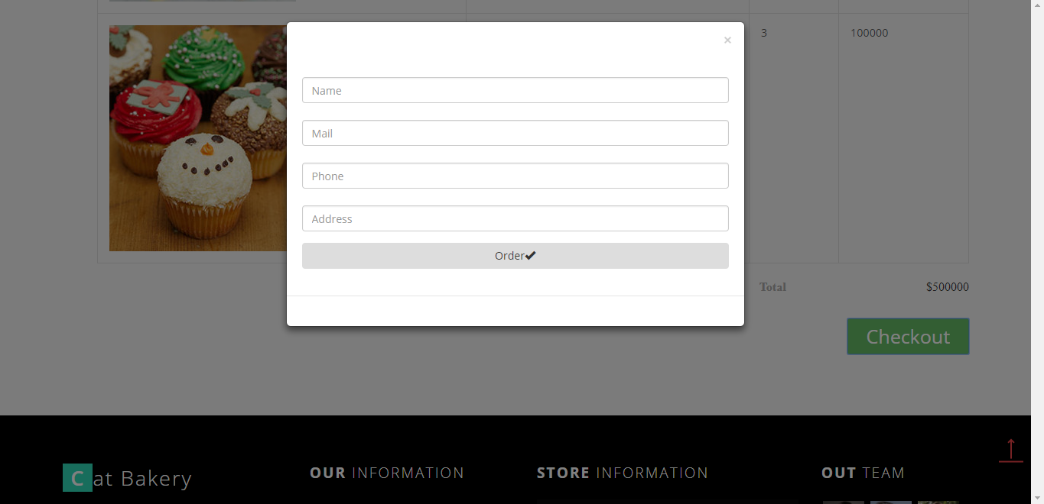

1. Checkout Screen

|  |  |  |  |  |  |  |
| --- | --- | --- | --- | --- | --- | --- |
| No | Field name | Type | Require | Mandatory | Max-Length | Description |
| 1 | Name | Text |  | Y |  | Name of Customer |
| 2 | Mail | Text |  | Y |  | Mail of Customer |
| 3 | Phone | Text |  | Y |  | Phone of Customer |
| 4 | Address | Text |  | Y |  | Address of Customer |
| 5 | Order | Button | Click |  |  | Order |

1. Check out

#### Profile

##### Account information

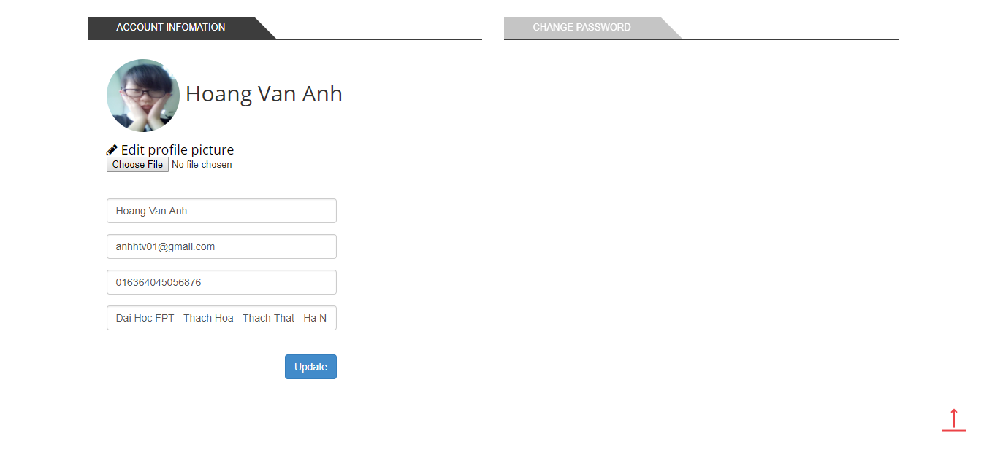

1. Account Information screen

|  |  |  |  |  |  |  |
| --- | --- | --- | --- | --- | --- | --- |
| No | Field name | Type | Require | Mandatory | Max-Length | Description |
| 1 | Account Information | Tab | Click | Y |  | Tab Information of account |
| 2 | Purchase history | Tab | Click | Y |  | Tab purchase history |
| 3 | Change Password | Tab | Click | Y |  | Tab Change Password |
| 4 | Choose File | Button | Click | Y |  | Select Photo |
| 5 | Name Customer | Text |  | Y |  | Name of Customer |
| 6 | Email | Text |  | Y |  | Email of Customer |
| 7 | Phone Number | Text |  | Y |  | Phone of Customer |
| 8 | Address | Text |  | Y |  | Address of Customer |
| 9 | Update | Button | Click | Y |  | Update |

1. Account Information

##### Purchase history

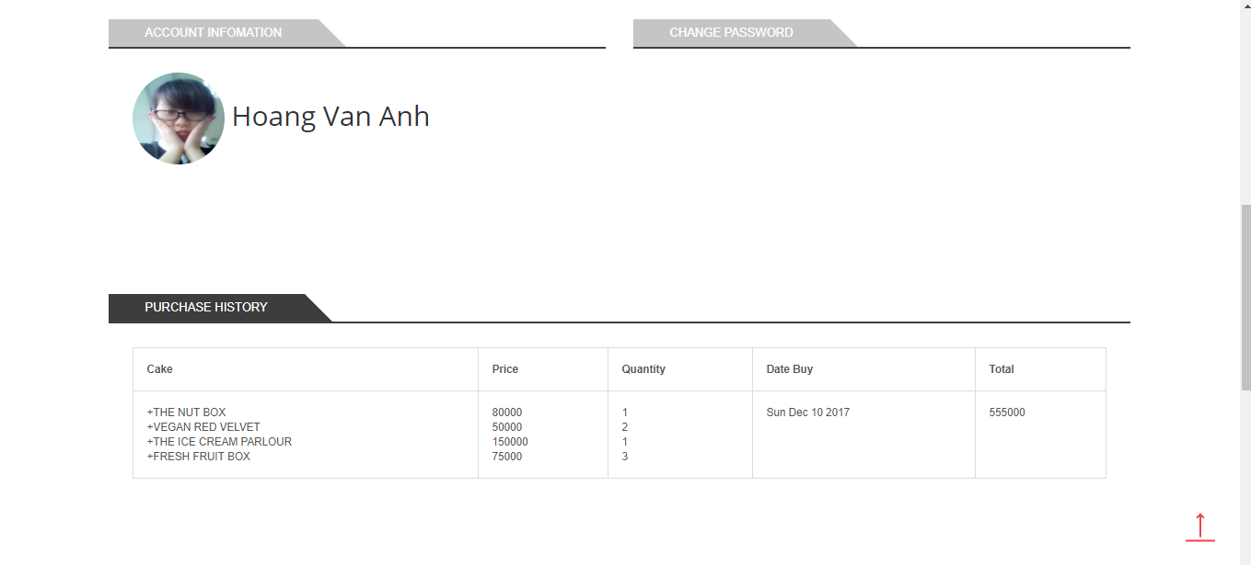

|  |  |  |  |  |  |  |
| --- | --- | --- | --- | --- | --- | --- |
| No | Field name | Type | Require | Mandatory | Max-Length | Description |
| 1 | Account Information | Tab | Click | Y |  | Information of account |
| 2 | Purchase History | Tab | Click | Y |  | Purchase History |
| 3 | Change Password | Tab | Click | Y |  | Change Password |
| 4 | List Purchase History | Table |  | Y |  | List Purchase History |

1. Purchase History Screen
2. Purchase History

##### Change Password

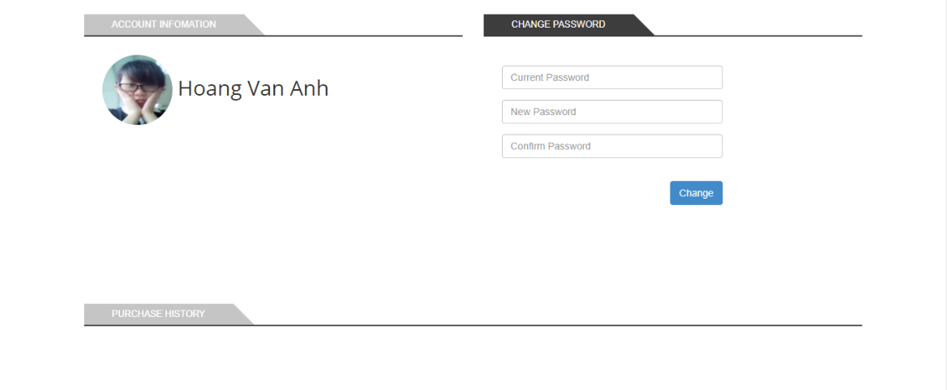

1. Change Password screen

|  |  |  |  |  |  |  |
| --- | --- | --- | --- | --- | --- | --- |
| No | Field name | Type | Require | Mandatory | Max-Length | Description |
| 1 | Old Password | Text |  | Y |  | Old Password |
| 2 | New Password | Text |  | Y |  | New Password |
| 3 | Repeat Password | Text |  | Y |  | Repeat Password |
| 4 | Change Password | Button | Click | Y |  | Change Password |

1. Change Password

#### Blog

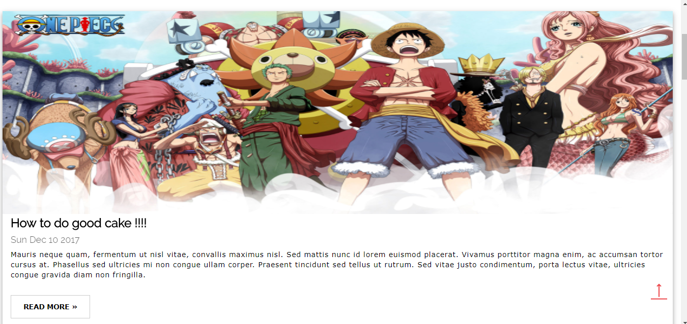

|  |  |  |  |  |  |  |
| --- | --- | --- | --- | --- | --- | --- |
| No | Field name | Type | Require | Mandatory | Max-Length | Description |
| 1 | List Blog | List |  | Y |  | List blog |
| 2 | Read more | Button | Click | Y |  | View Detail |

1. Blog Screen
2. Blog

##### Blog Detail

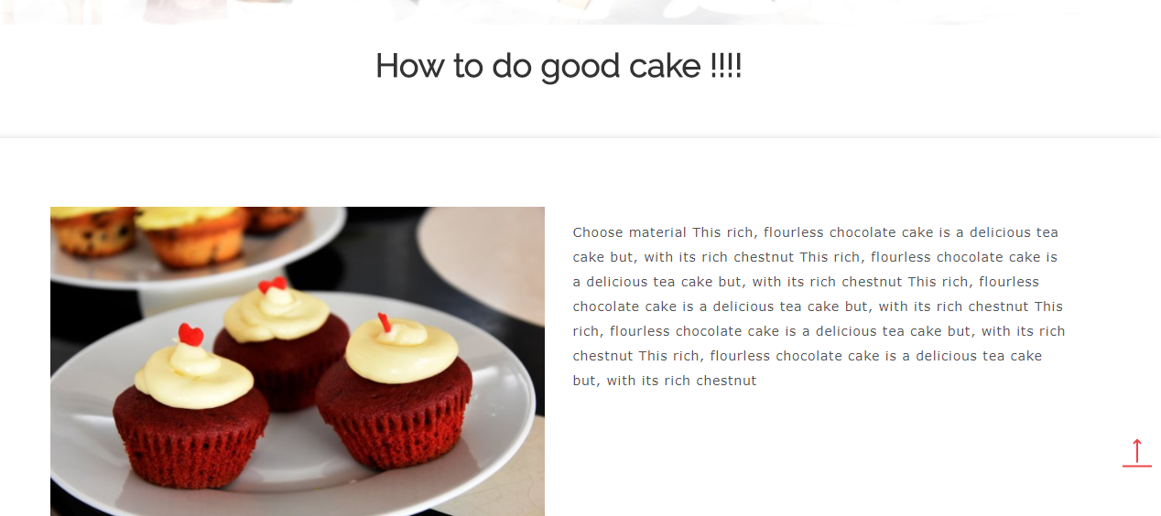

1. Blog Detail

### ADMIN

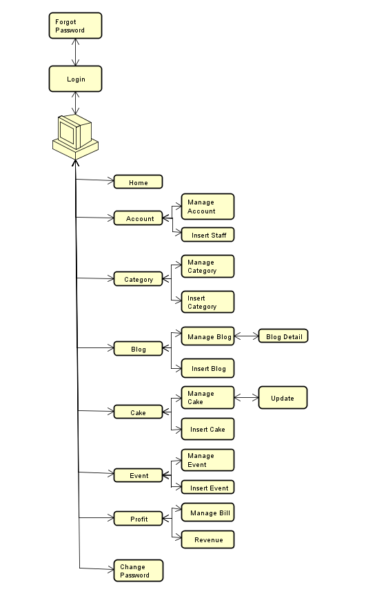

1. Admin screen flow

#### Sign In

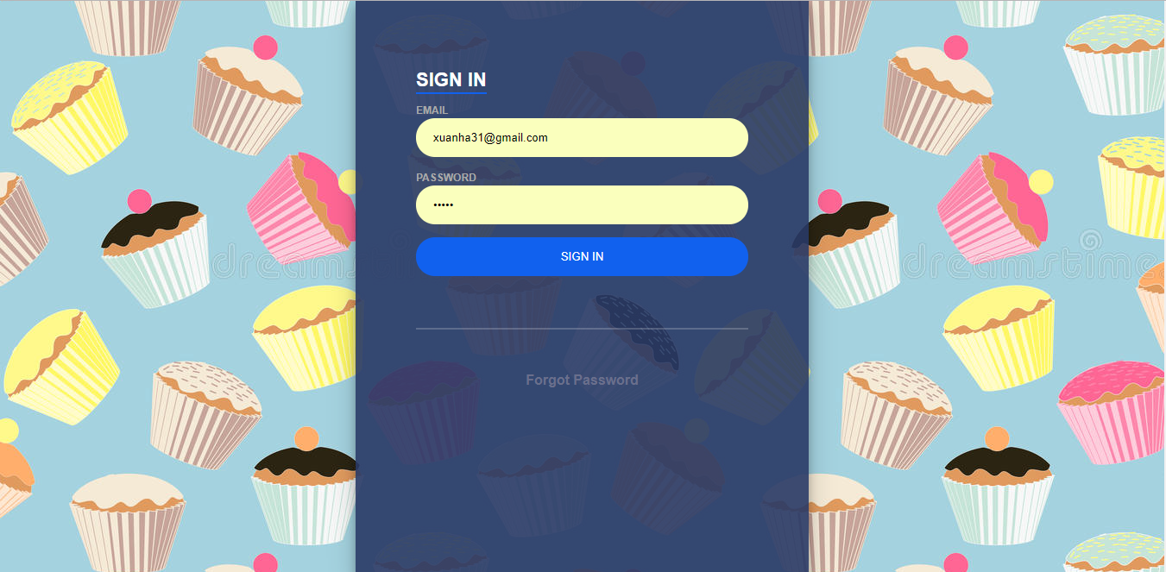

1. Login screen

|  |  |  |  |  |  |  |
| --- | --- | --- | --- | --- | --- | --- |
| No | Field name | Type | Require | Mandatory | Max-Length | Description |
| 1 | Email | Text box | Email | Y |  | Email of Admin |
| 2 | Password | Text box | Type | Y |  | Password of Admin |
| 3 | Sign in | Button | Click | Y |  | Login |
| 4 | Forgot Pasword | Link | Click | Y |  | Forgot Password |

1. Login

#### Forgot Password



1. Forgot Password screen

|  |  |  |  |  |  |  |
| --- | --- | --- | --- | --- | --- | --- |
| No | Field name | Type | Require | Mandatory | Max-Length | Description |
| 1 | Email | Text box | Email | Y |  | Email |
| 2 | Forgot Password | Button | Click | Y |  | Forgot Password |
| 3 | Back to login | Link | Click | Y |  | Back to login |

1. Forgot Password

#### Account

##### Manage Account

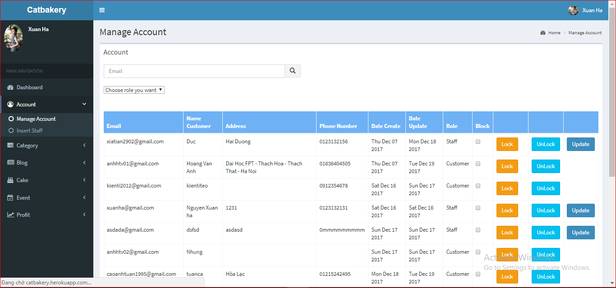

1. Manage Account screen

|  |  |  |  |  |  |  |
| --- | --- | --- | --- | --- | --- | --- |
| No | Field name | Type | Require | Mandatory | Max-Length | Description |
| 1 | Search | Input Text | Input Phone number | Y |  | Search by phone number of account |
| 2 | Icon Search | Button | Click | Y |  | Icon Search |
| 3 | Choose role you want | Drop Downlist | Click | Y |  | Search by role |
| 4 | List Account | Table |  | Y |  | List Account |
| 5 | Block | Check box |  | Y |  | Block account |
| 6 | Lock | Button | Click | Y |  | Button Lock Account |
| 7 | Unlock | Button | Click | Y |  | Button Unlock Account |

1. Table 2.13.1: Manage Account

##### Insert Staff

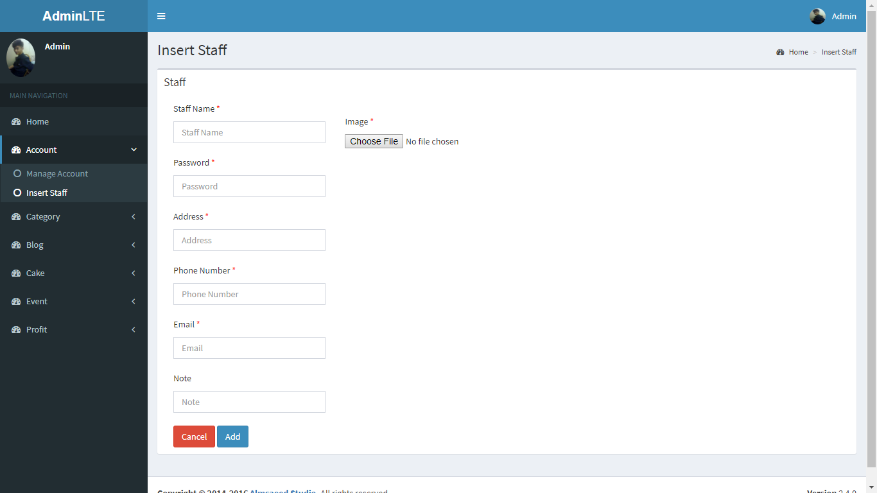

1. Insert Staff screen

|  |  |  |  |  |  |  |
| --- | --- | --- | --- | --- | --- | --- |
| No | Field name | Type | Require | Mandatory | Max-Length | Description |
| 1 | Staff name | Text |  | Y |  | Staff name |
| 2 | Password | Text |  | Y |  | Password of staff |
| 3 | Address | Text |  | Y |  | Address of staff |
| 4 | Phone Number | Text |  | Y |  | Phone Number of Staff |
| 5 | Email | Text |  | Y |  | Email of staff |
| 6 | Note | Text |  | N |  | Other information |
| 7 | Choose File | Button | Click | Y |  | Select photo |
| 8 | Cancel | Button | Click | Y |  | Cancel and back manage account page |
| 9 | Add | Button | Click | Y |  | Add Staff |

1. Insert Staff

#### Category

##### Manage Category

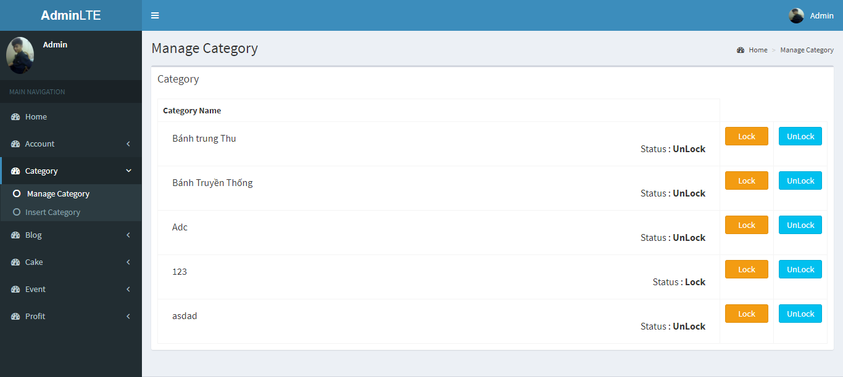

|  |  |  |  |  |  |  |
| --- | --- | --- | --- | --- | --- | --- |
| No | Field name | Type | Require | Mandatory | Max-Length | Description |
| 1 | List Category | Table |  | Y |  | List Category |
| 2 | Lock | Button |  | Y |  | Lock Category |
| 3 | UnLock | Button |  | Y |  | UnLock Category |

1. Mangage Category screen
2. Mangage Category

##### Insert Category

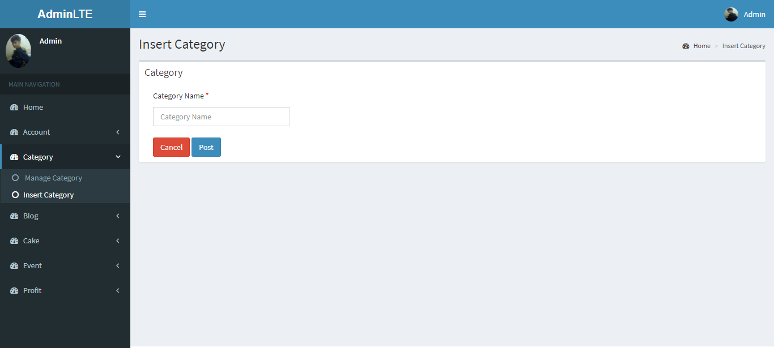

|  |  |  |  |  |  |  |
| --- | --- | --- | --- | --- | --- | --- |
| No | Field name | Type | Require | Mandatory | Max-Length | Description |
| 1 | Category Name | Text |  | Y |  | List projects |
| 2 | Cancle | Button | Click | Y |  | Cancle and back to manage category |
| 3 | Post | Button | Click | Y |  | Post Category |

1. Insert Category screen
2. Insert Catgegory

#### Blog

##### Manage Blog

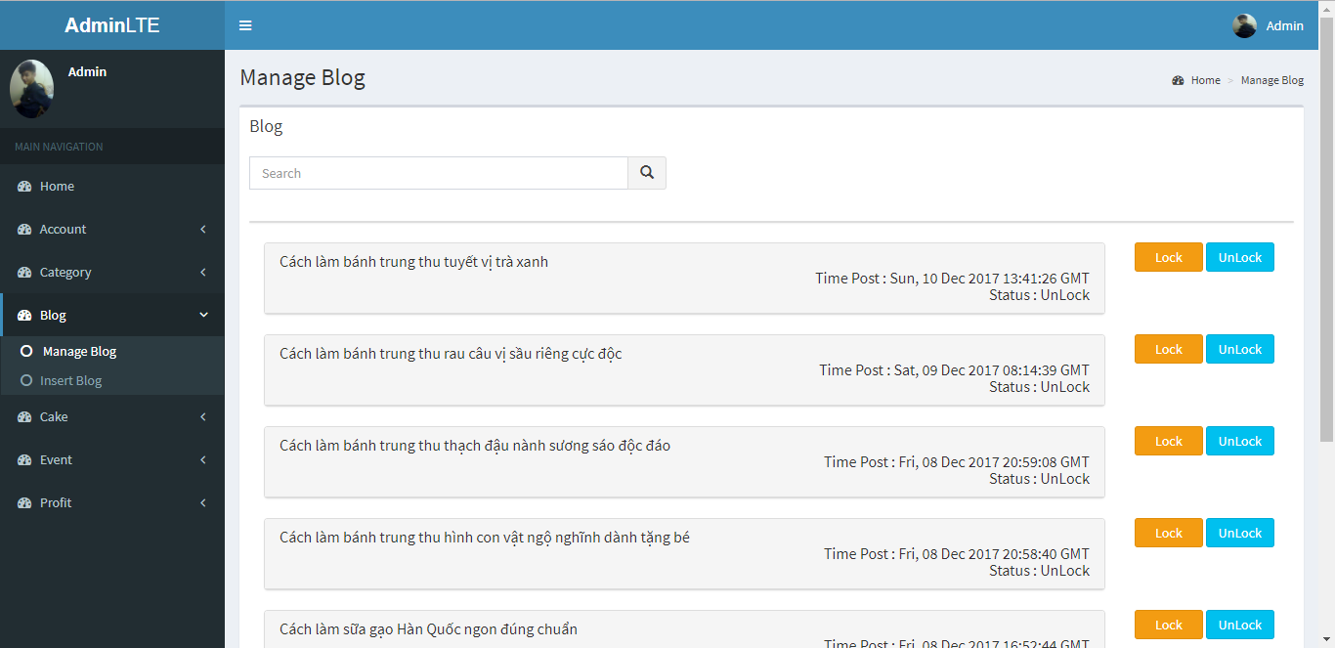

1. Manage Blog screen

|  |  |  |  |  |  |  |
| --- | --- | --- | --- | --- | --- | --- |
| No | Field name | Type | Require | Mandatory | Max-Length | Description |
| 1 | Search | Text |  | Y |  | Search by name blog |
| 2 | Search (icon) | Button | Click | Y |  | Icon search |
| 3 | List Blog | List | Click | Y |  | List blog (click to view detail blog |
| 4 | Lock | Button | Click | Y |  | Lock blog |
| 5 | UnLock | Button | Click | Y |  | Unlock blog |

1. Manage Blog

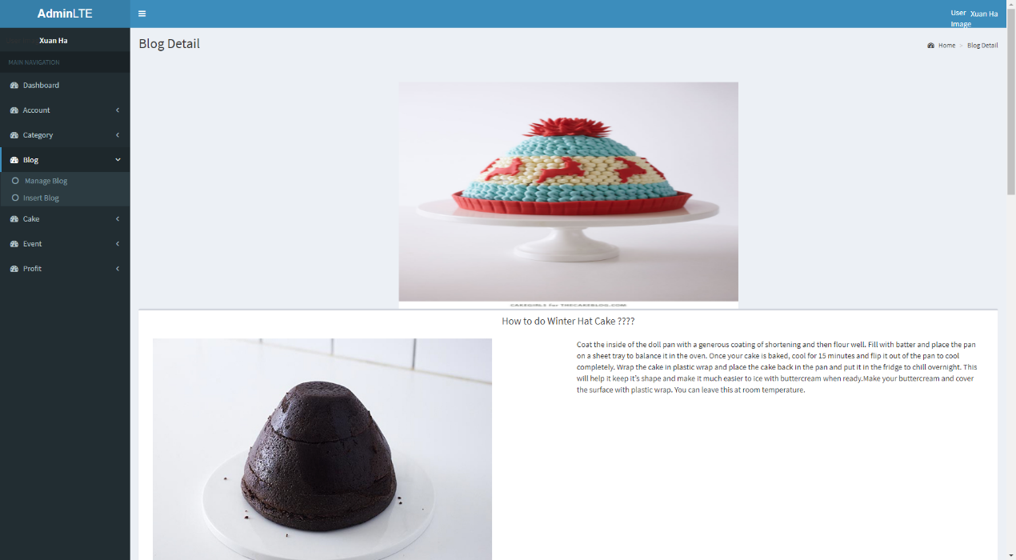

1. Blog Detail Screen

##### Insert Blog

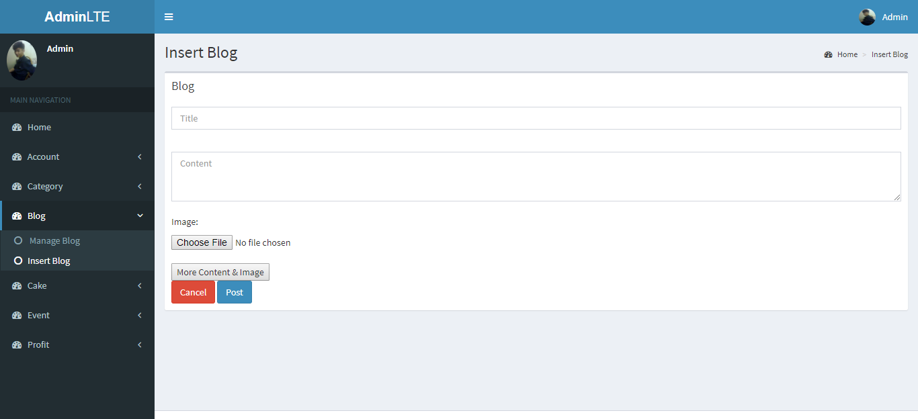

1. Insert Blog Screen

|  |  |  |  |  |  |  |
| --- | --- | --- | --- | --- | --- | --- |
| No | Field name | Type | Require | Mandatory | Max-Length | Description |
| 1 | Title | Text |  | Y |  | Title blog |
| 2 | Content | Text |  | Y |  | Content blog |
| 3 | Choose File | Button | Click | Y |  | Select Photo |
| 4 | More Content & Image | Button | Click |  |  | More Content and Image |
| 5 | Cancle | Button | Click | Y |  | Cancle and back to manage blog |
| 6 | Post | Button | Click | Y |  | Post Blog |

1. Insert Blog

#### Cake

##### Manage Cake

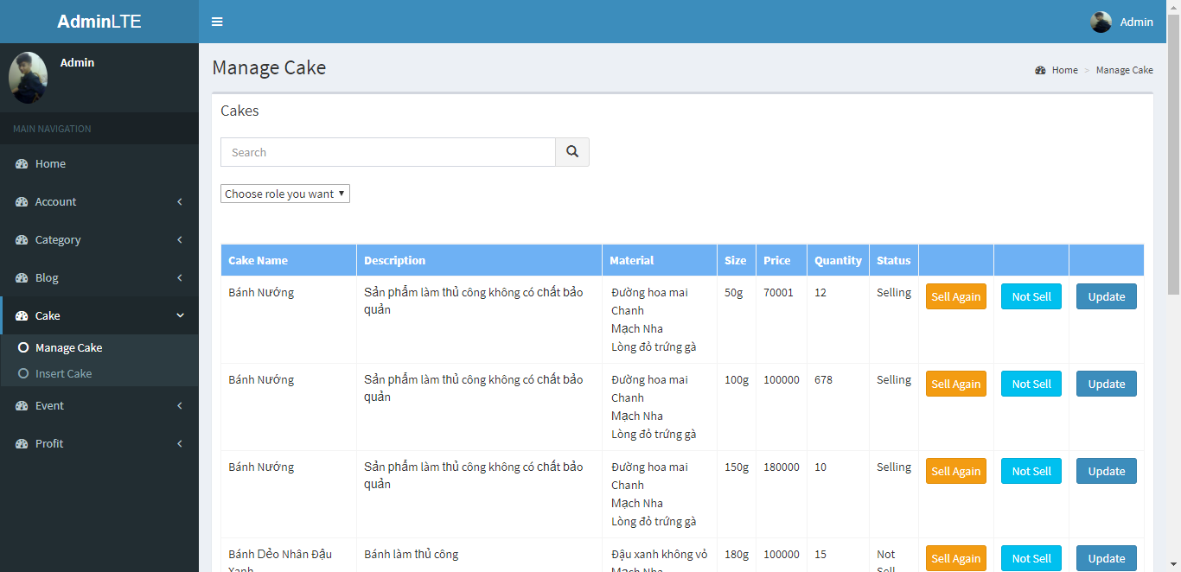

1. Manage Cake screen

|  |  |  |  |  |  |  |
| --- | --- | --- | --- | --- | --- | --- |
| No | Field name | Type | Require | Mandatory | Max-Length | Description |
| 1 | Search | Input Text |  | Y |  | Search by name |
| 2 | Icon Search | Button | Click | Y |  | Icon Search |
| 3 | Choose role you want | Drop Downlist | Click | Y |  | Search by role |
| 4 | List Cake | Table |  | Y |  | List Cake |
| 5 | Sell Again | Button | Click | Y |  | Updates Status |
| 6 | Not Sell | Button | Click | Y |  | Updates Status |
| 7 | Update | Button | Click | Y |  | Update cake |

1. Cake management

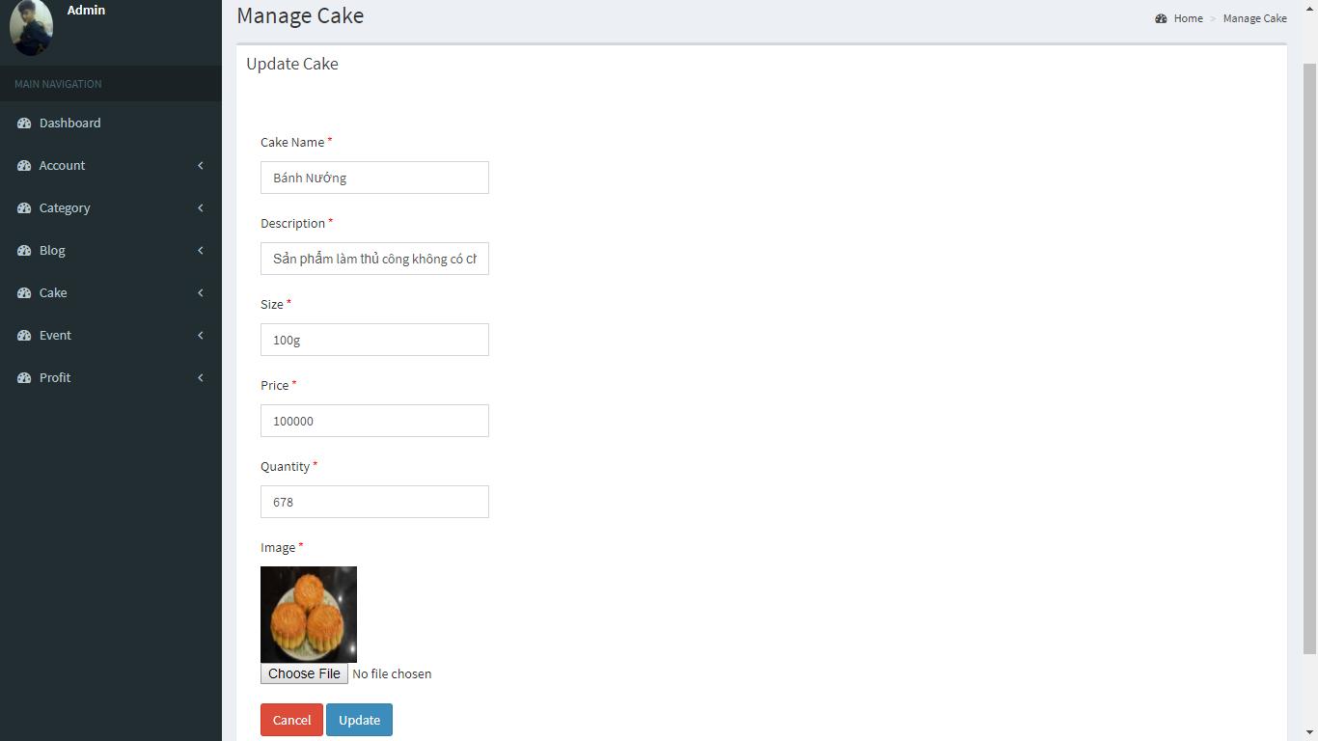

1. Updates Cake Screen

|  |  |  |  |  |  |  |
| --- | --- | --- | --- | --- | --- | --- |
| No | Field name | Type | Require | Mandatory | Max-Length | Description |
| 1 | Cake Name | Text |  | Y |  | Cake Name |
| 2 | Decsription | Text |  | Y |  | Decsription Cake |
| 3 | Size | Text |  | Y |  | Size Cake |
| 4 | Price | Text |  | Y |  | Price of cake |
| 5 | Quantity | Text |  | Y |  | Quantity |
| 6 | Choose File | Button | Click | Y |  | Select photo |
| 7 | Cancel | Button | Click | Y |  | Cancel and back manage Cake |
| 8 | Update | Button | Click | Y |  | Update cake |

1. Update cake

##### Insert Cake

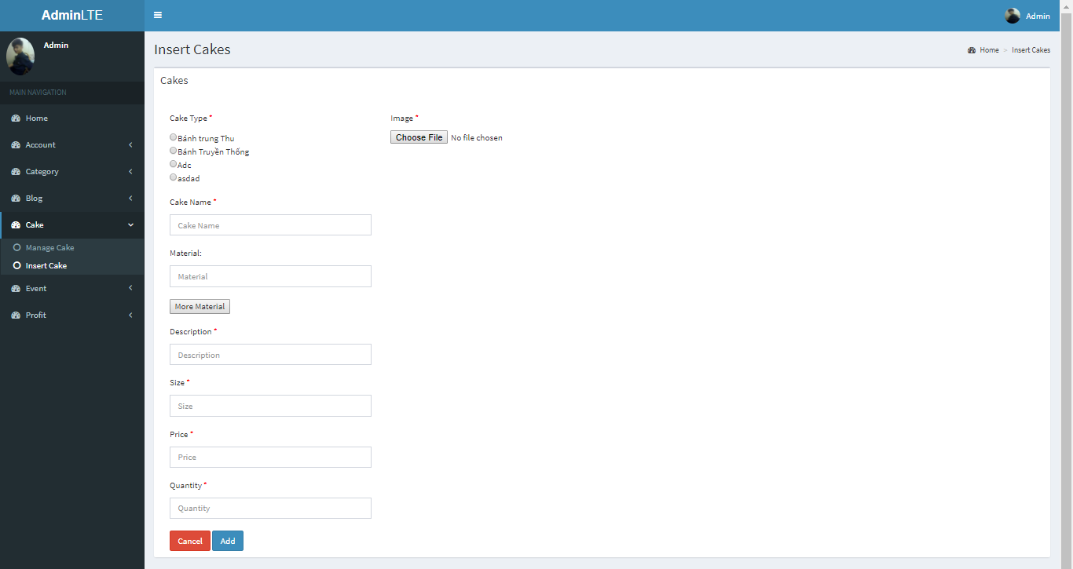

1. Insert Cake Screen

|  |  |  |  |  |  |  |
| --- | --- | --- | --- | --- | --- | --- |
| No | Field name | Type | Require | Mandatory | Max-Length | Description |
| 1 | Cake Type | Check box | Click | Y |  | Cake Type |
| 2 | Cake Name | Text |  | Y |  | Cake Name |
| 3 | Material | Text |  | Y |  | Material |
| 4 | More Material | Button | Click | Y |  | More Material |
| 5 | Description | Text |  | Y |  | Description cake |
| 6 | Size | Text |  | Y |  | Size cake |
| 7 | Price | Text |  | Y |  | Price of cake |
| 8 | Quantity | Text |  | Y |  | Quantity |
| 9 | Choose File | Button | Click | Y |  | Select photo |
| 10 | Cancel | Button | Click | Y |  | Cancel and back manage Cake |
| 11 | Add | Button | Click | Y |  | Add cake |

1. Insert Cake

#### Event

##### Manage Event

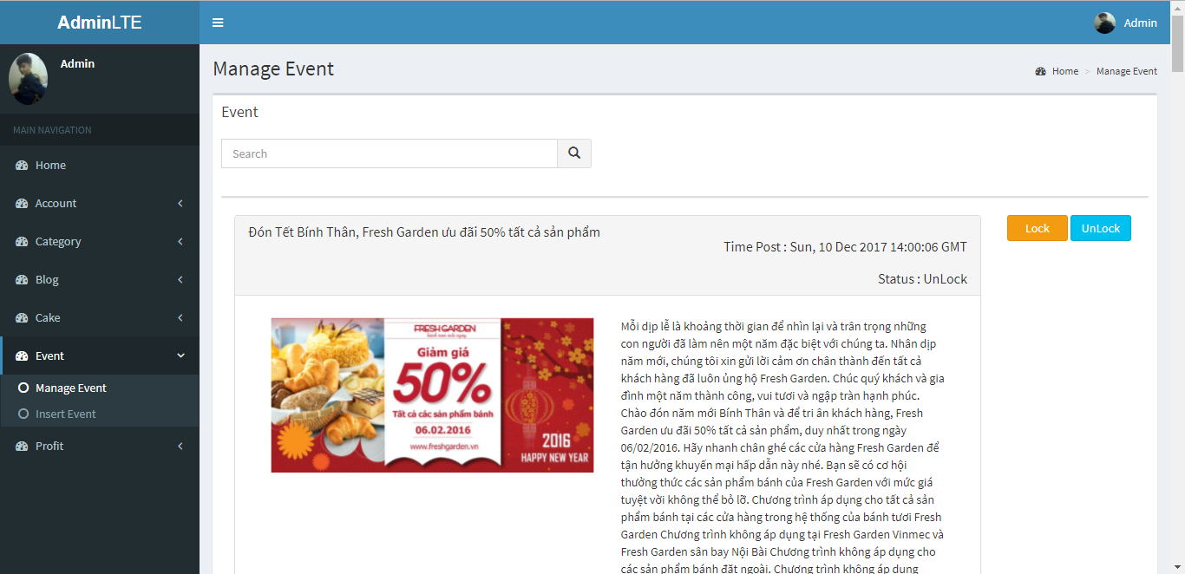

1. Manage Event screen

|  |  |  |  |  |  |  |
| --- | --- | --- | --- | --- | --- | --- |
| No | Field name | Type | Require | Mandatory | Max-Length | Description |
| 1 | Search | Text |  | Y |  | Search by name Event |
| 2 | Search (icon) | Button | Click | Y |  | Icon search |
| 3 | List Event | List |  | Y |  | List Event |
| 4 | Lock | Button | Click | Y |  | Lock Event |
| 5 | UnLock | Button | Click | Y |  | Unlock Event |

1. Manage Event

##### Insert Event

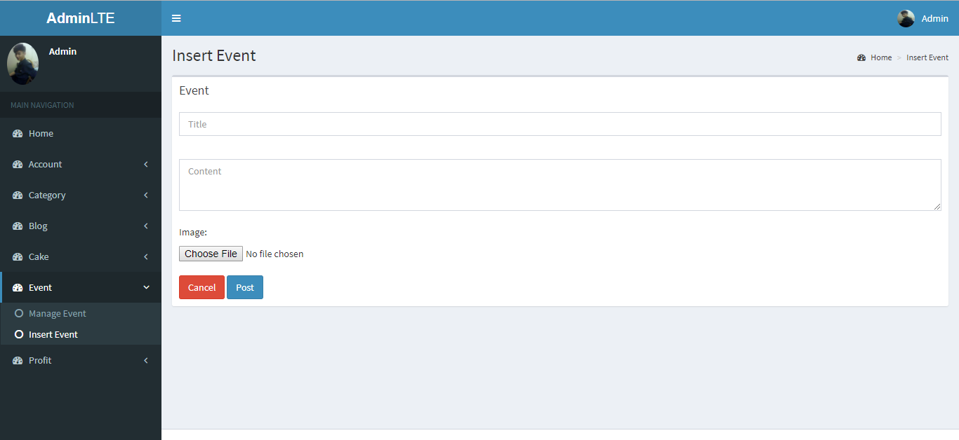

1. Insert Event screen

|  |  |  |  |  |  |  |
| --- | --- | --- | --- | --- | --- | --- |
| No | Field name | Type | Require | Mandatory | Max-Length | Description |
| 1 | Title | Text |  | Y |  | Title event |
| 2 | Content | Text |  | Y |  | Content event |
| 3 | Choose File | Button | Click | Y |  | Select Photo |
| 4 | Cancle | Button | Click | Y |  | Cancle and back to manage Event |
| 5 | Post | Button | Click | Y |  | Post Event |

1. Insert Event

#### Profit

##### Manage Bill

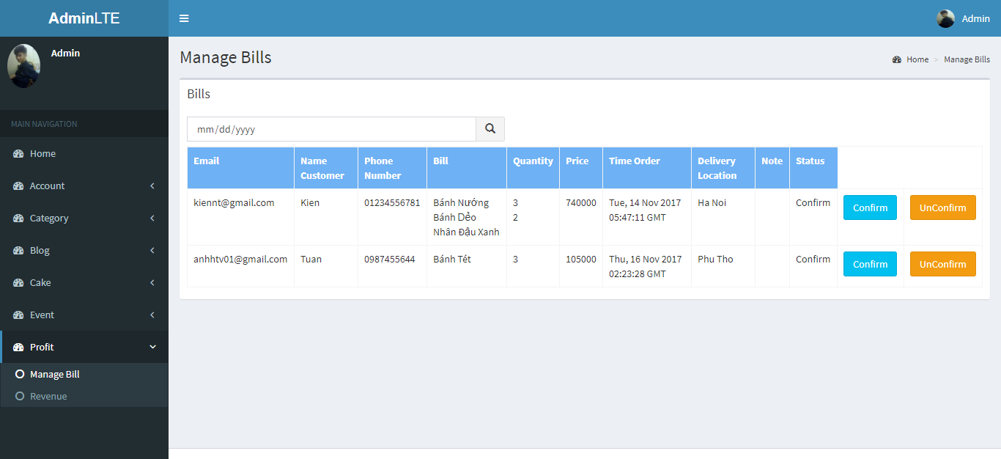

1. Manage Bill Screen

|  |  |  |  |  |  |  |
| --- | --- | --- | --- | --- | --- | --- |
| No | Field name | Type | Require | Mandatory | Max-Length | Description |
| 1 | Search | Date |  | Y |  | Search by date |
| 2 | Search (icon) | Button | Click | Y |  | Icon search |
| 3 | List Bill | Table |  | Y |  | List Bill |
| 4 | Confirm | Button |  | Y |  | Confirm bill |
| 5 | UnConfirm | Button |  | Y |  | UnConfirm bill |

1. Manage bill

##### Revenue

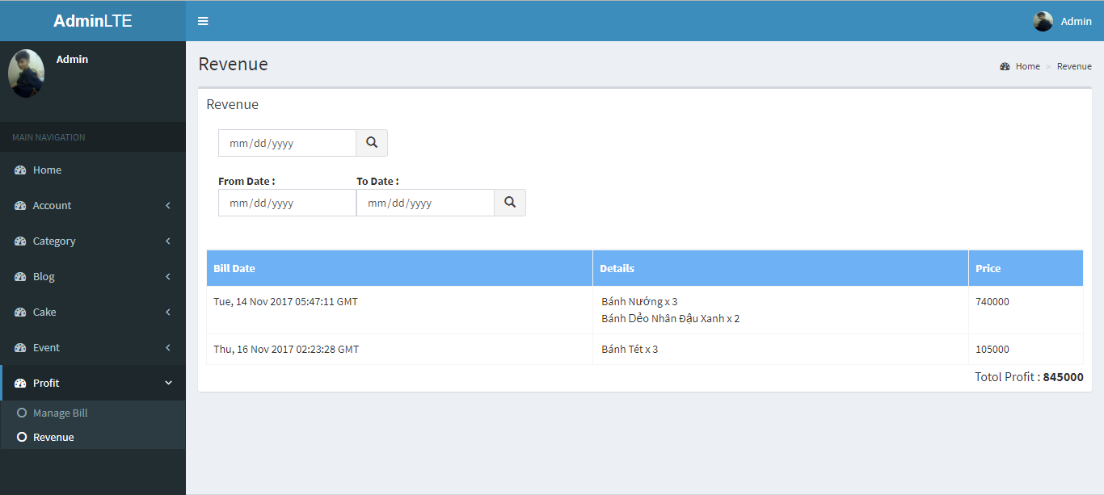

|  |  |  |  |  |  |  |
| --- | --- | --- | --- | --- | --- | --- |
| No | Field name | Type | Require | Mandatory | Max-Length | Description |
| 1 | Search | Date |  | Y |  | Search by date |
| 2 | Search (icon) | Button | Click | Y |  | Icon search |
| 3 | From Date | Date |  | Y |  | From Date |
| 4 | To Date | Date |  | Y |  | To Date |
| 5 | Search (icon) | Button | Click | Y |  | Icon search |
| 6 | List Bill | Table |  | Y |  | List Bill |

1. Revenue Screen
2. Revenue

##### Change Password

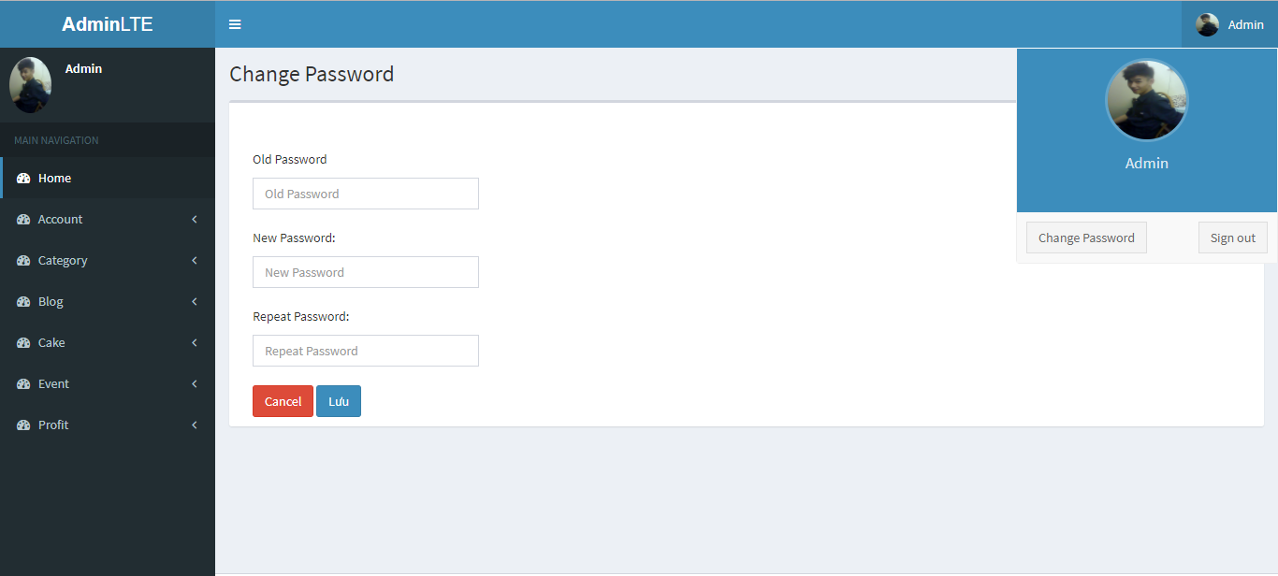

|  |  |  |  |  |  |  |
| --- | --- | --- | --- | --- | --- | --- |
| No | Field name | Type | Require | Mandatory | Max-Length | Description |
| 1 | Old Password | Text |  | Y |  | Old Password |
| 2 | New Password | Text |  | Y |  | New Password |
| 3 | Repeat Password | Text |  | Y |  | Repeat Password |
| 4 | Cancel | Button | Click | Y |  | Cancel |
| 5 | Change Password | Button | Click | Y |  | Change Password |

1. Change Password Screen
2. Change Password

### Staff

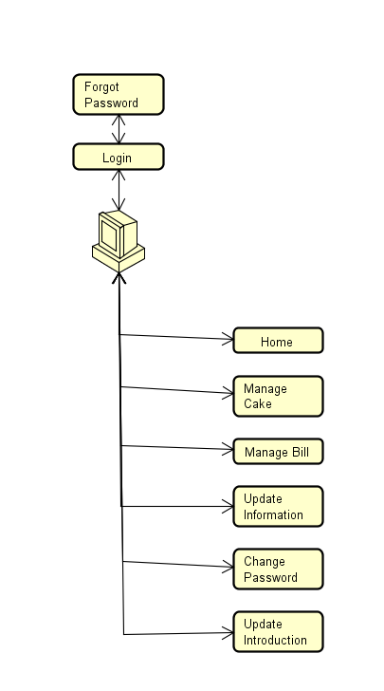

1. Staff screen flow

#### Sign In

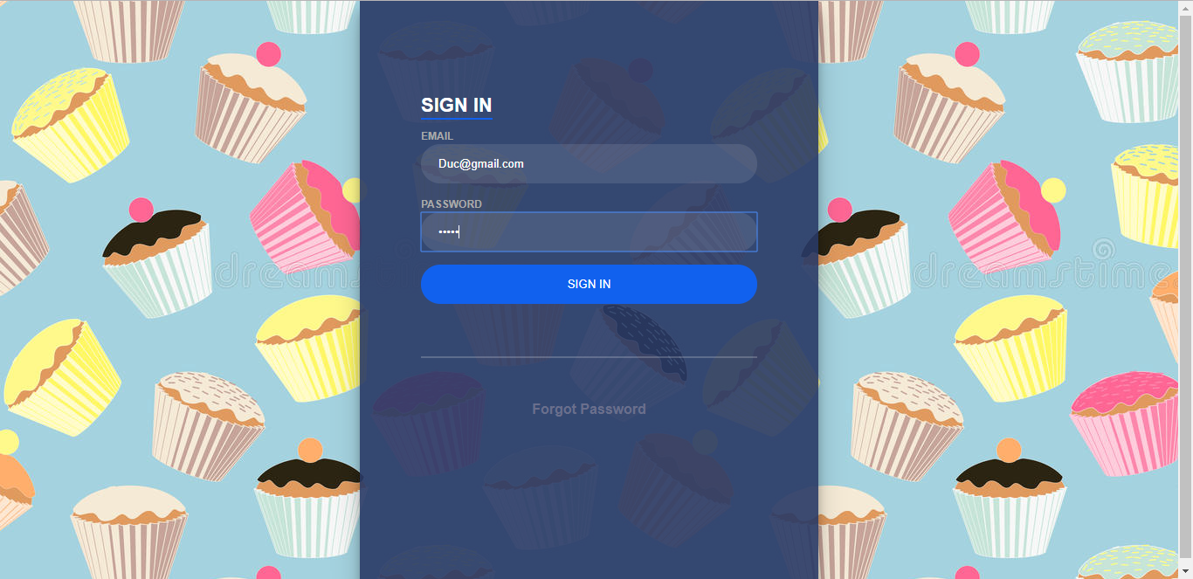

|  |  |  |  |  |  |  |
| --- | --- | --- | --- | --- | --- | --- |
| No | Field name | Type | Require | Mandatory | Max-Length | Description |
| 1 | Email | Text box | Email | Y |  | Email of Staff |
| 2 | Password | Text box | Type | Y |  | Password of Staff |
| 3 | Sign in | Button | Click | Y |  | Login |
| 4 | Forgot Pasword | Link | Click | Y |  | Forgot Password |

1. LoginStaff Screen
2. LoginStaff

#### Forgot Password

|  |  |  |  |  |  |  |
| --- | --- | --- | --- | --- | --- | --- |
| No | Field name | Type | Require | Mandatory | Max-Length | Description |
| 1 | Email | Text box | Email | Y |  | Email |
| 2 | Forgot Password | Button | Click | Y |  | Forgot password |
| 3 | Back to login | Link | Click | Y |  | Back to login |



1. Forgot Password screen
2. Forgot Password

#### Manage Cake

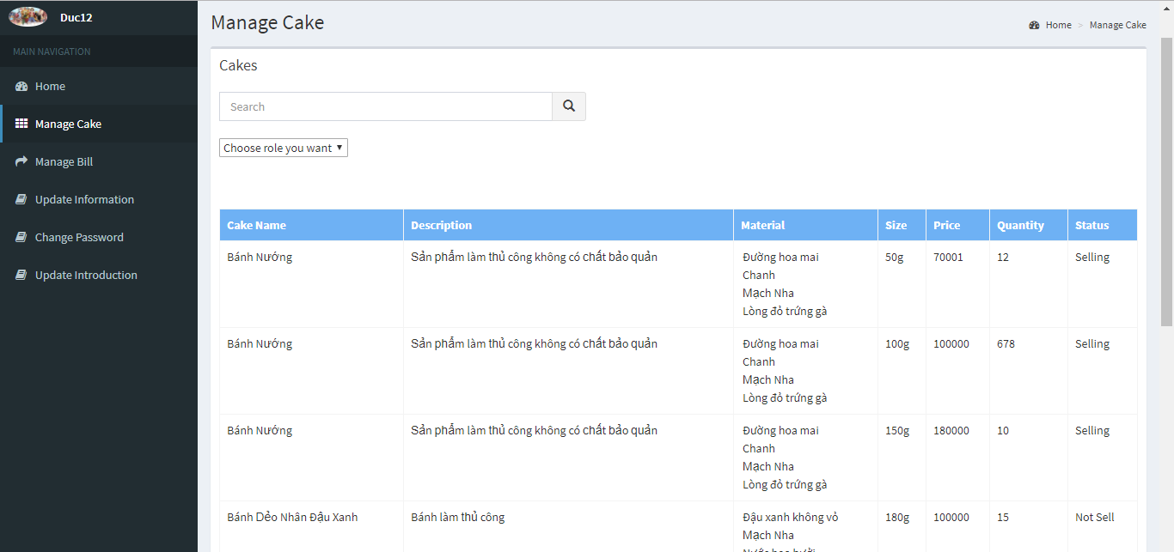

1. Manage Cake screen

|  |  |  |  |  |  |  |
| --- | --- | --- | --- | --- | --- | --- |
| No | Field name | Type | Require | Mandatory | Max-Length | Description |
| 1 | Search | Input Text |  | Y |  | Search by name |
| 2 | Icon Search | Button | Click | Y |  | Icon Search |
| 3 | Choose role you want | Drop Downlist | Click | Y |  | Search by role |
| 4 | List Cake | Table |  | Y |  | List Cake |

1. Manage Cake screen

#### Manage Bill

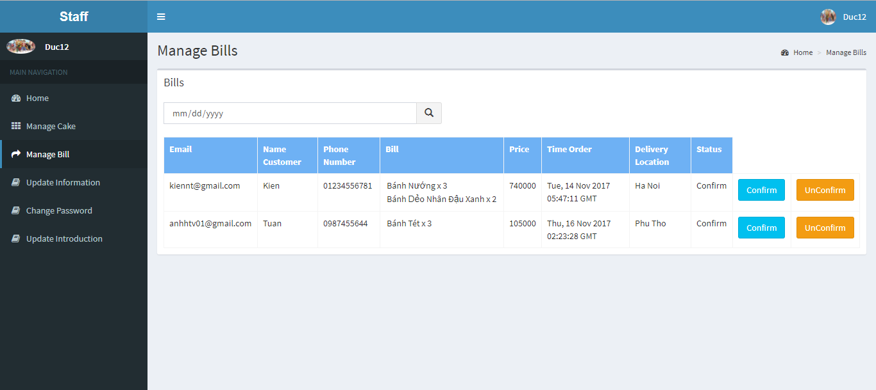

|  |  |  |  |  |  |  |
| --- | --- | --- | --- | --- | --- | --- |
| No | Field name | Type | Require | Mandatory | Max-Length | Description |
| 1 | Search | Date |  | Y |  | Search by date |
| 2 | Search (icon) | Button | Click | Y |  | Icon search |
| 3 | List Bill | Table |  | Y |  | List Bill |
| 4 | Confirm | Button |  | Y |  | Confirm bill |
| 5 | UnConfirm | Button |  | Y |  | UnConfirm bill |

1. Manage Bill
2. Manage Bill

#### Update Information

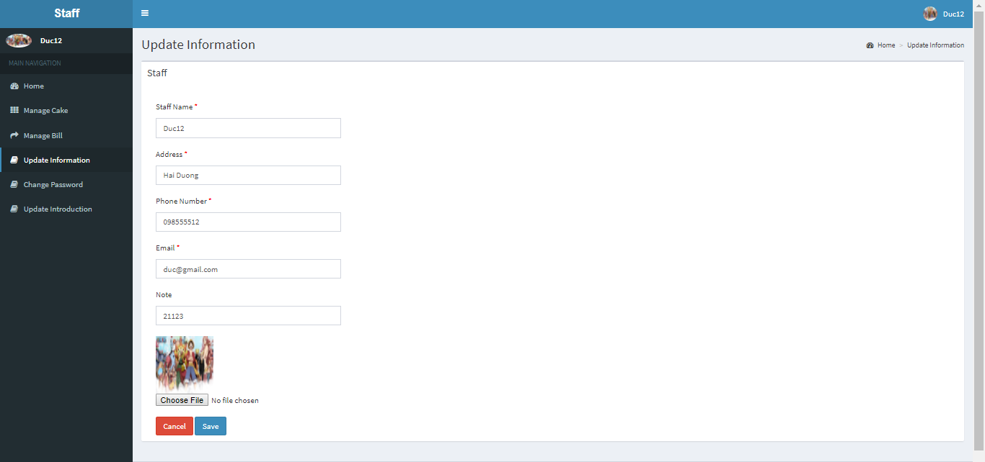

1. Update Information screen

|  |  |  |  |  |  |  |
| --- | --- | --- | --- | --- | --- | --- |
| **No** | **Field name** | **Type** | **Require** | **Mandatory** | **Max-Length** | **Description** |
| 1 | Staff Name | Text |  | Y |  | Staff Name |
| 2 | Addrees | Text |  | Y |  | Address Staff |
| 3 | Phone Number | Text |  | Y |  | Phone Number |
| 4 | Email | Text |  | Y |  | Email |
| 5 | Note | Text |  | Y |  | Other information |
| 6 | Choose File | Button | Click | Y |  | Select photo |
| 7 | Cancel | Button | Click | Y |  | Cancel |
| 8 | Save | Button | Click | Y |  | Save |

1. Update Information

#### Change Password

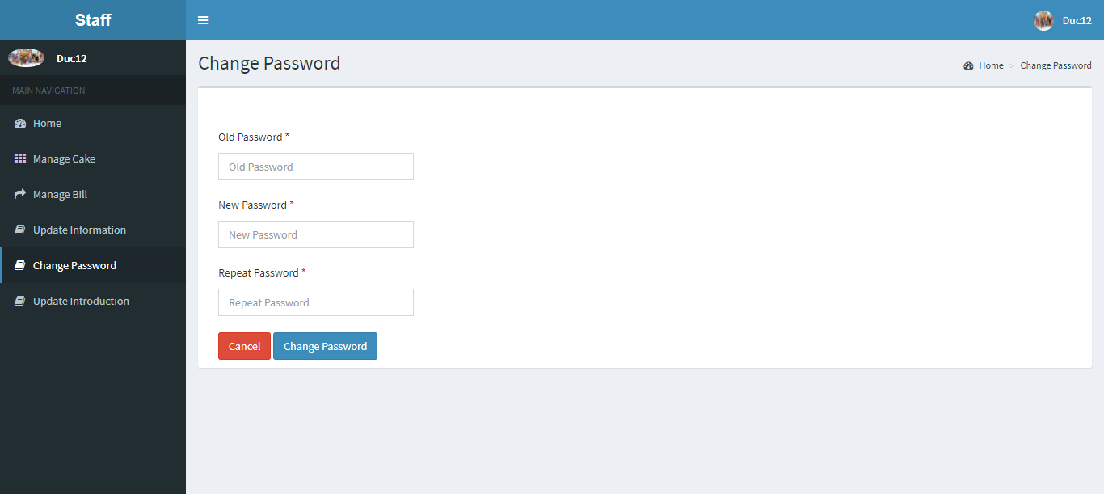

1. Change Password screen

|  |  |  |  |  |  |  |
| --- | --- | --- | --- | --- | --- | --- |
| No | Field name | Type | Require | Mandatory | Max-Length | Description |
| 1 | Old Password | Text |  | Y |  | Old Password |
| 2 | New Password | Text |  | Y |  | New Password |
| 3 | Repeat Password | Text |  | Y |  | Repeat Password |
| 4 | Cancel | Button | Click | Y |  | Cancel |
| 5 | Change Password | Button | Click | Y |  | Change Password |

1. Change Password

#### Update Introduction

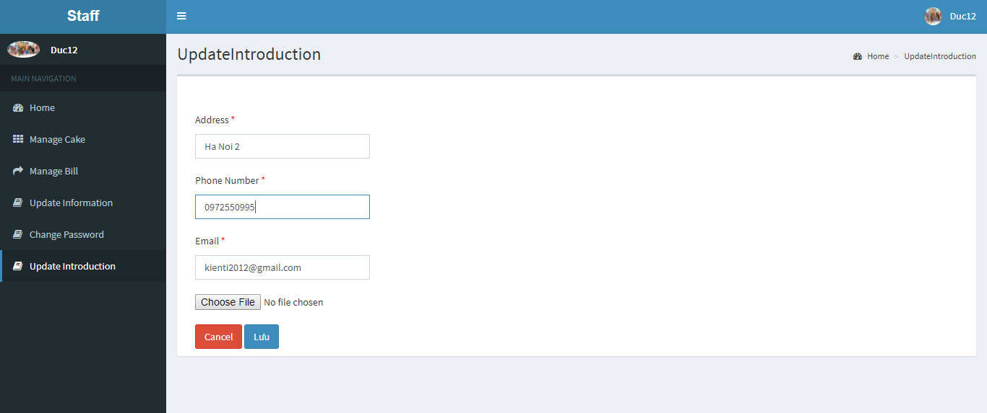

1. Update Introduction screen

|  |  |  |  |  |  |  |
| --- | --- | --- | --- | --- | --- | --- |
| **No** | **Field name** | **Type** | **Require** | **Mandatory** | **Max-Length** | **Description** |
| 1 | Address | Text |  | Y |  | Address your store |
| 2 | Phone Number | Text |  | Y |  | Phone Number |
| 3 | Email | Text |  | Y |  | Email |
| 4 | Choose File | Button | Click | Y |  | Map Photo |
| 5 | Cancel | Button | Click | Y |  | Cancel |
| 6 | Update | Button | Click | Y |  | Update |

1. Update Introduction

# SOFTWARE TESTING

## Introduction

### Purpose

This is the comprehensive test plan of the BSO project. The purpose of this chapter describes scopes of test and activities which need to be taken during test process of project. It addresses the following items: Scopes of Testing, Requirements for Testing, Test Strategy, Test Resources, Test Environment, Test Milestones and Deliverables.

### Definitions and Acronyms

This section describes the definitions, terms, and acronyms that are used in software requirements specification.

|  |  |  |
| --- | --- | --- |
| **Acronym** | **Definition** | **Note** |
| BSO | Bakery Store Online |  |
| GUI | Graphic User Interface |  |
| IT | Integration Test |  |
| KLOC | 1000 line of code |  |
| PM | Project Manager |  |
| QA | Quality Assurance |  |
| SRS | Software Requirement Specification |  |
| ST | System Test |  |
| TC | Test Case |  |
| TL | Test Leader |  |
| TP | Test Plan |  |
| TR | Test Report |  |
| UT | Unit Test |  |

1. Definitions and Acronyms

### Scope of testing

BSO will be tested by 3phases:

**Phase 1: Integration testing**

* After finishing component testing, integration testing will be performed by testers.
* Material are integration test cases, high- level design and test tools.
* Integration test focuses on specific areas of use cases when all requirements are completed.
* Integration test should be performed to ensure all components incorporate well.
* When executing integration testing, if any bugs are found, testers have to log on “Defect Log Management” file and assign to developer fix it and redo this process until it is correct.

*Rule for filling test result:*

|  |  |
| --- | --- |
| Test result pass | Pass |
| Test result fail | Fail |
| Do not test | Untested |
| Cannot test | N/A (Not available) |

1. Rule integration test

**Phase 2: System testing**

* After finishing integration testing and developers collect all functions and items, testers will be performed system testing, it means doing test whole system.
* Material area system test case, SRS
* If any bugs are found, developers have to fix and testers will verify them. System test is ended only when test cases are passed and no bug is found.

*Rule for filling test result:*

|  |  |
| --- | --- |
| Test result pass | Pass |
| Test result fail | Fail |
| Do not test | Untested |
| Cannot test | N/A (Not available) |

1. Rule system test

**Phase 3: Acceptance testing**

* Base on customer/user requirement specification, system is tested again, for ensure there is not lacking or mistake any requirement.
* If there is any problem, developers have to fix/update and tester will verify them.
* Acceptance testing is ended only when whole system met requirement specification.

### Constraints

* Deadline for testing only can be met if development progress is on time.
* Test execution can be performed when system passes Unit Test Inspection.
* At least one round of testing must be performed for requirements.
* Have more environments should be tested: Window 10, Window 8… and more browsers: Firefox 30 and Google Chrome 40…

## Test plan

### Test type

#### Function Testing

* Functional testing is a type of software testing whereby the system is tested against the functional requirements/specifications.
* Functions are tested by feeding them input and examining the output. Functional testing ensure that the requirements are properly satisfied by the website. This type of testing is not concerned with how processing occurs, but rather, with the results of processing.
* During functional testing, [Black Box Testing](http://softwaretestingfundamentals.com/black-box-testing/) technique is used in which the internal logic of the system being tested is not known to the tester.

|  |  |
| --- | --- |
| **Test Objective:** | The type of this test is to ensure proper target-of-test functionality, including user interaction, all function defined in specification document implemented correctly. |
| **Technique:** | Executing each use case, use-case flow, or function, using valid and invalid data, to verify the following:  - The expected results occur when valid data is used.  - The appropriate error or warning messages are displayed when invalid data is used.  - Each business rule is properly applied. |
| **Completion Criteria:** | - All planned tests have been executed.  - All identified defects have been addressed and closed. |
| **Special Considerations:** | Testing may be stopped when  Time runs out  A certain number of defects found  Test coverage > 97%  Stop when testing becomes unproductive |

1. Function Testing

#### User Interface Testing

GUI testing is the process of ensuring proper functionality of the GUI for a given web and making sure it conforms to its written specifications.

GUI testing evaluates design elements such as layout, colors, fonts, font sizes, labels, text boxes, text formatting, captions, buttons, lists, icons, links, content and more.

|  |  |
| --- | --- |
| **Test Objective:** | Verify the following:  - Navigation through the target-of-test properly reflects business functions and requirements, including window-to-window, field-to-field, and use of access methods (tab keys, mouse movements, accelerator keys)  - Window objects and characteristics, such as menus, size, position, state, and focus conform to standards. |
| **Technique:** | Create or modify tests for each window to verify proper navigation and object states for each application window and objects. |
| **Completion Criteria:** | Each window successfully verified to remain consistent with benchmark version or within acceptable standard |
| **Special Considerations:** | Not all properties for custom and third party objects can be accessed. |

1. GUI Testing

##### Data and Database Integrity Testing

The databases and the database processes should be tested as a subsystem within the Project. These subsystems should be tested without the target-of-test’s User Interface as the interface to the data.  Additional research into the Database Management System (DBMS) needs to be performed to identify the tools and techniques that may exist to support the testing identified below.

|  |  |
| --- | --- |
| **Test Objective:** | Ensure database access methods and processes function properly and without data corruption. |
| **Technique:** | - Invoke each database access method and process, seeding each with valid and invalid data or requests for data.  - Inspect the database to ensure the data has been populated as intended, all database events occurred properly, or review the returned data to ensure that the correct data was retrieved for the correct reasons. |
| **Completion Criteria:** | All database access methods and processes function as designed and without any data corruption. |
| **Special Considerations:** | - Testing may require a DBMS development environment or drivers to enter or modify data directly in the databases.  - Processes should be invoked manually.  - Small or minimally sized databases (limited number of records) should be used to increase the visibility of any non-acceptable events. |

1. Data and Data Integrity Testing

### Test stages

Clearly state the stage in which the test will be executed. Identified below are the stages in which common test are executed

| **Type of Tests** | **Stage of Test** | |
| --- | --- | --- |
| **Integration** | **System** |
| Function Testing | X | X |
| User Interface Testing |  | X |

1. Test stages

### Test model

BSO follows V-Model process:



1. V-model process

Testing progress is divided to 5 phases include: Unit test, Component test, Integration test, System test and Acceptance test

* Unit test:
  + Unit testing is used to verify a single minimal unit of source code. The purpose of unit testing is to isolate the smallest testable parts of BSO and verify that they function properly in isolation.
  + Unit testing is the first level of testing and is perform prior to component testing
  + Unit testing will be done by developer.
* Integration test:
  + Integration testing is a level of the software testing process where individual units or component are combined and tested as a group.
  + The purpose is to expose faults in the interaction between integrated units.
  + Integration testing is performed after component testing
  + Integration testing will be done by tester

|  |  |
| --- | --- |
| **No** | **Integration Testing Method** |
| 1 | Bottom-up integration  This testing begins with unit testing, followed by tests of progressively higher-level combinations of units called modules. |
| 2 | Top- Down integration  This testing, the highest-level modules are tested first and progressively lower-level modules are tested after that |

* + There are two methods of doing integration testing: Bottom-up Integration testing and Top Down Integration testing:

1. Integration test

* System test:
  + System Testing is a level of the software testing process where a complete, integrated system is tested
  + The purpose is to evaluate the system’s compliance with the specified requirements
  + System testing is performed after integration testing
  + System testing will be done by tester
* Acceptance test:
  + Acceptance testing is performed after system testing
  + Acceptance testing will be performed by the test leader and team leader.
  + The acceptance test will be done for a period of 1 weeks after completion of the system test process

### Acceptance test criteria.

* Criteria for Integration test:
  + Number of TC/KLOC: 30 TC/KLOC
  + Number defects/KLOC: 2-3 defects/KLOC
* Criteria for System test:
  + Number of TC/KLOC: 20 TC/KLOC
  + Number defects/KLOC: 4-6 defects/KLOC
* Criteria for Acceptance test:
  + Number defects/KLOC: 1-2 defects/KLOC

### Futures to be tested

Refer 3.2.1.2 Product features for more detail.

### Feature not to be tested

* The stable of website when do not connect internet.
* Over than 5000 users connect to system at the same time.

### Resources

#### Human resource

|  |  |  |
| --- | --- | --- |
| **Worker/Doer** | **Role** | **Specific Responsibilities/Comments** |
| PhuongHA | Test Leader | Manage Test Resource and assign test tasks.  Create and review Test Plan.  Create and review Test Case.  Execute test.  Create and review Test Report |
| PhuongPTM | Tester | Create and review Test Case.  Execute test.  Create Test view points  Create and review Test Report |

1. Human resource

#### Test Environment

##### Hardware

|  |  |  |
| --- | --- | --- |
| **Name** | **Purpose** | **Detail** |
| Laptop HP | Device for create and execute test | Window 8.1 Pro Core i3 |
| Laptop Asus | Device for create and execute test | Window 8.1 Pro Core i5 |

1. Hardware

##### Software

|  |  |  |
| --- | --- | --- |
| **Name** | **Purpose** | **Detail** |
| Test Plan | Managing test | Microsoft Word 2010, 2013 |
| Test case | Executing test | Microsoft Excel 2010, 2013 |
| Test report, Test checklist | Tracking test | Microsoft Excel 2010, 2013 |
| Chrome | Executing test | Chrome 40.0 |
| Firefox | Executing test | Firefox |

1. Software

##### Infrastructure

|  |  |  |  |  |
| --- | --- | --- | --- | --- |
| **Name** | **Purpose** | **Detail** | **Vendor/In-house** | **Version** |
| BSO_Defect Log Management_v1.0_EN | Tracking bug during testing time | Microsoft Excel 2013, 2010 | FPT-University | v1.0 |
| Test Effort | Effort execute test | Microsoft Excel 2013, 2010 | FPT-University | v1.0 |

1. Infrastructure

### Test milestones

|  |  |  |  |
| --- | --- | --- | --- |
| **Milestone Task** | **Effort (pd)** | **Start Date** | **End Date** |
| Create Test Plan | 5 | 21/10/2017 | 23/10/2017 |
| Create Integration Test case | 2 | 06/11/2017 | 10/11/2017 |
| Review & Update Integration Test Case | 2 | 11/11/2017 | 12/11/2017 |
| Create System Test case | 5 | 30/10/2017 | 05/11/2017 |
| Review & Update System Test Case | 2 | 04/11/2017 | 05/11/2017 |
| Execute Integration test phase 1 | 2 | 13/11/2017 | 17/11/2017 |
| Execute Integration test phase 2 | 2 | 24/11/2017 | 26/11/2017 |
| Execute Integration test phase 3 | 2 | 03/12/2017 | 05/12/2017 |
| Execute System test phase 1 | 4 | 18/11/2017 | 20/11/2017 |
| Execute System test phase 2 | 4 | 27/11/2017 | 01/12/2017 |
| Execute System test phase 3 | 4 | 06/12/2017 | 09/12/2017 |
| Create Test Plan | 5 | 21/10/2017 | 23/10/2017 |
| Review & Update Test Plan | 2 | 16/12/2017 | 17/12/2017 |

1. Test milestones

### Deliverables

| **No** | **Deliverables** | **Responsibilities** | **Delivered Date** |
| --- | --- | --- | --- |
| 1 | Test Plan | Tester |  |
| 2 | Integration Test case | Tester |  |
| 3 | System Test case | Tester |  |
| 4 | Defect Log Management | All members |  |
| 5 | Test report | Test Leader |  |

1. Deliverables

## Test case

Refer to:

* + BSO_Integration Test Case_v1.0_EN.xlsx
  + BSO_System Test Case_v1.0_EN.xlsx
  + BSO_Common Test Case_v1.0_EN.xlsx

## Test Report

### System test report

|  |  |  |  |  |  |
| --- | --- | --- | --- | --- | --- |
| **No** | **Module Code** | **Pass** | **Fail** | **N/A** | **Number of Test Case** |
| 1 | Display Personal Page | 16 | 0 | 0 | 16 |
| 2 | Admin Login | 64 | 0 | 0 | 64 |
| 3 | Account Management | 58 | 0 | 0 | 58 |
| 4 | Category Management | 16 | 0 | 0 | 16 |
| 5 | Blog Management | 16 | 0 | 0 | 16 |
| 6 | Cake Management | 38 | 0 | 0 | 38 |
| 7 | Event Management | 66 | 0 | 0 | 66 |
| 8 | Profit Management | 30 | 0 | 0 | 30 |
| 9 | Staff Login | 66 | 0 | 0 | 66 |
| 10 | Message | 52 | 0 | 0 | 52 |
| 11 | Admin Module | 160 | 0 | 0 | 160 |
| 12 | User Login | 104 | 0 | 0 | 104 |
|  | **Total** | 634 | 0 | 0 | 634 |

1. System test report

### Integration test report

|  |  |  |  |  |  |
| --- | --- | --- | --- | --- | --- |
| **No** | **Module Code** | **Pass** | **Fail** | **N/A** | **Number of Test Case** |
| 1 | Registered_User_function | 128 | 0 | 0 | 128 |
| 2 | Admin_Function | 244 | 0 | 0 | 244 |
| 3 | Staff_Function | 126 | 0 | 0 | 126 |
|  | **Total** | 498 | 0 | 0 | 498 |

1. Integration test report

### Test report

|  |  |  |  |  |  |  |  |  |
| --- | --- | --- | --- | --- | --- | --- | --- | --- |
| **No** | **Module Code** | **Round 1** | | **Round 2** | | **Round 3** | | **Final** |
| Pass | Fail | Pass | Fail | Pass | Fail |
| 1 | Integration Test | 498 | 0 | 498 | 0 | 498 | 0 | 498 |
| 2 | System Test | 583 | 51 | 602 | 32 | 634 | 0 | 634 |
|  | **Total** | 1081 | 51 | 1100 | 32 | 1131 | 0 | 1131 |

1. Test Report

### Defect report

|  |  |  |  |  |
| --- | --- | --- | --- | --- |
| **Defects** | **Logged** | **%Closed** | **%Invalid** | **%Open** |
| **Critical** | 0 | 0% | 0% | 0% |
| **High** | 4 | 0% | 0% | 0% |
| **Medium** | 24 | 100% | 0% | 0% |
| **Low** | 38 | 100% | 0% | 0% |
| **Critical** | 0 | 0% | 0% | 0% |

# USER MANUAL

## Introduction

### Purpose

This document contains guide-lines step by step to deploy BSO App to Azure website and This user's manual has been developed to help users better understand the requirements that may apply to use this website by providing them simple step by step tutorials. This manual is intended to help make website's functions more accessible and their associated requirements more understandable to users.

### Environment

Following are the software required to start the BSO system:

* Operating System: Windows 7, Windows 8, Window 10
* Browsers: Firefox 40, Chrome 44 or higher.
* Database: MongoDB
* NodeJS Framework
* Express
* Multer
* BodyParser
* Passport
* LocalStrategy
* Session
* CookieParser
* Flash
* Morgan
* Nodemailer

## Installation Guideline

### Connecting Mlab

#### Creating the Mongo Database

The first thing to do is creat your database on Mlab:

* Step 1: Go to your mlab, and click the Create new button in the right corner.

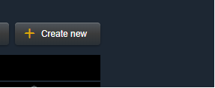

1. New button

* Step 2: Choose one in three Clooud Provider and PlanType then click continue button.

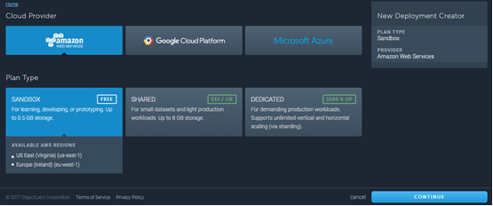

* Step 3: Select Region then click continue button.

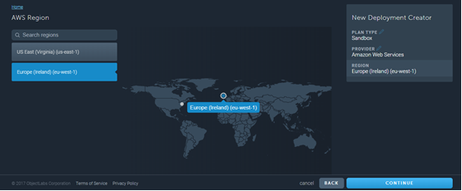

* Step 4: Write your database name
  + Database Name: **catbakery**

Then click continue button.

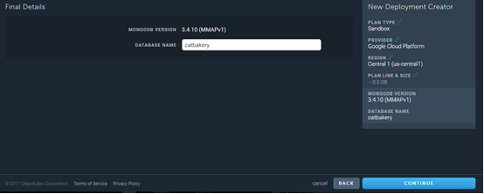

1. List SQL Database

* Step 5: Confirm all the things you have done then click Submit order button

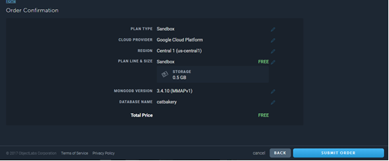

After waiting a few seconds your database should be created.

* Step 6: Click on your Database

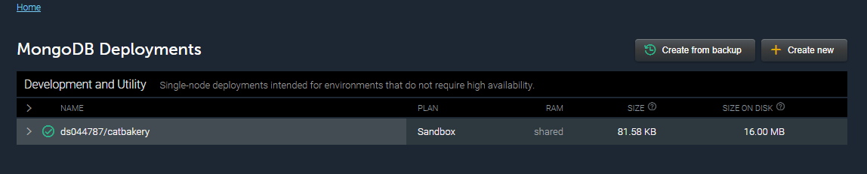

Figure 6-6:

* Step 7: Then choose Users >> Select Add database users

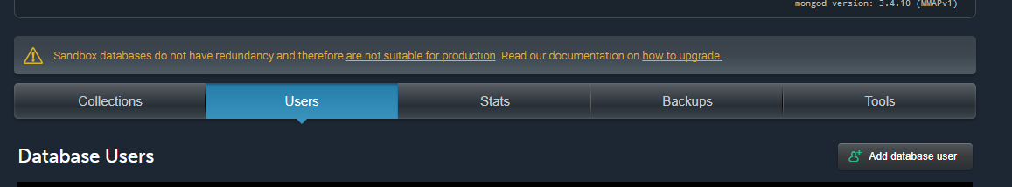

Figure 6-7:

* Step 8 : Fill in the form. My settings were:
  + Database username: **admin**
  + Database password: **123456**
  + Confirm password: **123456**

Then click Create button

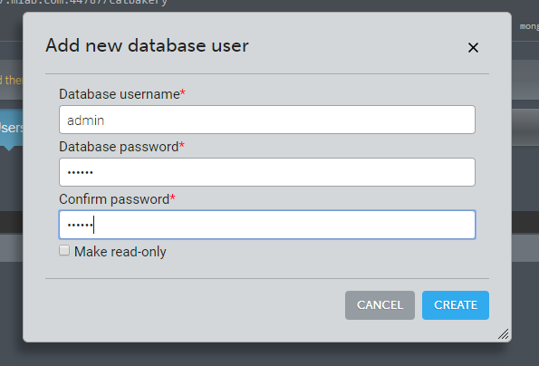

Figure 6-8:

After waiting a few seconds your database user should be created.

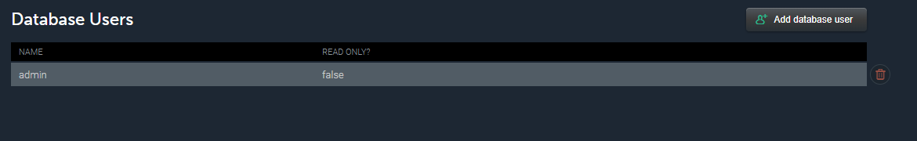

* Step 9 : Go back to Homepage



Figure 6-10:

Your database is now set-up and ready for you to configure in your web app.

#### Updating Connection Details in Your Web App

The next step is to update you mvc appication to point at the newly created mongo database.

Step 1: Within your atom, find the file called config.json and open it

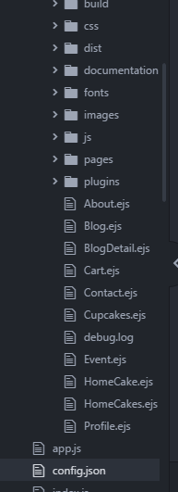

Figure 6-11:

* Step 2: Add the following code into the file directly.

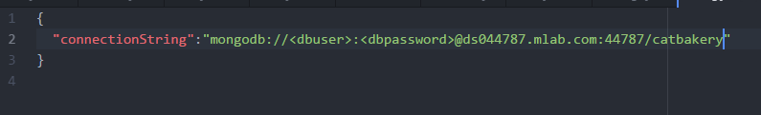

Figure 6-12:

* Step 3: Enter you dbuser and db password that you create on mlab (Figure 6-8).

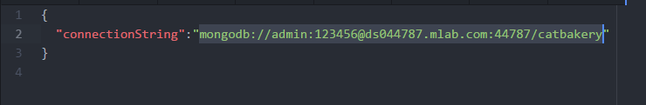

* Step 5: Save the file

### Create & Deploying the Heroku Website

#### Create Heroku Website

In order to deploy your website to Heroku you’re going to need to set-up an account. At [Heroku Website](https://www.heroku.com/) you can create an account for free and have a free trial. Furthermore, at this point in time you can set-up up to 5 heroku websites for free – you cannot use custom domain names, ssl or several other features, but they are perfect for experimentation.

Once you have created you account head to <https://dashboard.heroku.com/apps> where you can set-up your first website:

* Step 1: From the main screen click the new button in the right corner

Then select Create new app

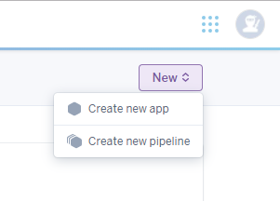

* **Step 2:** Enter the name for your website, I used “catbakery” (note that you have to choose a name that’s available).
* Step 3: Select a region where you want your site to be hosted, I suggest choose United States
* Step 4: Press create website

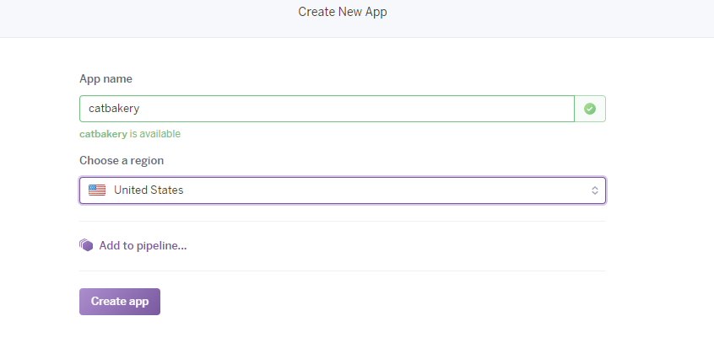

1. Create Web Site

You’ll have to wait a few seconds for heroku to spin up the website

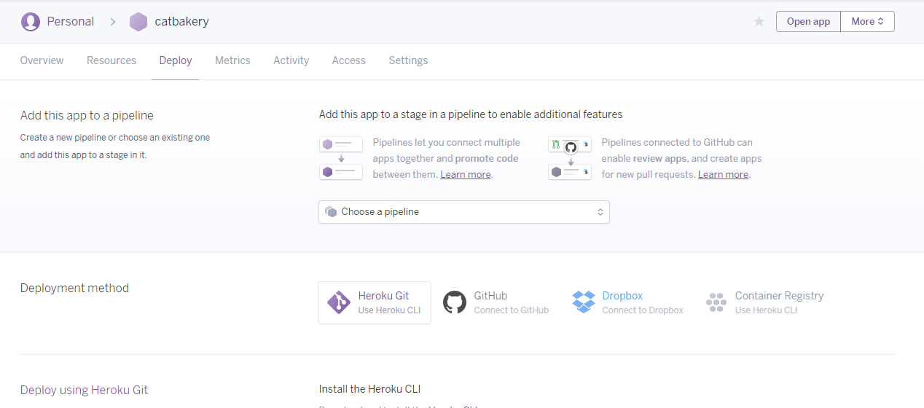

1. List Website

Now you’ve got an heroku website ready, we can get to publishing your mvc site to the heroku service.

* Step 6 : Click Open app in the right corner to see your website looklike.

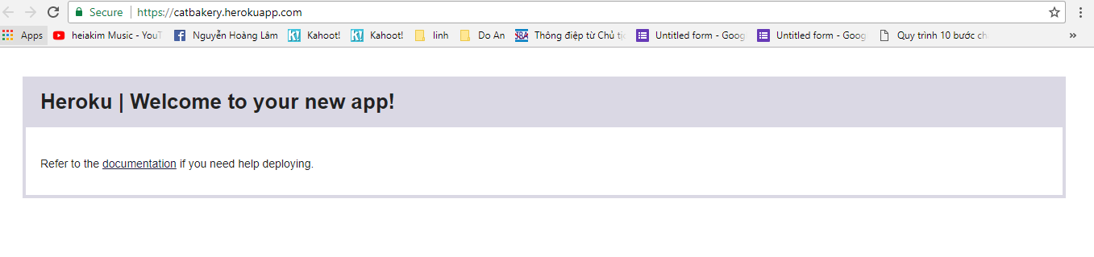

Figure 6-16:

#### Deploying to the Heroku Website

* Step 1: From heroku dashboard, right click to your app in the left corner.

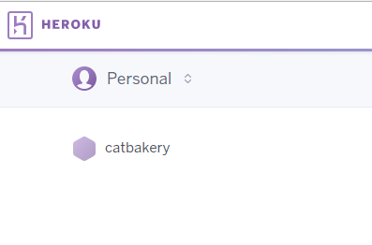

Figure 6-17:

* Step 2: Then select Deploy

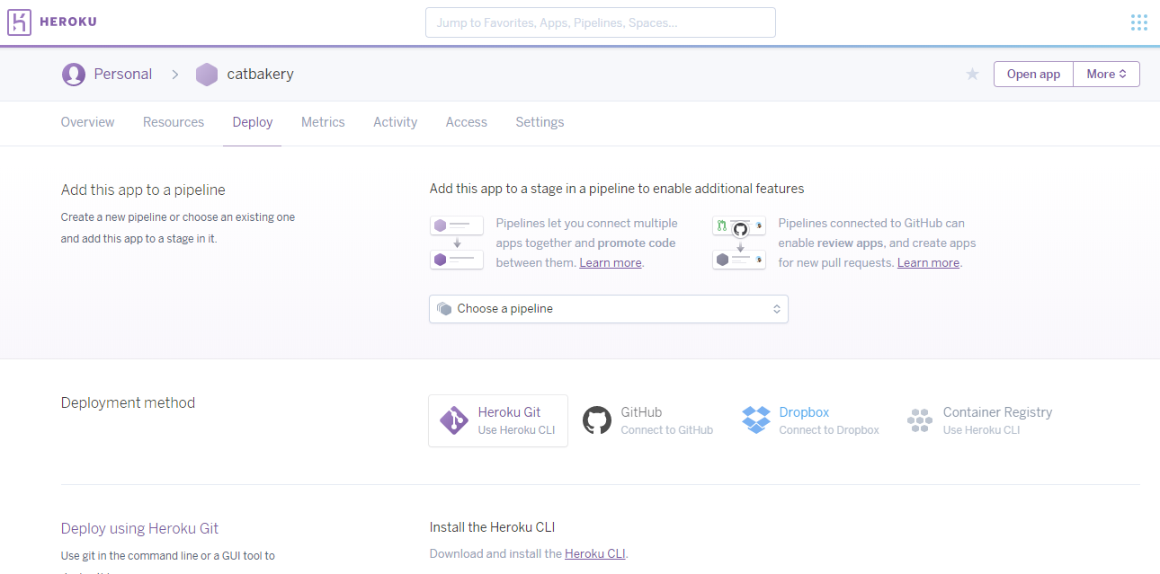

You will see the Deployment method. Select one. I choose Heroku Git.

* Step 3: Install the Heroku CLI

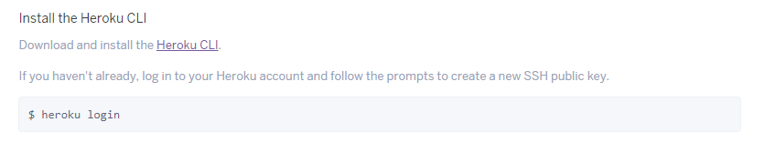

Figure 6-18:

* Step 4: Open the Command Prompt type: heroku login
* You need to enter your email and your password

(email and password of your heroku account)

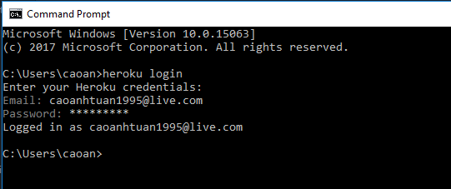

Figure 6-18:

* Step 5: Create a new git repository

Follow this step.

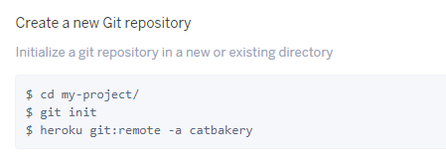

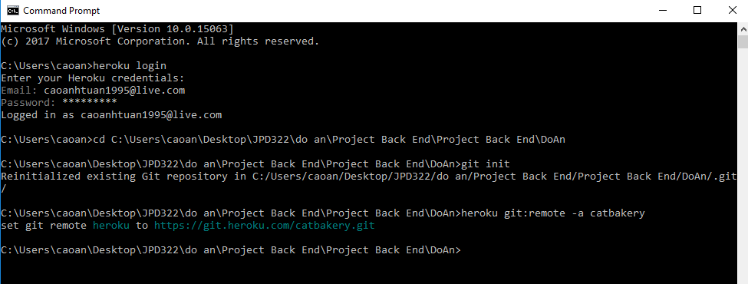

Figure 6-19:

* Step 6: Deploy you application

Follow this step.

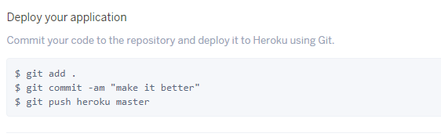

Once your website has finished deploying, open your browser type [yourwebsitename.herokuapp.com](https://catbakery.herokuapp.com/)

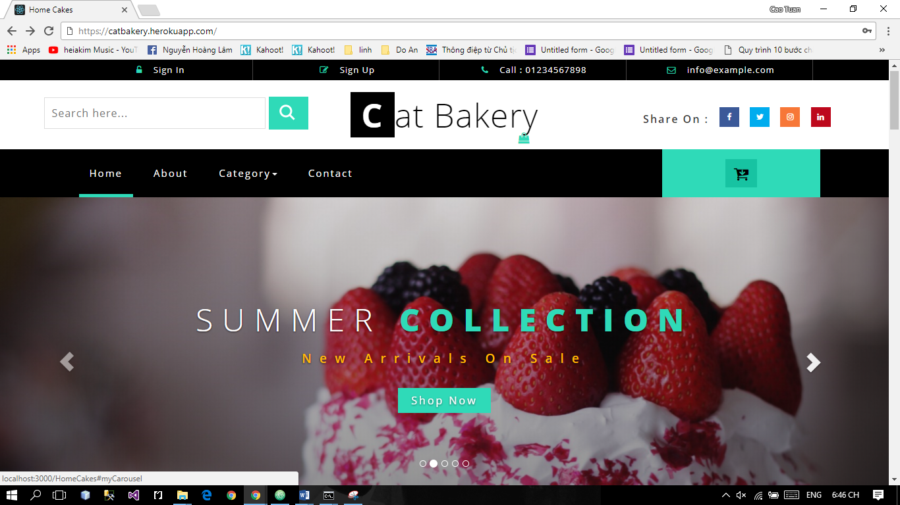

1. Save button

## User Guideline

### User Client

#### Sign up

This is the first page which user will see. From this page the user can go to every page they want.

To register account on website, the users do the steps below:

Step 1: Open browser and enter to the address bar: <http://catbakery.herokuapp.com/>. Homepage is displayed.

Step 2: Click on Sign in button in header. Users will go to Sign in page.

Step 3: Click Sign up on Sign in page. Users will move to Sign up page.

Step 4: Enter information and click on Sign up to register.



1. Sign up screen

#### Login

To login account on website, the users do the steps below:

Step 1: Open browser and enter to the address bar: <http://catbakery.herokuapp.com/>. Homepage is displayed.

Step 2: Click on Sign in button in header. User will go to Login page.

Step 3: User can Login with BSO’account:

Step 3.1: User enter username and password

Step 3.2: Click on Login button

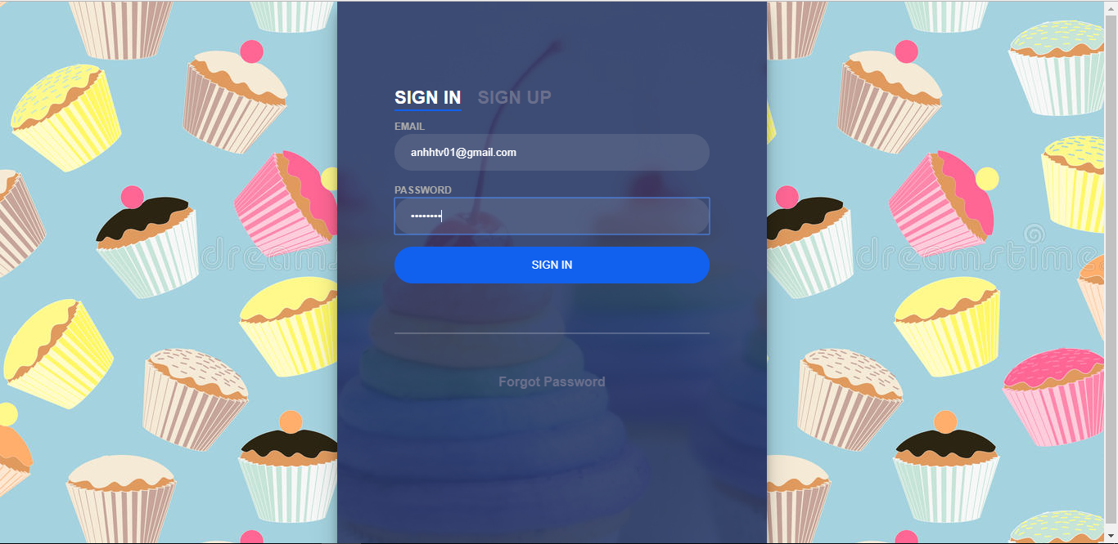

1. Login page

#### Buy Cake

To buy a cake on website, the users do the steps below:

Step 1: In Home page user will see list of cake.



1. List cake

Step 2: Click on add to cart to add cake to your cart.



1. Oder cake

Step3: Click order to view your order



1. Check out

Step4: Click check out to finish your oder

If your don’t have an acount you need to fill this form to finish your order



1. Finish order

If you have an acount your order will be success.

#### Profile

When you loggin to the page with BOS’account.

In this page, user can view, edit profile, change password, view purchase history, the user do the steps below:

Step 1: Go to Homepage.

Step 2: Click on your name in the top left corner

Step 3: You will see the popup then click to the Profile button. User will go to Profile page

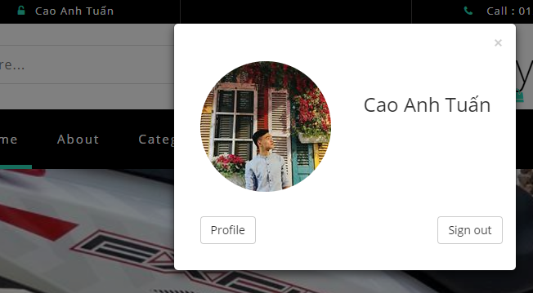

1. Go to Profile Page

##### View and Edit Profile

In this page, user can view and edit profile, the user do the steps below:

Step 1: Click to Account Information.

Step 2: User can change any item in account information.

Step 3: User click update to update profile



1. Account Infomation

##### Change Password

In this page, user can change account password , the user do the steps below:

Step 1: Click to Change Password.

Step 2: User type curent password then type new password và confirm new password

Step 3: Click on Change to chage your password.



1. Change Password

##### Purchase History

In this page, user can view purchase history, the user do the steps below:

Step 1: Click to Purchase History.

Step 2: User can view all the has bought.



Figure 2-10: **Purchase History**

#### Event

In Homepage User can see slide event.

User can view detail event, the user do the steps below:

Step 1: Click on the image of the event in slide on screen



Figure 2-11: **Slide event**

Step 2: Users will go to Event detail page.



Figure 2-12: **Detail Event**

#### Blog

User can view blog, the user do the steps below:

Step 1: Click on the blog button on menu bar

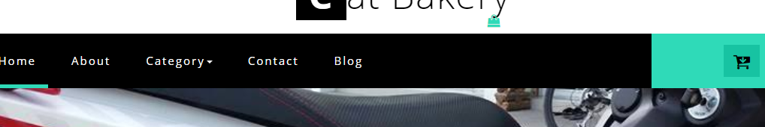

Figure 2-13: **Menu Bar**

Step 2: User will go to the Blog page

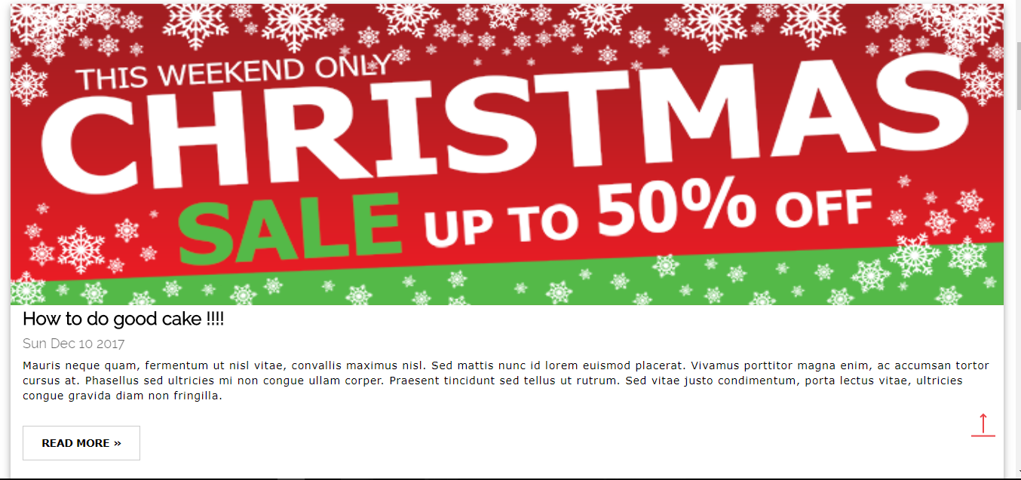

Figure 2-14: **Blog page**

Step 3: User can view detail of blog by click to the button Read more

Step 4: User will go to Detail Blog page

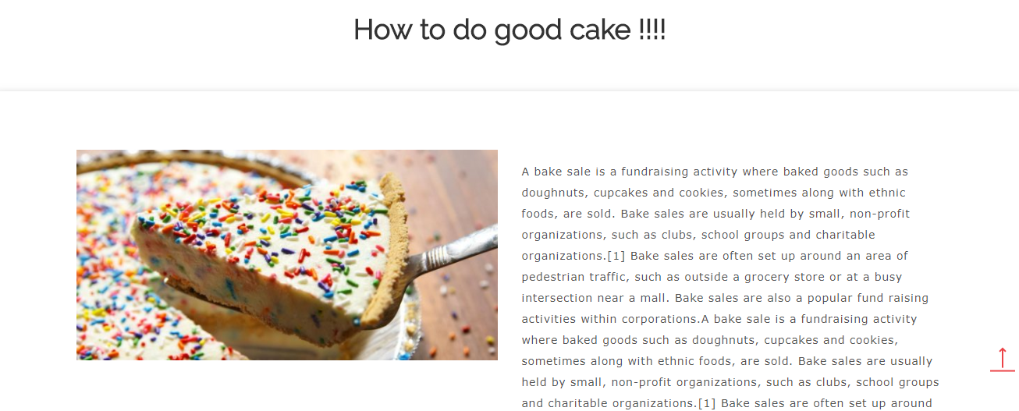

Figure 2-15: **Blog detail page**

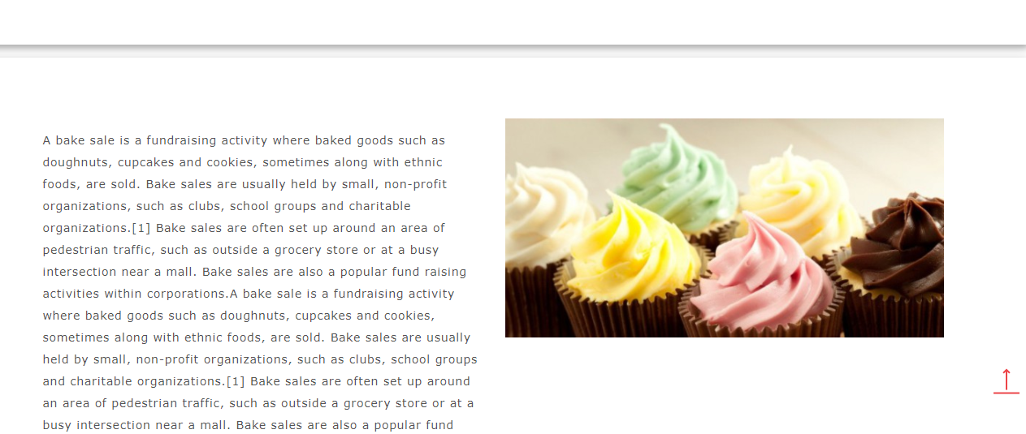

Figure 2-16: **Blog detail page**

### Admin

#### Login



Figure 2-17: **Sign in Screen**

To login admin account, the users do the steps below:

Step 1: Open browser and enter to the address bar: <http://catbakery.herokuapp.com/loginAD/>.

Step 2: User enter username and password

Step 3: Click on Sign in button

#### Forgot Password



Figure 2-18: **Forgot password Screen**

If forgot password , the users do the steps below:

Step 1: Open browser and enter to the address bar: <http://catbakery.herokuapp.com/loginAD/>.

Step 2: Click to the Forgot password button below sign in button.

Step 3: Enter the email of admin

Step 4: System will sent to your mail a new password with random character

#### Change password

To change admin account password, the users do the steps below:

Step 1: Click admin on the top right corner then select change password. User will go to change password page

Step 2: User enter old password then enter new password and confirm password

Step 3: Click on change to change password or cancel to cancel.



Figure 2-19: **Change password Screen**

#### Acount

##### Manage Account

To lock/unlock a account. Admin do the step below:

Step 1: Go to Admin page, Click on “Account”. Then click on manage account. System return list account.

Step 2: Choose account and click on lock/unlock icon button to lock/unlock account.

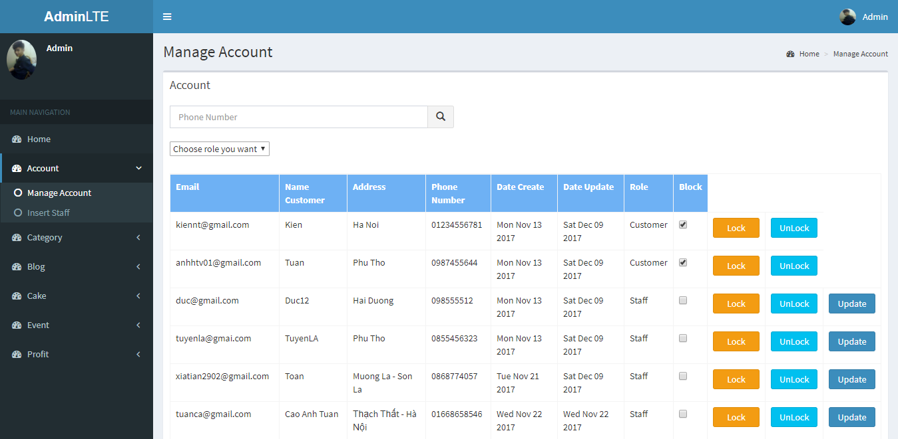

Figure 2-20: **Manage Account Screen**

To update a staff profile. Admin do the step below:

Step 1: Go to Admin page, Click on “Account”. Then click on manage account. System return list account.

Step 2: Choose staff account and click update icon button to update account. Admin will go to update staff profile page.

Step 3: Fill the form and click save to update staff profile or click cancel to cancel the update

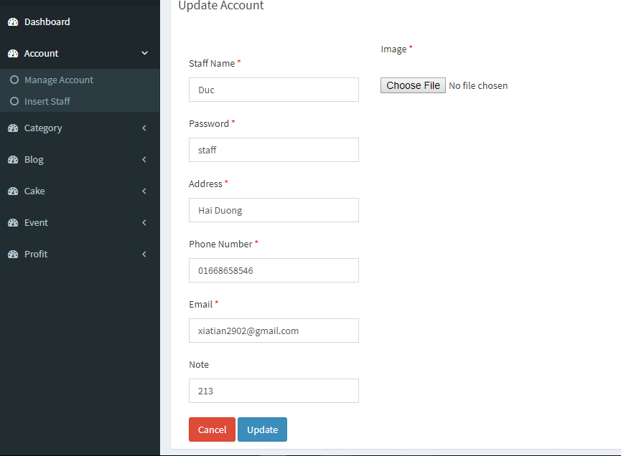

Figure 2-21: **Update Account Staff Screen**

##### Insert Staff

Admin can add a new staff. Admin do the step below:

Step 1: Go to Admin page, Click on “Account”. Then click on insert staff. System return a form.

Step 2: Fill the form and click add to add to add new staff account or click cancel to cancel.

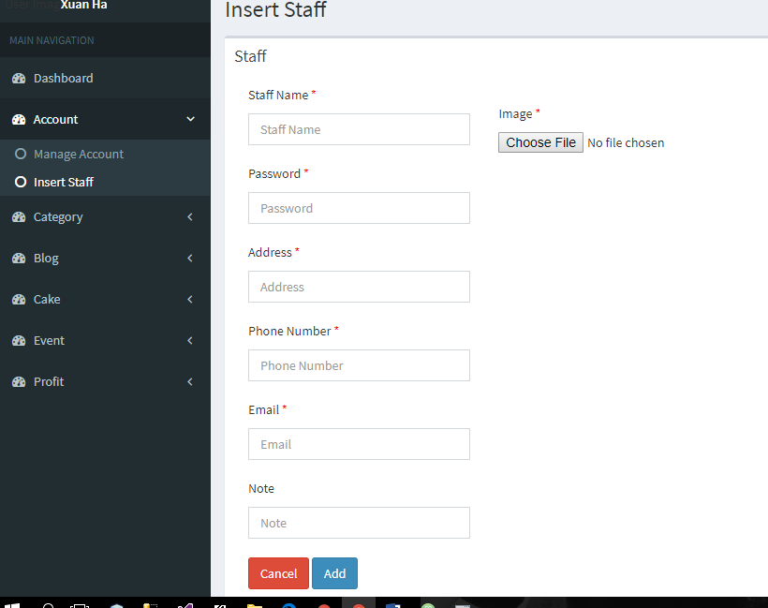

Figure 2-22: **Add Account Staff Screen**

#### Category

##### Manage Category

To lock/unlock a category. Admin do the step below:

Step 1: Go to Admin page, Click on “Category”. Then click on manage category. System return list category.

Step 2: Choose account and click on lock/unlock icon button to lock/unlock category.



Figure 2-23: **Manage Category Screen**

##### Insert Category

To insert category. Admin do the step below:

Step 1: Go to Admin page, Click on “Category”. Then click on insert category. System return a form.

Step 2: Fill the form and click add to add to add new category or click cancel to cancel.



Figure 2-24: **Add Category Screen**

#### Blog

##### Manage Blog

To lock/unlock a blog. Admin do the step below:

Step 1: Go to Admin page, Click on “Blog”. Then click on manage blog. System return list blog.

Step 2: Choose blog and click on lock/unlock icon button to lock/unlock blog.



Figure 2-25: **Manage Blog Screen**

Admin can view detail of a blog by click on them to view detail



Figure 2-26: **Blog detail Screen**

##### Insert Blog

To insert blog. Admin do the step below:

Step 1: Go to Admin page, Click on “Blog”. Then click on insert blog. System return a form.

Step 2: Fill the form and click add to add to add new blog or click cancel to cancel.



Figure 2-27: **Inserrt Blog Screen**

#### Cake

##### Manage Cake

To lock/unlock a cake. Admin do the step below:

Step 1: Go to Admin page, Click on “Cake”. Then click on manage cake. System return list cake.

Step 2: Choose cake and click on lock/unlock icon button to lock/unlock cake.



Figure 2-28: **Manage Cake Screen**

To update a cake. Admin do the step below:

Step 1: Go to Admin page, Click on “Cake”. Then click on manage cake. System return list cake.

Step 2: Choose cake and click update icon button to update cake. Admin will go to update Cake page.

Step 3: Fill the form and click save to update ake or click cancel to cancel the update



Figure 2-29: **Update Cake Screen**

##### Insert Cake

To insert cake. Admin do the step below:

Step 1: Go to Admin page, Click on “Cake”. Then click on insert cake. System return a form.

Step 2: Fill the form and click add to add to add new cake or click cancel to cancel.



Figure 2-30: **Insert Cake Screen**

#### Event

##### Manage Event

To lock/unlock a event. Admin do the step below:

Step 1: Go to Admin page, Click on “Event”. Then click on manage event. System return list event.

Step 2: Choose event and click on lock/unlock icon button to lock/unlock event.



Figure 2-31: **Manage Event Screen**

##### Insert Event

To insert event. Admin do the step below:

Step 1: Go to Admin page, Click on “Event”. Then click on insert event. System return a form.

Step 2: Fill the form and click add to add to add new event or click cancel to cancel.



Figure 2-32: **Insert Event Screen**

#### Profit

##### Manage Bill

To Confirm/Unconfirm a bill. Admin do the step below:

Step 1: Go to Admin page, Click on “Profit”. Then click on manage bill. System return list Bill.

Step 2: Choose bill and click on Confirm/Unconfirm icon button to Confirm/Unconfirm bill.

Admin can search Bill by date with search bar



Figure 2-33: **Manage Bill Screen**

##### Revenue

Admin can view revenue of the store by date, month, quarter, years.



**Figure 2-34:** Revenue Screen

## Staff

### Sign in

To login staff account, the users do the steps below:

Step 1: Open browser and enter to the address bar: <http://catbakery.herokuapp.com/loginStaff/>.

Step 2: User enter username and password

Step 3: Click on Sign in button



Figure 2-35: **Sign in Screen**

### Forgot Password

If forgot password , the users do the steps below:

Step 1: Open browser and enter to the address bar: <http://catbakery.herokuapp.com/loginStaff/>.

Step 2: Click to the Forgot password button below sign in button.

Step 3: Enter the email of staff

Step 4: System will sent to your mail a new password with random character



Figure 2-36: **Forgot password Screen**

### Change Password

To change staff account password, the users do the steps below:

Step 1: Go to Staff page, Click on “Change Password”.

Step 2: User enter old password then enter new password and confirm password

Step 3: Click on change to change password or cancel to cancel.



Figure 2-37: **Change password Screen**

### Manage Cake

Staff can view all the cake in store and can search cake by category and name



Figure 2-38: **Manage Cake Screen**

### Manage Bill

To Confirm/Unconfirm a bill. Staff do the step below:

Step 1: Go to Staff page, Click on “Manage Bill”. System return list Bill.

Step 2: Choose bill and click on Confirm/Unconfirm icon button to Confirm/Unconfirm bill.

Staff can search Bill by date with search bar



Figure 2-39: **Manage Bill Screen**

### Update information

To update profile. Staff do the step below:

Step 1: Go to Staff page, Click on “Update Infomation”.

Step 3: Fill the form and click save to update profile or click cancel to cancel the update



Figure 2-40: **Update Staff Information Screen**

### Update Introduction

Staff can update the information of the store (Change location, email, phone number)



Figure 2-41: **Update Introduction Screen**

# PROJECT RESULT REPORT

## Product Judging

### Advantage of Bakery Store Online system

The idea of Bakery Store Online project is to develop a website where can look for cakes with many different flavors. As the goals that we have set before started project, the Bakery Store Online system has been developed in right direction. And what it provides to users is listed below:

* Customer: customer can view cake, refer to the formula in the blog, order cake, view purchase history
* Staff: staff can manage quantity of cake, manage contact, manage order (check confirm or unconfirm)
* Admin: Admin can manage customer, staff, benefit...

### Current Limitations

* Some screen can’t display well on Mobile or screen which has resolution lower than 1024x768.
* Website not support for English language.
* Not support payment methods online.
* Not support payment by mobile cards..

### Expectation in Future

* Support multi-language and other payment method such as visa and master card to get funding from people in other countries.
* Support payment by mobile cards such as Viettel, Mobi, Vina, …
* App for Android and IOS which supports members manage their projects and admin can manage system anywhere by smart phone.
* Expand server to inscrease number of users.

## Project Summary

|  |  |  |  |  |
| --- | --- | --- | --- | --- |
| **Project Title** | | **Bakery Store Online** | | |
| **Project Supervisor** | | Nguyễn Văn Sang | | |
| **Committers (6)** | | | | |
| **1** | **Project Manager** | Phạm Thị Minh Phương | [phuongptmse03773@fpt.edu.vn](mailto:phuongptmse03773@fpt.edu.vn) | |
| **2** | **Team member** | Nguyễn Xuân Hà | [hanxse03484@fpt.edu.vn](mailto:hanxse03484@fpt.edu.vn) | |
| **3** | **Team member** | Hoàng Anh Phương | [phuonghase03715@fpt.edu.vn](mailto:phuonghase03715@fpt.edu.vn) | |
| **4** | **Team member** | Cao Anh Tuấn | [tuancase03737@fpt.edu.vn](mailto:tuancase03737@fpt.edu.vn) | |
| **5** | **Team member** | Ngô Trung Kiên | [se03736@fpt.edu.vn](mailto:se03736@fpt.edu.vn) | |
| **Main objective** | | Develop a system which will provide to users functionality to collect funding for their project and back to get the amazing products from creative projects. | | |
| **Purpose** | | Provide a Bakery Store Online online on website. | | |
|  | | **Plan** | | **Actual** |
| **Start Date** | | 07/09/2017 | | 07/09/2015 |
| **End Date** | | 25/12/2017 | | 23/12/2015 |
| **Releases version** | | 1.0 | | 1.0 |
| **Duration** | | 81 | | 70 |
| **Effort (person-day)** | | 405 | | 350 |
| **Test cases** | | 1000 | | 1192 |
| **Defects** | | 200-300 | | 66 |
| **Document pages** | | ~ 3000 pages | | ~ 3500 pages |
| **Lines of code (Nodejs)** | | ~ 10000 | | ~ 15000 |
| **Lines of code (HTML)** | | ~ 5000 | | ~ 10000 |
| **LOC (Total)** | | ~ 25000 | | ~ 38000 |

1. Project summary

Knowledge:

* Putting the learned knowledge into practice.
* Improve skils: teamwork, leader-ship, research and self-study, plan and manage time.
* Technical: Node.JS, MongoDB
* Tools: Atom, Robo3T, SmartGit, Office tools.

## Lesson Learnt

* The success of a project is largely dependent on the skills and strengths of the people involved. Therefore, a project needs to have a dedicated, talented set of individuals working towards a common goal.
* When things go wrong, know who you can turn to for help.
* Always disclose information to those, who will need it. This is not the time or place for obtaining an edge over another by keeping crucial data close to your chest. People, who know what is expected of them and have the means of doing so, will play a pivotal role in making the project a success.
* Know what resources are available. Not just those under your purview but those which are at the discretion of other teams. Sometimes, others may be happy to help.
* Be open to change. Sometimes, you may find that the things you knew along may not be correct at this given time, under these specific conditions.
* Good communication is that which will stop mistakes from becoming failures.
* Please think carefully before making a decision because if the wrong decisions you'll have to redo it from scratch.

# REFERENCES

1. Paris Gateaux

<http://parisgateaux.vn/>

1. Madame Huong

<https://madamehuong.vn/>

1. Wikipedia, 2012, IBM Rational Unified Process, viewed 30 September 2013

<http://en.wikipedia.org/wiki/IBM_Rational_Unified_Process>

1. Capstone Project Report Teamplate – FPT University, Ha Noi, Viet Nam.
2. Report document guidelines (2013) – FPT University, Ha Noi, Viet Nam.
3. Template_Project_Plan, (2010), FPT University, Hanoi, Vietnam
4. Template Software_Requirements_Specification, (2010), FPT Software, Hanoi, Vietnam
5. Template Software_Design_Template, (2010), FPT Software, Hanoi, Vietnam
6. Templates for Test case & Defect log, FPT Software, Hanoi, Vietnam
7. The Unified Modeling Language diagram

<http://www.uml-diagrams.org/>